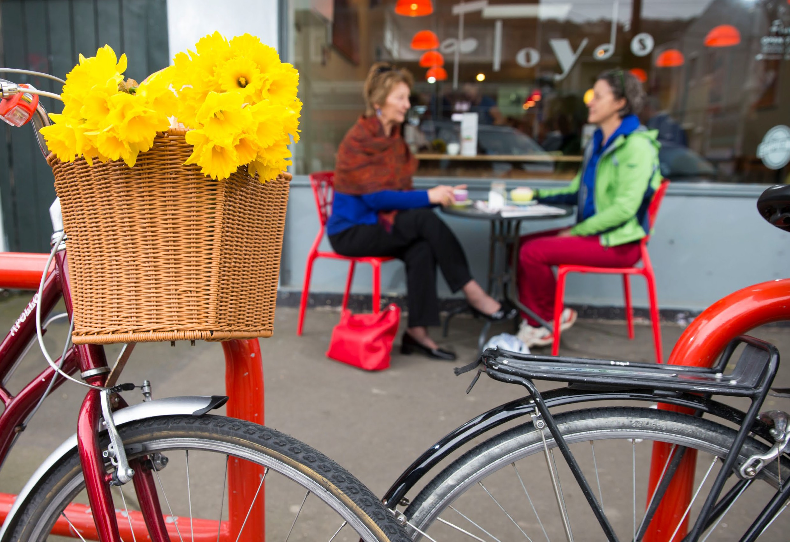
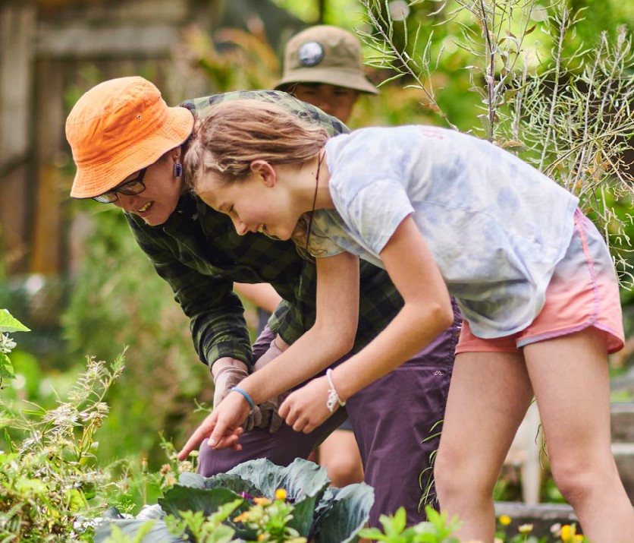
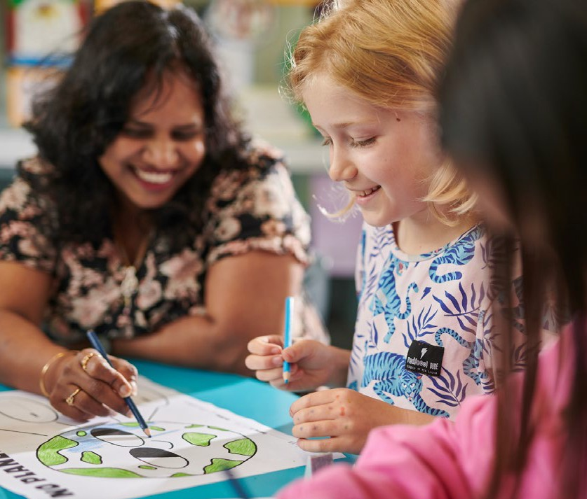
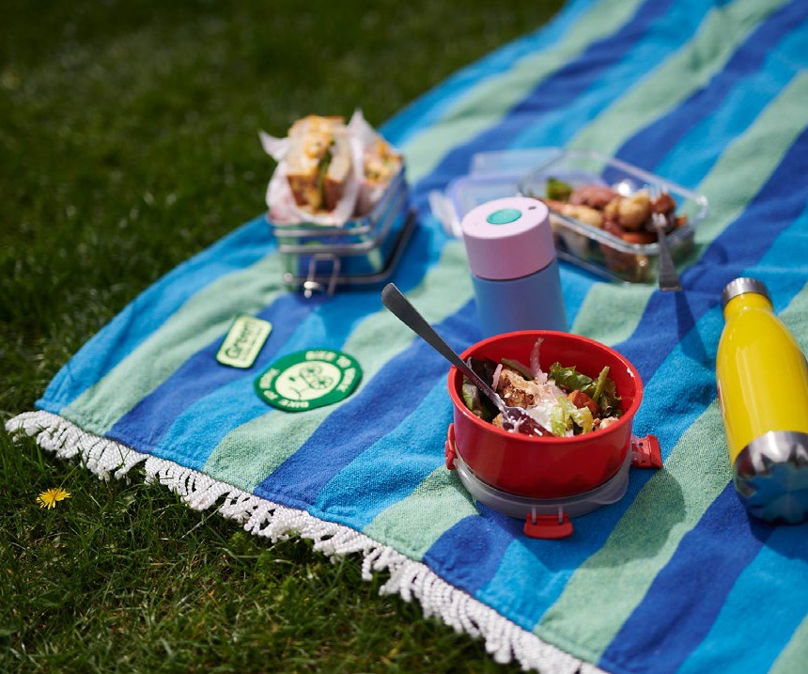

2023 Update

Te Atakura First to Zero

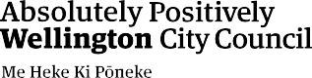

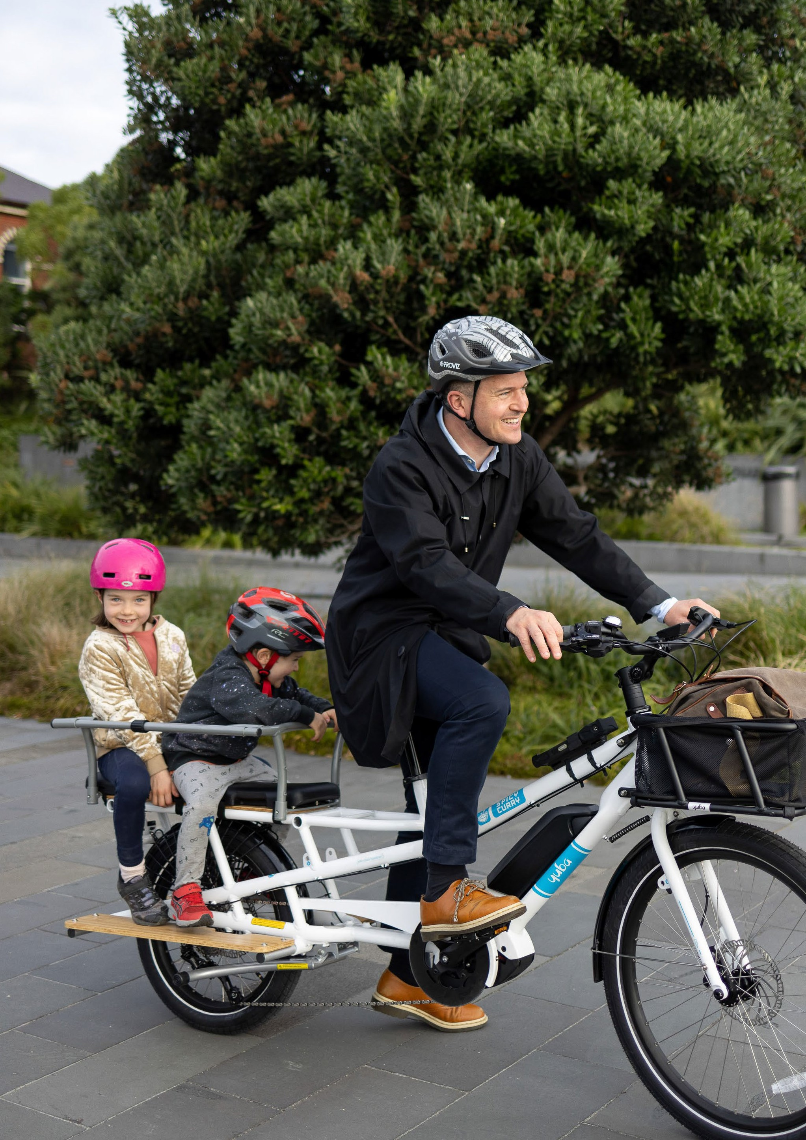

Te wero
Toitū te marae a Tāne Toitū te marae a Tangaroa Toitū te iwi
Ngāi Tātou o Pōneke, me noho ngātahi Whāia te aratika.

Our challenge
Protect and enhance the realms of the Land and the Waters, and they will sustain and strengthen the People. People of Wellington, together we decide our way forward.

Contents
Glossary 05
Introduction 07
Overall progress against the Te Atakura
Implementation Plan 10
Climate action in the capital 15
Progress on action areas to reduce emissions 22
Action area: Transport and urban form 23
Action area: Building energy 31
Action area: City-wide initiatives 34
Action area: The Council itself 39
Action area: Advocacy 45
Progress on action areas to adapt to the
impacts of climate change 48
Action area: Understanding the problem 49
Action area: Developing a strategic
adaptation approach 51
Action area: Advocacy 52
Action area: Working with local communities 53
Appendix 1: Actions Status 57
Transport & Urban Form Actions 58
Building Energy Actions 59
City-wide Initiatives Actions 60
The Council Itself Actions 61
Adaptation Actions 62
Appendix 2: Climate and Sustainability
Fund projects update 64

Glossary: Climate change terms

This glossary defines some of the specific terms used in this document and that are common in discussions on climate change.

Adaptation
Actions that help manage, moderate, and cope with the effects of climate change. For example, avoiding
building in areas likely to be affected by rising sea levels.

Biodiversity
Biological diversity. The variability among living organisms from all sources, and the ecological systems of which they are part; this includes diversity within species, between species and within ecosystems.

Climate change
A pattern of change attributed directly or indirectly to human activity that alters the composition of the atmosphere, affecting global or regional climate, as measured by factors such as average temperature and rainfall, or an alteration in the frequency of extreme weather conditions.

Carbon dioxide
A naturally occurring gas, CO₂ is also a by-product of burning fossil fuels (such as oil, gas, and coal), of burning biomass, of land-use changes, and of industrial processes (eg cement production). See also Greenhouse gas (GHG).

Decarbonisation
The process by which countries, individuals or other entities aim to achieve zero fossil carbon existence.
It typically refers to a reduction of the carbon emissions associated with electricity, industry, and transport.

Fossil fuels
Fuels made from decomposing animals or plants. Examples include coal, oil, and natural gas, which all contain hydrocarbons. As they are carbon-based, these fuels produce carbon dioxide when burnt.

Global warming
The steady rise in the global average temperature of the earth’s atmosphere, which is largely caused by increased levels of human-produced greenhouse gas emissions.

Greenhouse gases (GHG)
Natural and industrial gases that cause the greenhouse effect on Earth. Carbon dioxide and methane are natural GHGs, and hydrofluorocarbons are industrial GHGs.

Liquefaction
Takes place when loosely packed, water-logged soil at or near the ground surface loses its strength in response to strong ground shaking, eg during an earthquake.

Mitigation
Actions aiming to reduce the impacts of climate change by preventing or reducing the emission of greenhouse gases.

Net zero
Refers to a balance between the amount of greenhouse gas emissions produced and the amount removed from the atmosphere, whereby we are not adding new greenhouse gases to the atmosphere.

Scope 1, 2 and 3 emissions
Scope 1 emissions are all the direct emissions from an organisation’s actions or under their control (eg emissions from gas boilers, vehicles, and industrial processes). Scope 2 emissions are indirect emissions from electricity purchased and used by the organisation. Scope 3 emissions are all other indirect emissions from activities of the organisation, occurring from sources that they do
not own or control (eg all purchased goods, emissions from suppliers, any travel not in company owned vehicles). Scope 3 emissions are usually the greatest share of the carbon footprint.

Sequester/carbon sequestration
The process of capturing from the atmosphere and storing carbon dioxide. This can happen naturally, as growing trees and other plants turn CO₂ into biomass stored within the plant. It can also refer to the capture and storage of CO₂ through technical processes.

Tiakina te Taiao
Protect the environment.

About this report
The purpose of the Te Atakura – First to Zero 2023 Update is to report back on progress in delivering the Te Atakura – First to Zero Implementation Plan (the ‘Implementation Plan’) that was adopted by Council in 2020. The period under review focuses on the 2022/23 financial year (FY23) and in some places summarises progress to date. Progress is reported below against key objectives, targets and principles including the commitments made in the Te Atakura – First to Zero Blueprint (the ‘Blueprint’) and against each action area of the Implementation Plan.
We are always keen to hear from Wellingtonians and other interested people and organisations. You can contact us at climateaction@wcc.govt.nz

Te Atakura – First to Zero timeline

April 2019
Over 1200 Wellingtonians were involved in the Te Atakura engagement process to help shape the First to Zero blueprint.

June 2019
Wellington City Councillors declared a climate and ecological emergency and adopted the
Te Atakura Blueprint. The Blueprint set Wellington’s ambition to become a net zero carbon capital by 2050.

August 2020
Councillors adopted the Te Atakura Implementation Plan to to deliver on the commitments made in the Te Atakura Blueprint.

July 2021
Funding was granted through the Long-term Plan 2021–31, to deliver on key action areas over the next 10 years.

September 2021
Our 2021 Update included a science-based target of a 57% reduction in emissions between 2020 and 2030.

December 2022
Our 2022 Update showed good progress on the plan and highlighted the need for urgent collective climate action.

May 2023
The Community Adaptation Engagement Roadmap was adopted by Council’s Kōrau Tūāpapa Environment and Infrastructure Committee.
The roadmap will guide progress on action areas to adapt to the impacts of climate change.

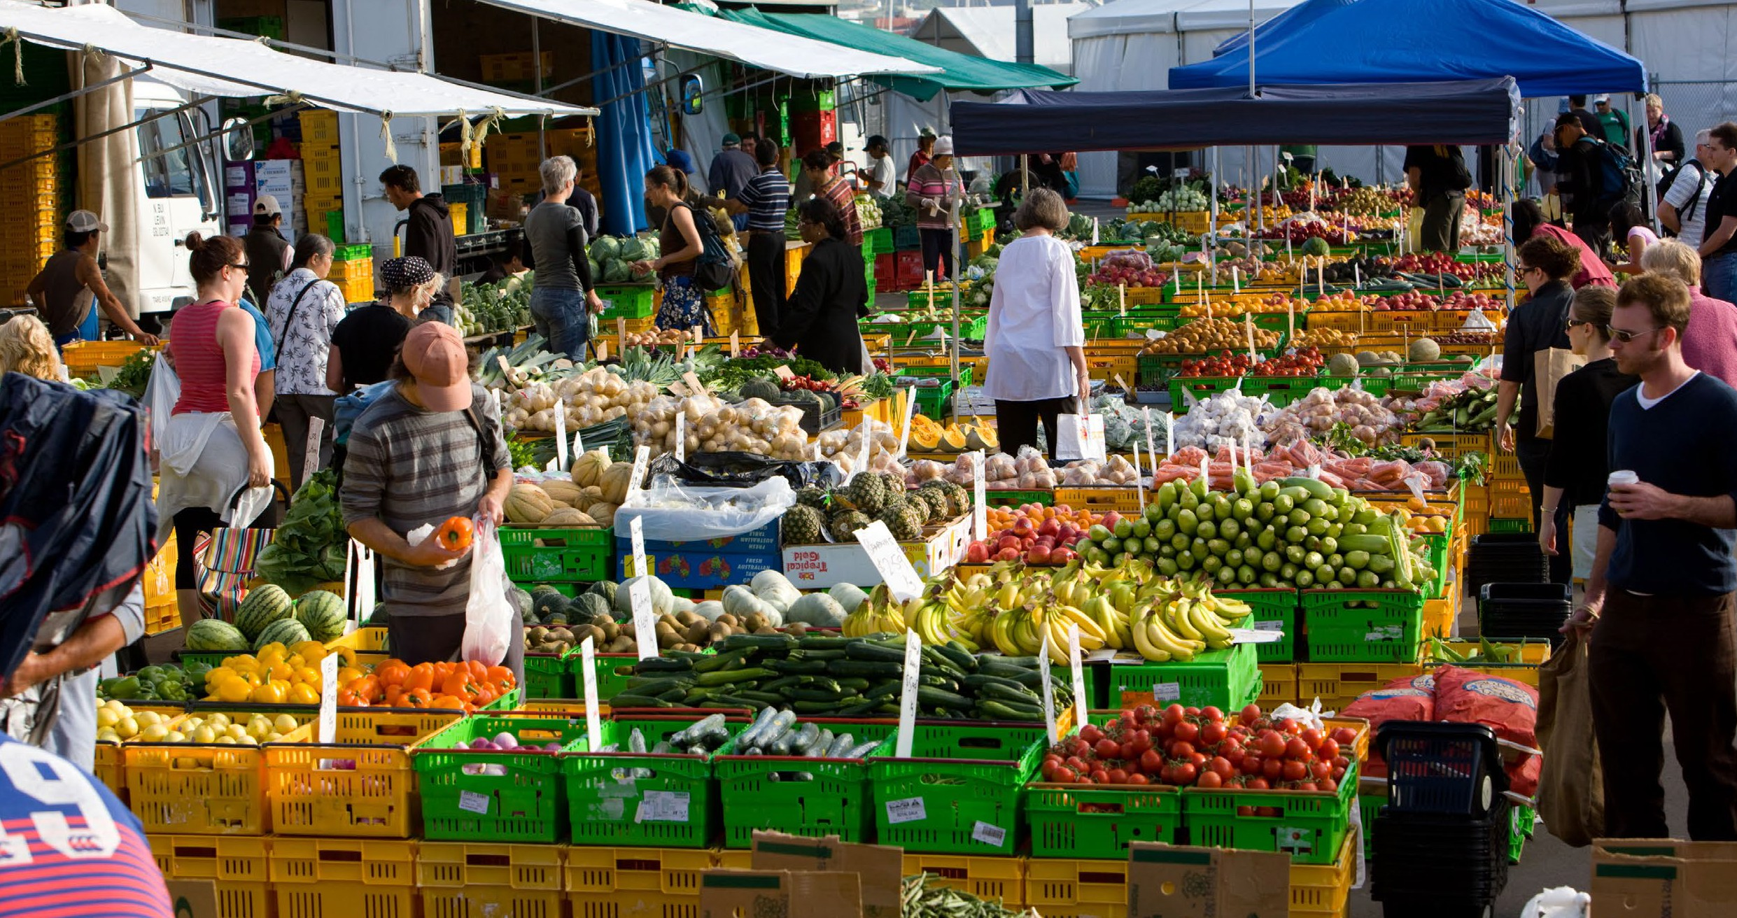
Introduction

We love this city
With its green hills and sparkling harbour, Wellington is a place we love. We’re creative and innovative, and we have a sense of responsibility for our whenua and tamariki. We are rightly proud to have the lowest carbon emissions per capita in Australasia, the highest rates
of public transport use, and rich biodiversity. Yet this is not enough.

Climate change is already threatening much of what we love most
Recent weather events in New Zealand demonstrate the impacts of a warming world: extreme weather impacts to our buildings and roads, parks, reserves, and coastlines, and our food supplies. Reducing our emissions – locally in our neighbourhoods, collectively as a city, nationally and globally – is essential. Above
a certain level of warming, we risk a world where the impacts will outpace our ability to adapt.

We are committed to responding
In 2019 Wellington City Council declared a climate and ecological emergency and adopted Te Atakura – First to Zero as its climate action strategy. Te Atakura focuses on three objectives:
- Reducing the city’s emissions to net zero by 2050, with the greatest cuts before 2030
- Reducing the Council’s own emissions to net zero by 2050
- Improving Wellington’s resilience.
Council adopted the Te Atakura Implementation Plan in August 2020, and funded the first round of actions described in that plan in the 2021 Long-term Plan.
In alignment with the latest science on what is required to avoid increasing risks from climate change, the city’s reduction target was updated in 2021, using the One Planet City Challenge
methodology. Significant emissions reductions are required as soon as possible if we are to stay well below 2 degrees of warming, and cuts now will have more impact than cuts we make later. The city’s target is to reduce 2020 emissions by 57% by 2030, which reflects both the speed at which we need to act, and the bigger opportunity for decreasing emissions because we are a developed country.

Since Te Atakura was adopted the world has changed
Extreme weather events, the COVID-19 pandemic, and international conflicts have added pressure to the cost of living, and arguably contributed to a decrease in social cohesion at home and abroad. This year we’ve experienced flooding in Auckland, Cyclone Gabrielle and other extreme weather events. The ripples of these events impact our city’s ability to respond to climate change, and climate change will increase the magnitude and frequency of social and economic impacts.

While the task ahead is significant, change is possible
This is a complex challenge, but we also know that every fraction of a degree of warming we avoid is an achievement worth fighting for. We’re now in a better place to deliver on Te Atakura than when it was written.
Support from Wellingtonians for responding to the climate emergency is steadfast. Climate leadership is coming from community-led climate action, low-
carbon local businesses, and multiple universities and research institutes specialising in climate change.
The global and local understanding of effective climate response has deepened, with a more nuanced understanding of the science, and an ever-growing suite of solutions.
The headway we are making as a Council and a city is encouraging, particularly with the complexity of
Wellingtonians want action on climate change, and they want to know we’re doing everything we can.
the local, national and global context. Work is already underway to future-proof the things we care most about. The city’s emissions have fallen by 10% since 2020, cycling has increased by 9% in the last year 1, and kiwi have been returned to the city after being extinct here for well over 100 years.

  - Comparing January and October 2023 data to the same time period last year
The city’s emissions have fallen by 10% since 2020.

Responding to climate change is an opportunity, as well as a challenge
The climate emergency is intertwined with social equity, recognition of the role of mana whenua, and the ecological emergency. As we address the causes of climate change in Wellington and make our city more resilient to the impacts of a warming world, we can solve multiple challenges at once and make our city more equitable, more dynamic, more joyous – for us and for our mokopuna after us.

There is more to do
Te Atakura originally focused almost exclusively on the reduction of the greenhouse gases that cause global warming and climate instability. Since then, it has become clear that we also need to start adapting to the impacts of climate change we cannot avoid.
We need to make physical changes to protect our city, and we also need to adapt socially and economically to external forces. This is driven by the global movement to decarbonise, particularly from some of New Zealand’s significant trading partners, and by increasingly volatile investment and insurance markets, and supply chain disruptions. Council’s commitment to supporting the transition to a zero carbon circular economy has been signalled in the Economic Wellbeing Strategy and the Zero Waste Strategy.
In the Te Atakura Blueprint we committed to Council adopting and supporting a just transition for vulnerable and low paid Wellingtonians by ensuring the burden of change is equitably shared. In the context of current cost of living challenges, this is of increasing importance and needs to be embedded in all our mahi.
Te Atakura is a living document
Te Atakura means ‘the peak of dawn’ and symbolises new opportunities. It comes from a karakia ‘Whakataka te hau’ that highlights that moment of stillness and opportunity as you leave at dawn to fish. Four years on, we have left the shore, and are now navigating the choppy waters of change. Analysis of our progress against the Blueprint and the Implementation Plan reveals where we have made progress, and where actions have been harder to achieve.
A transformation of this scale requires an agile approach. The Implementation Plan signalled our intention to conduct a review in 2023. This update is intended to provide information on performance against our plan to inform that review, with public engagement planned in 2024.

The global and local understanding of effective climate response has deepened, with a more nuanced understanding of the science, and an ever-growing suite of solutions.
We need to act now. Later will be too late.

Overall progress against Te Atakura

Implementation Plan

Holding ourselves accountable to the plan
The Implementation Plan delivered on the commitment from the Blueprint to develop an accountability framework to measure the impact of our actions. Initiatives were identified as contributing directly to emissions reduction in a way that could
be modelled, and others were classified as ‘enabling’ in that they created the conditions under which emissions reductions outside of our direct control were more likely to occur.
Building energy Incentivising energy efficiency, and a shift from natural gas to renewable electricity.

How the plan has evolved
The key action areas outlined in the plan have been updated and will be reported on in the later sections of this report. Urban form was shifted to transport to reflect that these areas work together to reduce emissions from transport. We made it clearer that ‘city-wide initiatives’ is an action area. We expanded the adaptation work to four action areas to focus
City-wide initiatives Enabling the innovation and creativity of Wellingtonians to develop and deliver solutions with support of Council.
our work and to deliver on the Climate Adaptation Community Engagement Roadmap adopted by Council in April 2023.
The Council itself Walking the talk and demonstrating leadership by reducing our own emissions.

Te Atakura Action areas

First to Zero Adaptation
Developing a strategic adaptation approach Incorporating multiple voices, enabling proactive and agile responses to a fast-changing context.
Understanding the problem
Increase our knowledge of how the impacts translate locally, so we can make well-informed decisions.
Transport and urban form
Changing how we move around the city, supported by a compact urban form.

Advocacy
Advocating for funding, financing and regulatory mechanisms to support local adaptation work, and guidance on how the costs of adaptation will be funded.
Advocacy
Advocating for stronger central and regional climate action, and better regulatory and policy frameworks.
Working with local communities Enabling the people closest to the impacts a seat at the table.

Our evaluation approach
At a high level, we track delivery of key objectives of the Implementation Plan, while also holding ourselves to account on whether we have delivered on the foundational principles and commitments of the strategy.
For the action areas, where possible we evaluate the change in gross emissions, track delivery against
the plan, and we use a range of indicators to evaluate the effectiveness of our interventions in each area.
Reduce Council emissions (Scope 1 and 2) by 57% between 2021 and 2030 and achieve net zero by 2050
Council emissions (Scope 1 and 2) have reduced by 44% since FY21

Progress against targets
Te Atakura Targets

Reduce city emissions by 57% between 2020 and 2030 and achieve net zero by 2050
City emissions have reduced by 10%
since 2020

Increase the city’s resilience
Council adopted the Climate Adaptation Community Engagement Roadmap in April 2023

57%
reduction of our 2020 city
emissions needed by 2030

Progress on delivering the actions in the plan
One of the key performance indicators we use to track progress against Te Atakura is how many of the actions have been completed or are underway.
Actions were evaluated in the plan for their potential contribution to reducing emissions, with some actions classified as ‘enabling’. In 2021 we estimated that if central and regional government policies and targets were achieved (which are inclusive of our transport and urban form initiatives), city emissions would reduce by 21%. This would then leave a 36% gap to our 2030 target of 57%. The additional enabling actions outlined in the Implementation Plan are designed to support communities and business to reduce their emissions and contribute to closing that gap.
As we reported in Council’s Annual Report for 2022/23, 34 out of 42 actions were either underway, ongoing or completed in that period.
Over the last three years, several actions have been evolved, combined, stopped (if discovered to be unworkable or not impactful), and additional actions have been created to deliver the intended outcomes of each action area.

Progress on the ecological emergency
The Implementation Plan was primarily crafted to address the climate emergency, however the same root causes of the climate crisis are also driving the ecological emergency. Many of the solutions
proposed for addressing climate change also respond to ecological challenges. For example, we are working on increasing the amount of Council land that is regenerating, which has both carbon sequestration and biodiversity benefits. Actions to improve our city’s ecological footprint are also contained across several Council strategies and plans, including the Zero Waste Strategy, our biodiversity strategy
Our Natural Capital and the Green Network Plan, as well as being integrated into a range of other plans and policies.

Progress on adaptation
The Implementation Plan discusses the need for adaptation, however it was drafted to focus on our primary method of defence – reducing emissions as part of the global effort to stabilise the climate by limiting warming to 1.5 degrees.
Over the past three years, we have developed our understanding of how climate change is impacting and will impact Wellington specifically, and we’ve updated the city’s hazard maps and included them in the proposed District Plan. We’re working across the region to understand what those hazards mean for our communities and our neighbourhoods.
As government develops the national response, we’re advocating strongly on behalf of Wellingtonians to ensure funding and regulations are developed to support residents to adapt. Our next steps are to develop specific plans for the most at-risk communities and to create the Wellington City Council Adaptation Framework and the Wellington Regional Council Adaptation Plan.
This year, Council approved the Climate Adaptation Community Engagement Roadmap which sets out the approach to planning for climate change in Wellington over the next six years, and how we will continue working with communities, ensuring they have a strong voice in charting our way forward. Greater detail is provided in the action area sections below.
For the action areas, where possible we evaluate the change in gross emissions, track delivery against the plan, and we use a range of indicators to evaluate the effectiveness of our interventions in each area.

As government develops the national response, we’re
advocating strongly on behalf of Wellingtonians to ensure funding and regulations are developed to support residents to adapt.

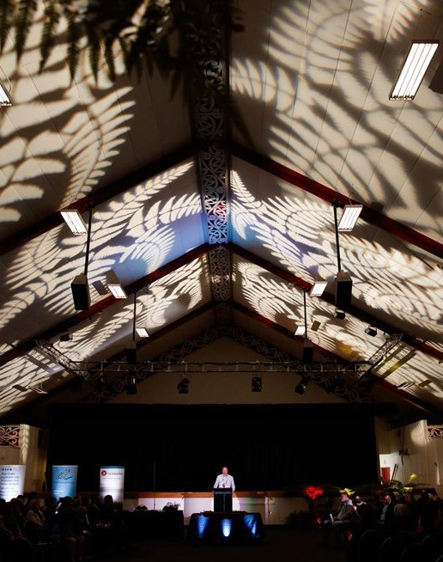

Progress on delivering on
Tākai Here and Tūpiki Ora
Climate change is a key focus for mana whenua Taranaki Whānui ki Te Upoko o Te Ika, Te Rūnanganui o Te Ātiawa and Te Rūnanga o Toa Rangatira, which is reflected in Tūpiki Ora, our 10-year Māori strategy.
Through Tākai Here, our landmark partnership agreement with mana whenua, and Tūpiki Ora, Council has committed to establishing stronger relationships and developing our capability to support mana whenua climate action efforts, ensuring the mātauranga (wisdom) of mana whenua is incorporated into our mahi and that we bring a te ao Māori lens into Te Atakura over time.
Council acknowledges the pivotal role of mana whenua as kaitiaki of Te Whanganui-a-Tara with them intergenerational knowledge of caring for te taiao. Our intent is to develop our collaboration with, support for, and learning from mana whenua and Māori to achieve our shared aspirations around climate change response. We will continue to support existing and new initiatives that are led by mana whenua
and we will better coordinate our internal work to support tiakina te taiao and climate response.

Partnership and Council’s role
The necessary scale and pace of change mean no organisation can do this alone. One of the commitments Council made in the Blueprint is to provide leadership and collaboration, in partnership with iwi and the city. We recognise that systematic transformation will be needed from both the public and private sectors, as well as individual behaviour shifts.

Regional coordination
We partner with mana whenua and other councils in the region through the Wellington Regional Leadership Committee, which now includes the scope previously held by the Wellington Region Climate Change Working Group (mentioned in the Implementation Plan). Council is part of the Regional Emissions Reduction Plan working group drafting a plan to ensure our climate response, particularly around transport and urban form, are aligned with our neighbouring councils. We have also project managed the impact assessment part of the Regional Adaptation Plan. In addition, we have contributed to central government policy, regulatory reform and inquiry work.

Working in collaboration with communities
Wellingtonians are already working to reduce emissions and to adapt to the effects of climate change. We amplify their impact by providing seed funding, advice and guidance and facilitating connections.
Council has supported community and businesses through initiatives including the Zero Together community sustainability programme, the Climate and Sustainability Fund, Te Anamata Ā-Kai o Tō Tātou Tāone – Our City’s Food Future strategy, and a Let’s Talk Shop sustainability project with the retail sector.

Partnerships on a global scale
Internationally we are a member of several initiatives that give us access to expertise, thinking, data and connections across the world. These include the 100 Resilient Cities Network helping cities around the world become more resilient to physical, social, and economic shocks and stresses, the Global Covenant of Mayors which is the largest global alliance
for city climate leadership across the globe, the Bloomberg Mayors Challenge that aims to inspire bold, replicable innovations developed by cities and gifted US$1 million to Wellington City Council for the development of our digital twin adaptation engagement tool, and the Race to Zero Campaign.
In June this year Wellington’s innovative bike network gained global recognition, $650,000 in prize money, and a place on the prestigious Bloomberg Initiative
for Cycling Infrastructure (BICI). BICI is a competitive grant programme supporting cities around the world to build safe, connected, and sustainable city cycling infrastructure. The award-winning cities, whittled down from 270 to just 10 world-wide including Wellington, recognised our plan to rapidly roll out a city-wide bike network, for its ambitiously innovative approach, and its partnership with mana whenua.
Some of the prize money will be used to progress the concept of a nature-based, off-road bike network – an idea developed by community group Trails Wellington. Improved off-road cycle trails alongside
Wellington’s on-road bike network presents a massive opportunity for the capital to become a world-class destination to experience and enjoy by bike.
In November, Wellington scored an A for climate action for the third year running from global climate watchdog CDP. They analysed environmental disclosure data from over 900 cities, with the capital coming in the top 13% for climate action and ambition. Being recognised for taking bold leadership on environmental action and transparency, despite the pressures of a challenging global economic situation,
is a rewarding result. Wellington’s scorecard confirmed we had demonstrated best practice standards for addressing climate change, set ambitious goals and progressed towards achieving those goals.

Working with multiple voices on our plan
When Te Atakura was taken up in 2019 a steering group was formed to offer guidance in support of the strategic direction. Membership included representation from iwi, community, education
and business groups. The steering group was stood down in 2021 as the strategic direction of Te Atakura matured, however when we undertake the planned review in 2024 we will explore engaging with a similar group of local voices and experts.
Council acknowledges the pivotal role of mana whenua as kaitiaki of Te Whanganui-a-Tara with them intergenerational knowledge of caring for te taiao.

Wellingtonians are already working to reduce emissions and to adapt to the effects of climate change. We amplify their impact by providing seed funding, advice and guidance and facilitating connections.

Climate action in the capital
Wellingtonians have consistently told us they want climate action
and we’re making pleasing progress, but there is more mahi to be done.

The Council’s November 2022 Climate Action Monitor survey provided some insightful results, including that while many felt they understood the impacts of climate change, there was a general sense that not enough is being done to cope with or prepare for the impacts:

87%
83%
90%

of respondents said they understand the potential impacts of climate change fairly or very well.
of respondents believed the negative effects of climate change are already being felt in Wellington.
of respondents believed we need to act now to start reducing Wellington’s carbon emissions.

59%
<10%
6%

were not confident at all that enough action is being taken.
were confident enough action is being taken to prepare Wellington for the impacts of climate change.
believe we are on track to meet our 2030 and 2050 climate goals.

75%
74%
39%

ranked low or zero carbon transport options as a priority to reduce emissions.
said they had taken action to reduce waste.
said they had taken action to reduce their energy emissions.

15 Wellington City Council

Cities play a crucial role
Cities are estimated to contribute to 75% of all CO₂ emissions globally, which means that cities are the place where climate action is most needed and impactful.
According to the United Nations, 55% of the world’s population currently lives in cities and that figure is predicted to increase to 68% by 2050.
Cities are estimated to contribute to 75% of all CO
2
emissions globally, which means that cities are
the place where climate action is most needed and impactful. Our city emission reduction target of reducing emissions by 57% between 2020 and 2030 is science-based and is in alignment with national and international commitments to limit global warming to below 1.5 degrees, using the Worldwide Wildlife Fund’s One Planet City Challenge science-based methodology.2
The chart below shows the city’s historical gross emissions and the pathway to reaching our 2030 emissions reduction target.

Wellington city’s emissions over time

1,400
984
423
1,200
1,000
800
ktCOr-e
600
400
200
0
2001
2005
2010
2015
2020
FY20
FY25
FY30

2001–2020 (historical) FY20–FY23 (relevant to target) Trajectory to FY30 target
(straight line forecast)

  - Current best practice is to set science-based targets to ensure that each sector of the economy is doing their part, that targets are equitable, and likely to meet the Paris Agreement ambition of limiting global warming to 1.5 degrees. We have used the One Planet City Challenge (OPCC) methodology, as outlined in the SBTi’s City Guidance document. SBTs-for-cities-guide.pdf (sciencebasedtargetsnetwork.org). Note that we used 2018 to set the target in alignment with the methodology, and then
re-calculated it to use 2020 as the base year.

How are we doing?
Wellington city’s greenhouse gas emissions fell by 10% between FY20 and FY23, to 887,115 tCO₂-e.3 This was an additional 1% reduction from last year, which is encouraging given that we were concerned that reductions may have been temporary due to various periods of travel restrictions in response to the
COVID-19 pandemic. The reasons behind this reduction are mixed, with some reductions a result of changes outside of our control, such as a greater proportion of renewable energy in our electricity grid mix. Overall, we have increased the pace of our emissions reductions. In the 20 years prior to 2020 we reduced our emissions by 7%. In the last three years, we’ve reduced by 10%.
In the next seven years, we will need to reduce city emissions by 7% each year to meet our target.4
In calculating these figures we used ‘gross’ emissions, which means they are not adjusted for any change in forestry. We do this for two reasons: forestry has held steady over this period, so the change is not material and science-based target methodologies
only allow reductions to count towards a target if they are from reducing the amount of emissions produced, rather than increasing the amount of carbon drawn down from the atmosphere as an offset, commonly called ‘sequestration’.5
Overall, we have increased the pace of our emissions reductions.

Our measurement approach
Annually we measure and report on the main recognised emission sources that cover on average 90% of emissions, and every three years Greater Wellington Regional Council coordinates a full regional carbon measuring and reporting exercise that covers 100% of these emissions sources. This is an efficient approach to track how we are progressing.
Our measurement of city greenhouse gas emissions, and our targets, focus on emissions directly produced in Wellington city, for example emissions from using fossil fuel in vehicles, gas boilers, and industrial processes, electricity consumption, and methane produced by the breakdown of the city’s waste in landfill.6 This aligns to international best practice guidance for city inventories and aligns to the way national emissions are calculated.
For a household carbon footprint, you could also include emissions from purchases, otherwise known as consumption emissions, or Scope 3. In FY23 we conducted research on consumption emissions in Wellington for households, business and industry, and government. While this is a complex area with a high degree of estimation, the results gave us insights to inform new initiatives. In particular, we were reassured to find alignment with overseas research about recommended focus areas for individual
action (how you move around, food choices, buying goods that last and can be repaired). Looking beyond individuals, two areas were shown to have high emissions – food and drink, and construction – and these are not necessarily reflected in our production inventory as the materials involved are typically produced outside of our city boundary.

  - Carbon dioxide equivalent.
  - This reduction, which amounts to around 70,000 tCO₂-e per year, is from the base year.
  - Please see the Glossary for the definition.
  - Scope 1 refers to direct emissions. Scope 2 is indirect emissions resulting from electricity consumption. For science-based targets, the methodology recommends setting a target for Scope 1 and 2 emissions only, as these are under an organisation’s direct control, and then setting supplier engagement targets for Scope 3, which are emission from the full value chain.

Wellington city emissions breakdown 2022/23

Industrial Processes
and Product Use
6.6%
Waste
7.3%
Landfill
5.9%
Wastewater
1.2%
Composting
0.1%
Livestock Enteric Fermentation 1.3%
Other
0.3%
887,155
tCOr-e
Transportation
56.2%
Stationary energy 28.3%
Natural gas
14.3%
Electricity
9.8%
Other
2.2%
Petrol + Diesel 42.6%
Aviation
7.9%
Marine
4.9%
Other 0.8%

Agriculture

1.6%

Stationary petrol and diesel use 2.1%

Emissions and targets

Council targets
In November 2023 we set a near term Council emission reductions target to mirror our city target, committing us to reducing our FY21 Scope 1 and Scope 2 emissions by 57% by FY30. This is a science-based target and aligns with national and international commitments to limit global warming to below 1.5 degrees. We have a longer-term ambition to reduce our emissions to net zero by 2050.

How are we doing?
Wellington City Council’s organisational emissions were 98,791 tCO₂-e in FY23 (Scope 1, 2 and 3), with 39% of the emissions relating to the emissions produced by the Southern Landfill. The Southern Landfill is categorised within Council’s emissions because it is wholly owned by Council, even though it includes all the city’s waste. The next largest emissions category was heavy construction at 30%.
Pleasingly, our Scope 1 and 2 emissions fell by 44% between FY21 and FY23, primarily due to more effective methane capture and destruction facilities at the landfill.

Wellington City Council’s emission over time (Scope 1 & 2)

100
91
61
51
39
90
80
70
ktCOr-e
60
50
40
30
FY21 FY22 FY23 FY24 FY25 FY26 FY27 FY28 FY29 FY30

Our measurement approach
Council annually measures and reports its organisational emissions. We started including emissions from all our expenditure in FY21, which gives us a more complete picture of our emissions, although some of these emissions sources are only estimated at a high level using the amount spent within a supplier category and an emissions factor calculated from the average emissions produced by that type of good or service. This means that if the cost of something goes up it appears as an increase

in emissions, and changing suppliers to lower carbon options won’t be reflected in our data. We plan to transition over time to emissions data provided by our suppliers, as part of our conversation with them on climate change.
Our greenhouse gas inventory receives independent assurance from Audit New Zealand.

Wellington City Council’s emissions breakdown 2022/23

Scope 3 – Indirect value chain 48.33%
Other scope 3
0.24%
Investments
3.53%
Tenant electricity in WCC owned housing 1.05%
Transportation of waste 0.57%
Third party

Scope 1 – Direct

49.58%
Waste 39.44%
Mobile combustion (diesel and petrol) 0.53%
Wastewater
6.61%
Natural gas consumption 2.91%
Other

electricity
2.44%
Capital goods (civil engineering construction 33.54%
Purchased goods and services 6.96%

98,791
tCO2-e
0.09%

Scope 2 – Indirect electricity consumed 2.1%
Electricity consumption 2.1%
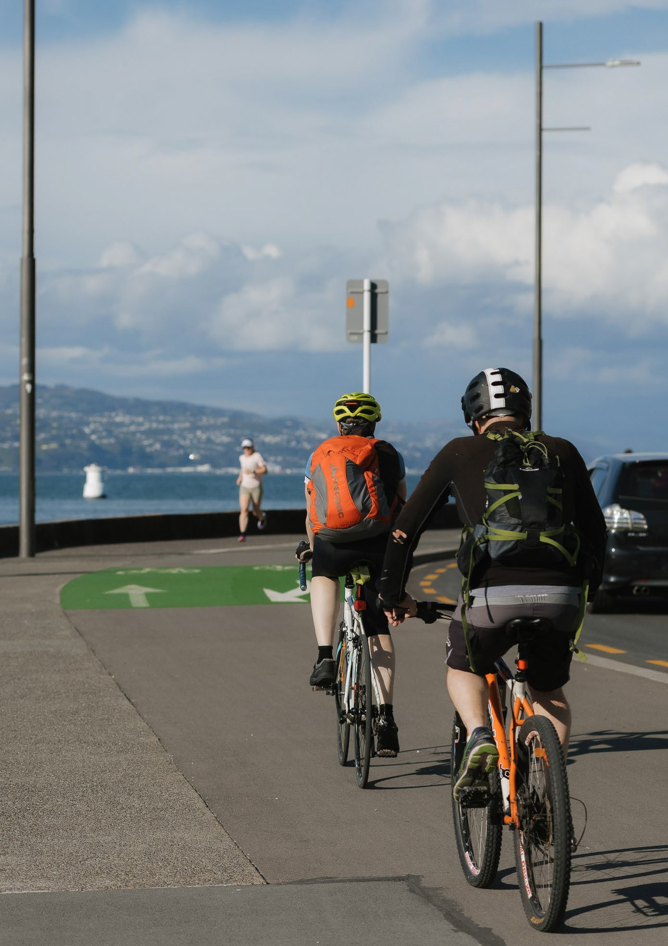

Progress on action areas to reduce emissions

Action area: Transport and urban form
How we move around contributes over half of our city’s emissions, but the capital’s density determines how easy it is to travel with low or zero carbon options.

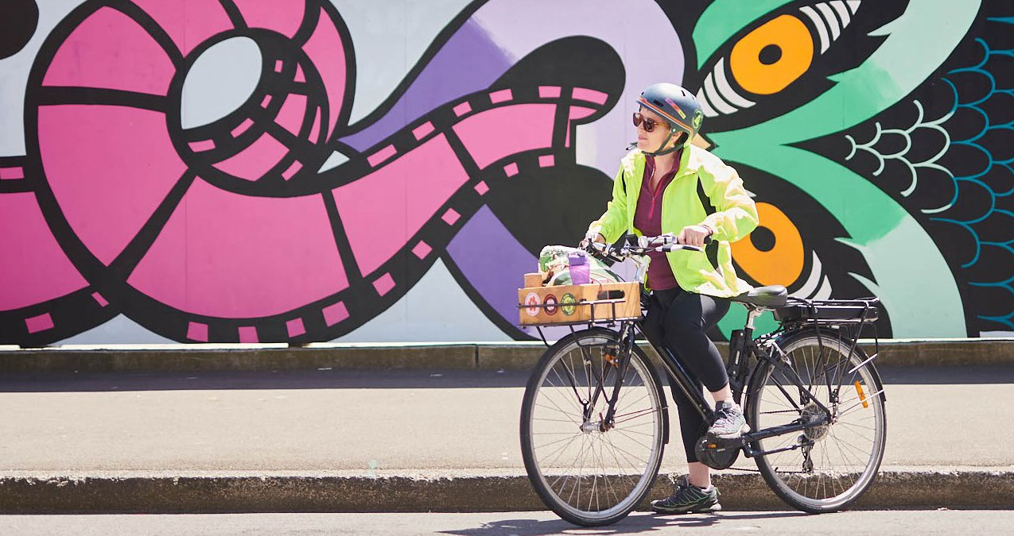
Reducing our need to travel
The Council plays a unique role in shaping the city so we can live, work, and play with minimal impact on our environment, making transport and urban form the most significant and direct opportunity for Council to reduce city emissions.
The desire for a compact, net zero carbon city has been a consistent message from Wellingtonians through the Planning for Growth programme and is now being formalised through the proposed District Plan.

Providing great ways to get places
We’re working to enable more people to move around with fewer vehicles so that our city’s streets work better for everyone. Our most significant investments – around 20% of Council’s annual budgets – are to maintain and improve our transport networks
(see our Annual Report for detailed reporting on our transport projects). We do this by improving the public transport network, the cycleways network, and the pedestrian network.
Wherever possible we look for opportunities to maximise the benefits across more than one network at a time in a place-based way. For example, the recent cycleway installation project by Wellington Regional Hospital also included the establishment of a 24-hour priority bus lane which then achieves improvements of two of the three systems.

Sustainable Transport Hierarchy
Our sustainable transport hierarchy guides our work on improving Wellington’s transport networks.

Walking
Cycling & micro-mobility
(shared e-scooter, e-bikes, e-mopeds)

Public transport
(trains, buses, light rail, ferries)
Delivery vehicles
Car sharing and pool vehicles
Rideshare and taxis
Private vehicles & motorcycles
Aircraft

Wherever possible we look
for opportunities to maximise the benefits across more than one network.

We do this work in partnership
Wellington City Council, Waka Kotahi and Greater Wellington Regional Council all have roles to play in providing improved transport options for both
residents of Wellington city, and the residents of the region who travel into our city for work or leisure.

We also work in partnership and collaboration with commercial service providers:
- Micro-mobility – Flamingo and Beam
- Secure bike storage – Locky Dock
- Car-share – Cityhop and Mevo
- EV charging networks – Meridian Energy and ChargeNet (who both operate Council-owned charging infrastructure).

Integrated transport benefits

WCC
Maintains and operates local roads
Allocates space on the road for different modes of travel
Delivers parking services and enforcement
Integrated travel behaviour change programme
Waka Kotahi
Maintains and operates State Highways
Funding partner for local and national land transport activities
Provides licensing and regulation for land transport
Integrated transport benefits
GWRC
Regional transport planning
Planning and funding of public transport
Maintains and operates local and regional public transport systems through Metlink

Progress since the implementation plan

Enabling urban density (Planning for Growth)
The proposed District Plan
The Spatial Plan, adopted in 2022, was the first significant step in the Planning for Growth
programme. The proposed District Plan will bring the decisions of the Spatial Plan into regulation. It enables more development capacity at greater densities across much of the city to accommodate the expected increase in our population of 50,000 to 80,000 people by 2050 and discourages
development in vulnerable coastal and hazard-prone environments.6 When combined with higher levels of public transport delivered by Greater Wellington Regional Council (GWRC) and Let’s Get Wellington Moving (LGWM), this will reduce travel distances, increase public transport use and active transport, and reduce city emissions.

The Green Network Plan
The Green Network Plan sets the direction and targets for how we improve and increase green space in Wellington’s central city in the next 10 years.
The goal is to double the number of trees from 2,000 to 4,000, improve the greening of twenty existing spaces, and deliver two new urban parks. This
will boost our climate action efforts by capturing carbon dioxide and make the city more resilient to the impacts of climate change through their cooling effect and reducing stormwater runoff. The first proposed new park has been identified on the corner of Taranaki and Frederick Streets and is due to be completed in 2025.

Investing in rapid transit and improving public and active transport
City transport projects are central to the Council’s work to encourage mode shift and reduce transport emissions, while delivering improved liveability, accessibility, safety, and resilience. Significant progress has been made in both planning and delivering investments in mass rapid transit, public transport, walking and cycling.

Public transport partnerships
Council partners with other entities to provide public transport.
Greater Wellington Regional Council is responsible for delivering public transport across the Wellington region, including the bus network, the train system, harbour ferry services, and total mobility services.
GWRC’s public transport brand, Metlink, plans routes and timetables, and contracts companies to operate services. As the road controlling authority, Wellington City Council allocates space on streets for bus stops, bus shelters and bus priority measures.

Mass rapid transit
Due to the potential for new housing and neighbourhood growth, the LGWM programme partners selected light rail from the station to Island Bay as the preferred programme option for mass rapid transit, while continuing to investigate bus rapid transit in further detail. The preferred programme includes improvements at the Basin Reserve and an extra Mt Victoria tunnel, including additional walking and cycling facilities and public transport lanes, along with enhanced bus priority to Miramar and the airport.

The goal is to double the number of trees from 2,000 to 4,000, improve the greening of twenty existing spaces, and deliver two new urban parks.

Paneke Pōneke
Our bike network plan, Paneke Pōneke, is creating a city-wide network of connected bike routes in
tandem with walking improvements and significant public transport changes. Over the past year we have completed the first two transitional bike paths outlined in the plan including the Newtown to the city route and the Botanic Garden ki Paekākā to the
city routes. Works have started on the Aro, Ngaio and Kilbirnie transitional routes and Evans Bay Little Karaka Bay to Weka Bay route.
More work is planned for next year including the Thorndon route and the final stage of safety
improvements at the Parade in Island Bay. Around 45% of the network is planned to be in place by 2025.

Street improvements
Key transformation projects have progressed over the past year, such as Golden Mile improvements for bus reliability and the walking environment, including an authorisation system restricting access for private vehicles, with early works started in September 2023 ahead of enabling works and main construction scheduled for 2024. At the same time, Thorndon Quay construction and consultation on Hutt Road improvements are set to start. These projects will significantly improve walking, cycling and public
transport connections to and from the north of the city.

People-friendly City Streets
The People-friendly City Streets programme has started improvements across the central city to support safer, quicker, and easier walking, and is developing preferred options to improve connections for people on bikes, buses, and walking on key corridors between suburban centres and the central city. Intersection upgrades have been completed along Whitmore Street and Vivian Street to create a better and accessible environment, to make the central city safer and a more enjoyable place to spend time.
Council’s workplace travel planning team support workplaces with tailored initiatives that encourage more active transport and sustainable commuting for staff.
The Central City Walking Improvements project continues upgrades along on the waterfront quays and is scheduled for completion by late December which will further improve connections to the waterfront.
We are making our roads safer for everyone with a new crossing on Cobham Drive, completed in January 2023, and safer speeds on SH1 between Mount Victoria Tunnel and the airport, while also improving local journeys between Miramar, Kilbirnie and the south coast.

Practical support to shift travel habits
Better infrastructure is only one part of supporting the shift from high emission options such as cars, vans and trucks, to low or zero emissions travel like buses, walking and cycling. Last year there was
a significant increase of investment in initiatives that help residents move around differently, with the approval of the LGWM business case for Travel Behaviour Change, and successful applications
for central government funding to support our rollout of the bike network. Using our existing and new sources of funding we delivered multiple initiatives including events and activations,
education, training and promotion, travel activities for schools and workplaces, and supported accessible journey planning.

Workplace travel planning
Council’s workplace travel planning team support workplaces with tailored initiatives that encourage and promote more active transport and sustainable commuting for staff. Council’s Active Transport Workplace Fund awards $50,000 each financial year and since 2020 has helped fund 14 projects aimed at increasing active travel options for staff at workplaces.

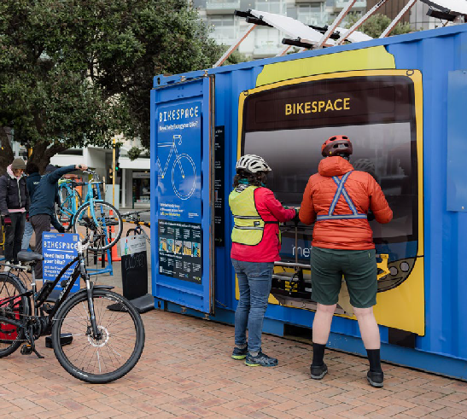
For example, in July 2023 Massey University of

Bikespace
The Council-sponsored bike education workshop, Bikespace, took off on two wheels in 2023 to provide a new mobile service to the wider Pōneke community. A cargo bike has been set up with all the necessary tools for
a mechanic, who then makes their way out to community events, workplaces or public spaces throughout the city. The kaupapa of empowering people remains the same, with bike owners getting hands-on education and experience repairing their bike.
New Zealand Te Kunenga Ki Pūrehuroa in Wellington received funding from the Active Transport Workplace Fund to help boost their end-of-journey facility project. The funding was used to provide bike racks, a bike fix-it stand, and an accessibility ramp for bikes. The project ensures safe and secure end-of-trip facilities are available for those people keen and able to ride a bike to work.

Supporting active transport in schools
Council has been working with schools to make it easier for students to get to and from school in more active ways. For example, enabling safe infrastructure for active travel and end-of-trip
facilities for biking, including establishing the Council School Cycling Support fund to provide facilities like bike parking at schools, with a pilot of six schools in progress. There are currently 14 Bikes in Schools bike tracks installed in Wellington, with a new bike track being built at Newtown School. This year, 49 schools participated in Movin’ March to promote active travel to schools. We have also been working with two schools to establish walking school buses.

Supporting micro-mobility
In FY23 there have been 1,043,596 e-scooter trips taken in Wellington. Additionally, since e-bikes were introduced to the city in February, there have been 23,044 e-bike trips taken between 21 February and the end of October 2023.

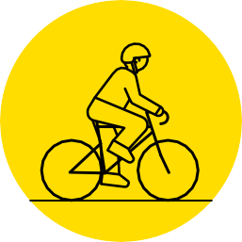

1,043,596
e-scooter trips taken in Wellington in FY23

23,044
e-bike trips taken in Wellington between
21 February and the end of October 2023

Supporting electrification of the fleet

Investing in electric vehicle charging infrastructure
Electric vehicles (EVs) are a growing presence in our city with 2581 EV passenger cars and vans registered in FY22–23.7 Council supports electrification by increasing EV charging infrastructure.

Charged-up Capital
Council plans to install 60 24kW DC chargers in partnership with the Energy Efficiency and
Conservation Authority (EECA) and installed by Meridian Energy as part of their Zero network. These chargers are located at community centres, parks, sports grounds and swimming pools. Council has installed 14 of the 60 chargers, with six more planned to be installed by the end of 2023 and the remaining 40 aimed to be installed in 2024.

What we’ve changed
Some of the actions in the Implementation Plan have either become part of other actions, or have been evaluated as needing further thought:

Clifton Park charging hub
This action was more difficult than anticipated, and we have instead focused on the public EV charger project to create greater impact.

Congestion charging
This is dependent on central government policy settings, and has been incorporated into our advocacy action area.

Incentivising city-wide flexible working
This is no longer a required action, as the COVID-19 pandemic created a shift in working habits, with a greater percentage of employees working from home. We are now focused on increasing the residential potential of the CBD to decrease the need for city workers to commute into town.

Identifying aviation and marine emissions reduction opportunities
This has not made any progress in the last three years. While this is an important area of emissions, the fuel choices of airlines and shipping companies are not under our control. Reducing demand for air travel and shipping is another option, however this could have negative impacts on Wellington’s economy until we have worked through our transition to a zero carbon circular economy.

14
fast chargers installed

  - Motor vehicle registrations – dashboard and open data | Waka Kotahi NZ Transport Agency (nzta.govt.nz).

Measuring our progress
In the Implementation Plan we outlined a range of potential indicators to evaluate the impact of the planned actions. Some of these have proven impractical or difficult to measure.

For this action area, we have focused on measures that demonstrate trends in how people are moving around the city, and we track the emissions generated from road transport.

Key indicators of change

Indicators | 2020  (as at 30 June) | 2021  (as at 30 June) | 2022  (as at 30 June) | 2023  (as at 30 June)
GHG emissions from on road transport (tCO₂–e) | 323,684 | 336,444 | 306,868 | 345,782
Walking – number of pedestrians entering the CBD during peak times | 9,157 | 10,375 | Not measured8 | Not measured9
Cycling – number of cyclists entering the CBD during peak times10 | 2,475 | 2,462 | Not measured8 | Not measured9
Cycleways – in kms (cumulative) | 33.5 | 35.3 | 35.6 | 40.0
Registered passenger cars and vans in Wellington City (cumulative)11 | 8,113 | 9,740 | 9,463 | 9,115
Registered EV12 passenger cars and vans in Wellington City (cumulative)11 | 459 | 617 | 2,136 | 2,581
Registered goods van/truck/utility vehicles in Wellington City (cumulative)11 | 1,440 | 1,330 | 1,370 | 1,305
Registered EV goods van/truck/utility vehicles in Wellington City (cumulative)11 | 6 | 12 | 18 | 20
Car sharing – total members | 7,512 | 12,955 | 25,308 | Not available13
Number of 24kW DC Fast Chargers that have been installed by Council (cumulative) |  | - | 12 | 14

  - No study in 2022 due to COVID-19 limitations.
  - Cordon count data provided for May instead of March in previous years making the data not comparable.
  - Taken from 5 cycle meters.
  - Sourced from Waka Kotahi NZ Transport Agency.
  - EV: Includes battery electric and PHEV vehicles.
  - Numbers for FY23 not available at time of publishing.

Action area: Building energy

Stationary energy use accounts for 28% of Wellington city’s total carbon emissions through the use of electricity and natural gas, and our role is to encourage building owners to improve the environmental performance of their assets.

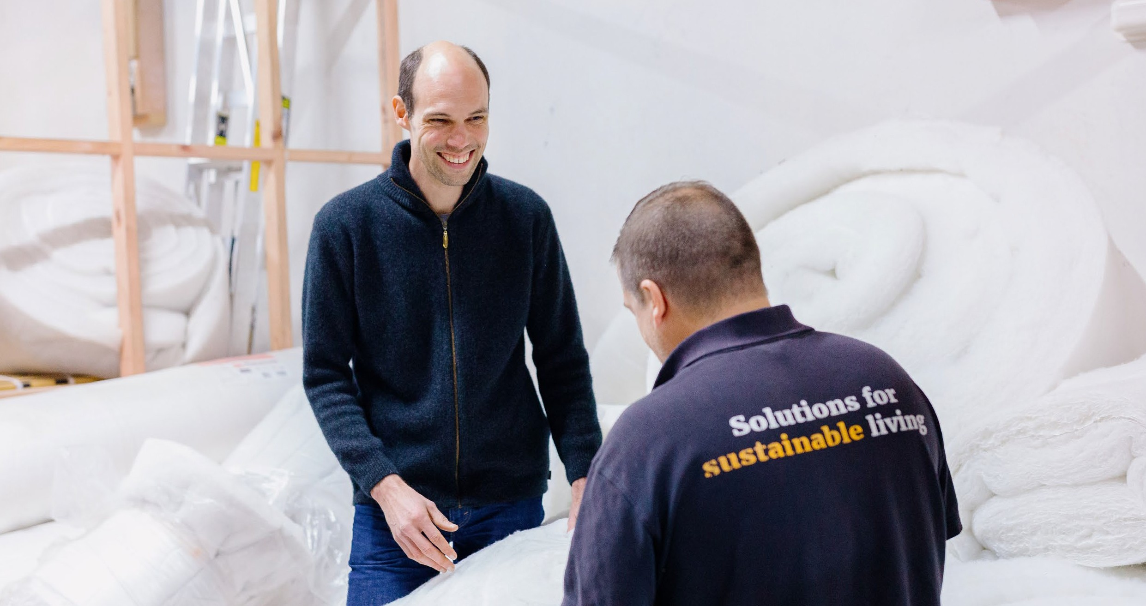
Although the Council administers the Building Act it has no power to require an ‘improved’ standard that would reduce energy consumption across
Wellington’s building stock. We continue to advocate for stronger policy settings, and focus on providing incentives and funding to support developers
and homeowners wanting to improve the energy performance of their buildings.

44
households helped through
Warmer Kiwi Homes

Progress since the implementation plan

Supporting home energy efficiency

Home Energy Saver
Council provides free home energy efficiency assessments and advice to Wellington households to create healthier, more energy efficient homes.
Sustainability Trust are the Council’s suppliers contracted to deliver these assessments, and in FY23 delivered 712 assessments. Since 2014, 14,396 homes have been assessed.

Warmer Kiwi Homes
In FY23 Sustainability Trust also delivered 44 home insulation upgrades supported by the Council as part of the EECA Warmer Kiwi Homes initiative. Since 2011, over 9,000 Wellington homes have received insulation through the programme.

Incentivising energy efficiency upgrades

The Environmental and Accessibility Performance Fund
The Environmental and Accessibility Performance Fund was approved during the 2022/23 Annual Plan process and replaces the previous policy of offering a 50% remission on development contributions. The fund provides up to $20million over seven years to
commercial and residential developments across new and retrofitted buildings that achieve a green building certificate and/ or accessible design certification, with the improvement of residential developments a key focus. In FY23 four applications were received and have reserved $2.5m of the fund to date. No fund applications have yet been drawn down, as funding is only granted once the certifications have been achieved.

Utilisation of regulatory levers to encourage energy efficiency uptake

Support building sustainability improvements
The purpose of this action was to look for opportunities in the District Plan review process to support sustainable buildings. Current legislation such as the Resource Management Act, Building Act and Local Government Act restrict local authorities from managing issues of climate change in the built environment. The Building Act manages issues relating to heat, humidity, and temperature rise and therefore does not give the District Plan the regulatory function to address matters such as passive design, uptake of low carbon and energy efficient design
and construction. With such limited scope, our proposed District Plan’s statutory direction focuses on sustainability, resilience and climate change seeking that land use, subdivision and development design integrates natural processes that provide for opportunities for carbon storage, natural hazard risk reduction and supports climate change adaptation.

What we’ve changed
Some of the actions we identified in the Implementation Plan have either become part of other actions, or
have been evaluated as impractical, or needing further thought.

Increasing neighbourhood resilience
As reported in 2021, the trial involving a combined solar and battery system along with emergency water storage and gas bottles was a partnership between the Council, Contact Energy and Wellington Electricity.
While the trial demonstrated the potential for community resilience it was concluded that a more durable business model would need to be established for it to progress further.

Supporting business energy efficiency
This action was intended to provide Wellington business owners and landlords with a free energy and carbon emission audit and action plan. This work was pushed back to FY22, and started by engaging with businesses in Wellington to understand the barriers faced in climate action, particularly reducing reliance on fossil fuels.
Following this exploratory work, we took the opportunity to design a more holistic approach and developed Let’s Talk Shop to support small businesses to understand the climate and waste impacts of their businesses and create an action plan to tackle both challenges. See the city-wide initiatives section for more details.

50% reduction off development contributions
This policy was replaced with the Environmental and Accessibility Performance Fund, as described above.

Building Performance Certificates for residential and commercial buildings
This action was superseded by the government’s introduction of the Healthy Homes Guarantee Act. Further work on incentivising warm, dry housing has been incorporated into Council’s Housing Action Plan.

Other incentives

Targeted rates
This has not been progressed as it relies on changes to legislation.

Natural gas displacement
This action has not progressed.

Measuring our progress
In the Implementation Plan, we outlined a range of potential indicators for us to evaluate the impact of the planned actions. Some of these have proven impractical or difficult to measure. For this action area, we have focused on measures that evaluate progress of our actions, and we track the emissions generated from building energy, noting that this is
highly dependent on how much renewable electricity is generated nationally each year.

Key indicators of change

Indicators | 2020 | 2021 | 2022 | 2023
 | (as at 30 June) | (as at 30 June) | (as at 30 June) | (as at 30 June)
GHG from residential building energy (tCO₂–e) | 76,218 | 100,767 | 74,886 | 51,319
GHG from commercial and institutional buildings energy (tCO₂–e) | 63,001 | 78,233 | 57,904 | 40,458
Home Energy Saver – No. of Wellington homes audited (cumulative total) | 12,179 | 12,955 | 13,645 | 14,396
Home Energy Saver – % of Wellington homes audited14 | 5% | 16% | 17% | 18%
Warmer Kiwi Homes – total homes insulated since 2011 | 9,065 | 9,197 | 9,271 | 9,315

  - 81,003 dwellings as per 2018 census.

Action area: City-wide initiatives

Addressing climate change will require action from the whole city.

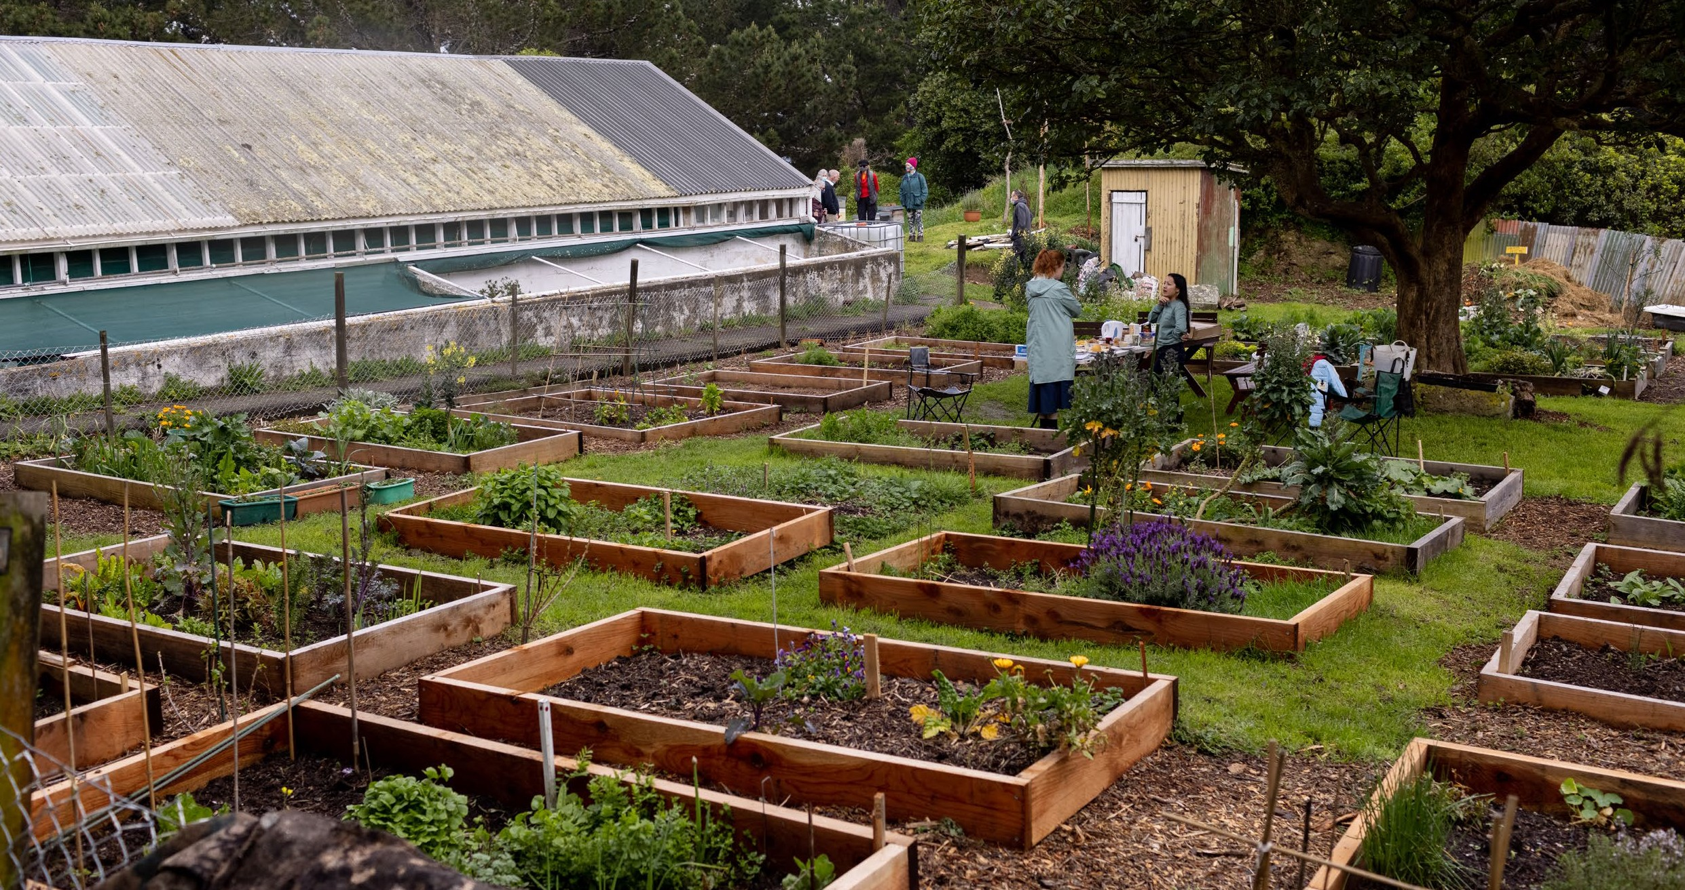
Te Atakura included a number of enabling actions where the Council can support climate action across the city and partner with others to foster innovation. While local and central government policy settings are essential, there is a significant amount of carbon reduction that can only be executed by businesses, community groups, and Wellingtonians.

Progress since the implementation plan

Accelerating opportunities to support carbon farming
Despite historical habitat loss, Wellington is one of the only cities in the world where we can see increasing biodiversity. This also increases the
amount of carbon drawn down from the atmosphere (referred to as “carbon sequestration”) in our city, ensuring we are responding to the climate and ecological emergency holistically.

Restoration planting
There have been over two million plants established across Pōneke’s hills and coastlines since the restoration planting programme started. The collaborative effort, with over 120 community groups, is now working towards a new target of three million native plants
by December 2030.

Native indigenous forests in partnership
We also have a partnership with Te Herenga Waka – Victoria University of Wellington to establish new
native indigenous forests and expanding carbon sink areas within the outer green belt. Roughly half of the
11-hectare site has natural regeneration coming through gorse cover that will be left to establish by itself, and the remaining half has now been fully planted with 12,500 eco-sourced native trees. Hundreds of university students, staff, and alumni have helped as volunteer planters over the past three years.
This project is providing teaching opportunities for undergraduate course work and summer scholarships and is the subject of a research project investigating the effectiveness of mānuka and kānuka as nursery crops. The university is looking to extend the programme to the remaining portion of the block adjacent to the leased area.

Climate and Sustainability Fund
The Climate and Sustainability Fund was launched in 2022 to boost climate action across the city. With a budget of $250,000 per year for five years, it has funded twelve initiatives to date (see Appendix 2 for details). FY23 was its second year and funding went
to six initiatives. Successful applicants included Voice of Aroha, to deliver climate awareness and leadership opportunities for former refugee and migrant communities in Wellington; Parents for Climate Aotearoa, to pilot their Let’s Talk Climate project – a series of workshops for parents and whānau to learn about how to effectively talk about climate change together and with their wider communities; and EkeRua ReBicycle, to increase their bike workshop opening hours and expand their services and community events.
The next rounds of funding are October 2023 and February 2024. The focus of these rounds is to support climate action projects and initiatives that are Māori-led, and/or projects that will deliver measurable emissions reductions in the short term as these are priority areas for the fund that have been underfunded to date.

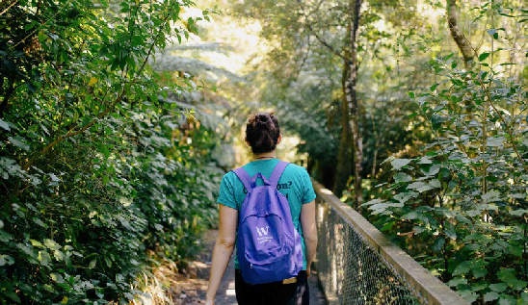
Zero Together

Ecological taonga in the capital
Our ecological treasures include Zealandia Te Māra a Tāne, a 225-hectare ecosanctuary and an outstanding conservation project that protects over 40 rare native wildlife species. Ōtari-Wilton’s Bush, New Zealand’s only botanic garden dedicated solely to native plants, has one hundred hectares of ancient and regenerating forest.
We continue to lead the way in urban animal pest control. Our landscape animal pest control programme has hundreds of volunteers checking traps across our reserves. Predator Free Wellington, supported by the Council and other partners, has eradicated stoats, weasels and Norway rats from Miramar and is working to eliminate ship rats from the last remaining 12 hectares.
Originally known as Future Living Skills, the Zero Together programme was developed to support Wellingtonians to engage in ‘everyday actions for a better climate future’. Since its launch in March this year, two courses were run with registrations of 30 people. The programme consists of five two-hour sessions covering climate change basics, transport, waste, food, and home energy use and is facilitated by a community member. Feedback from participants has been positive and additional gatherings are planned to continue building community among past participants, link them with opportunities for further climate action, and encourage local community initiatives to mitigate emissions and build community resilience.

Wellington’s food future
The Sustainable Food Plan has been integrated into the city’s food action plan, called Te Anamata Ā-Kai o Tō Tātou Tāone – Our City’s Food Future and adopted in March 2023. Short-term actions underway focus
on enhancing kai security, fostering collaboration within the Council, and implementing innovative strategies to ensure equitable access to nutritious and culturally appropriate food for the community. Achievements this year include the establishment of two new community gardens/orchards this year, Kai Hapori Whānui ki Linden and Kelburn Community Garden, and the development of a Sustainable Food Community Network that serves as a platform
for connecting food system stakeholders and encouraging collaboration.

What we’ve changed
Some actions that we identified in the Implementation Plan have been evolved into other initiatives, or have been evaluated as impractical or needing further thought. Other actions have been developed since the Implementation Plan was adopted.

Te Atakura action investigation
This new action was funded in the 2021 Long-term Plan (LTP) in recognition that the actions identified in Te Atakura, even when combined with policy changes by central government, are not enough for Wellington city to meet its carbon reduction targets. Additional actions are required to meet this shortfall and deliver the urgent, significant, and at-scale reductions needed by 2030, and in the following two decades.
Examples of how we have used this funding include projects to develop our thinking on how to support the transition of the Wellington economy to a zero carbon circular economy (Outcome 2 of the Economic Wellbeing Strategy), investigate Doughnut Economics (another action of the Economic Wellbeing Strategy), conduct a research project into city consumption emissions, and offer two internships each summer for Wellington students interested in a career in climate change response. We have also used this funding to expand our understanding of how Tūpiki Ora, our Māori strategy, can both influence and be delivered by Te Atakura.
Our research shows many Wellingtonians want urgent climate action, yet many are unsure about what needs to be done to significantly reduce everyday emissions.

Climate action education, events and activations
For the 2021 LTP, we identified a need to engage Wellingtonians in what climate action will mean for them as they live in and move around the city
differently. Our research shows many Wellingtonians want urgent climate action, yet many are unsure about what needs to be done to significantly reduce everyday emissions. Over the last two years we
have investigated the research into how to talk about climate change and we developed a best- practice guide for how we communicate with Wellingtonians on this complex and emotive topic in a way that supports an increase in understanding and undertaking of effective climate actions. This
research has also informed our approach to engaging with communities, schools, workplaces and other organisations across the city who are worried about climate change.

We want to empower everyone to take climate action individually and collectively.

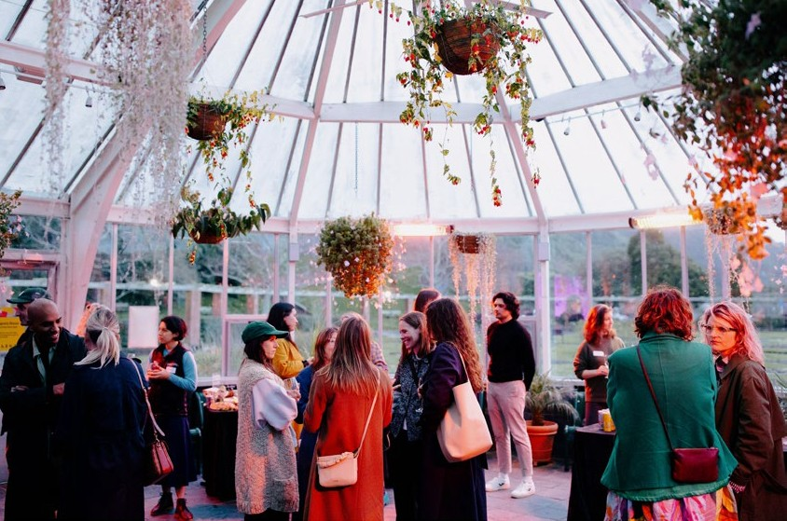
Wellington Climate Lab, the Zero Carbon Challenge & Climathon

Supporting Wellington’s retail sector
In response to insights from the co-design work with stakeholders during the investigation of the Climate Lab idea in 2021, what was originally scoped as the Business Energy Saver was updated to take a more holistic approach and address broader emission reduction needs of small and medium enterprises. Let’s Talk Shop was piloted this year, and offered hands-on, tailored support to 11 retailers to become more sustainable. The pilot helped retailers work together to problem solve as a community and provided practical help, from measuring carbon footprints and doing waste audits, to action planning to achieve emission reduction targets. Building on the pilot’s success, the programme will run again in the first half of 2024.
In the Blueprint, we identified the establishment of a Wellington Climate Lab as one of the seven big moves of the Te Atakura strategy. The lab was described
as an evolution of the Zero Carbon Challenge and Climathon, and sought to draw on the lessons learnt from other public co-creation engagements like the workshops held at Mākara Beach around adaptation. The intention was to collaborate with partners around the city and country on transformative solutions
that could deliver at scale on emission cuts and adaptation in a place-based way. We discontinued the Zero Carbon Challenge and Climathon, due to the challenges of COVID-19 lockdown periods, and in FY21 we ran a co-design process with stakeholders to develop the climate lab idea further. This process landed on a set of ‘givens’, or principles, that are helpful in guiding our climate response work as a city: working in partnership with others to create transformation not tweaks, resulting in significant emissions reductions to 2030, and taking a social
equity and mana whenua lens. The stakeholder group also identified storytelling, stakeholder mapping, and connecting as key interventions that are impactful.
While the lab as a separate entity or active group has not been achieved, we are using the insights from this process in our city-wide initiatives work, through our City Activation team. Some results from this new initiative are outlined here.

11
small businesses took part
in the new Let’s Talk Shop
sustainability programme

Measuring our progress
In the Implementation Plan, we outlined a range of potential indicators for us to evaluate the impact of the planned actions.

Some of these have proven impractical or difficult to measure. For this action area, we have focused on measures that evaluate progress of our actions.

Key indicators of change

Indicators | 2020 | 2021 | 2022 | 2023
 | (as at 30 June) | (as at 30 June) | (as at 30 June) | (as at 30 June)
Total funding disbursed by the Climate and Sustainability Fund | n/a | n/a | $250,000 | $250,000
Number of projects funded | n/a | n/a | 6 | 6
Number of people participating in Zero Together | n/a | n/a | n/a | 32
Number of businesses receiving support | n/a | n/a | n/a | 11
Number of new plants planted in the Victoria University partnership (cumulative total)15 | - | - | 2,400 | 12,500
tCO₂-e sequestered annually in Council owned exotic forestry (measured in carbon credits granted) | 975 | 932 | 67416 | 1,132

  - Only includes plants planted under the environmental partnership between the Council and Te Herenga Waka — Victoria University of Wellington.
  - Some radiata pine trees were harvested to prevent illegal track building and further damage to the forest.

Action area: The Council itself

The Council takes its responsibility to ‘walk the talk’ seriously and has set a target to reduce all emissions under our direct control to net zero by 2050.

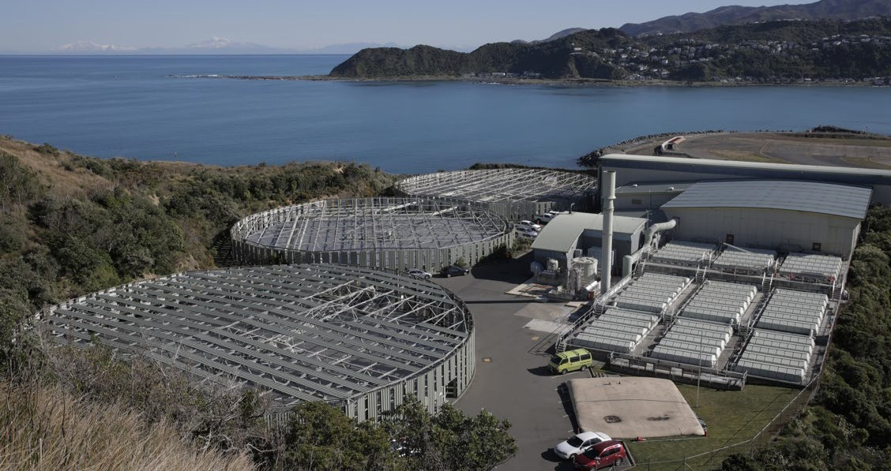
Council contributes 6% of the city’s emissions, mostly through our ownership of the Southern
Landfill. In addition, we are responsible for significant infrastructure projects that generate emissions.

Progress since the implementation plan

Council greenhouse gas emissions measurement
We continue to measure our greenhouse gas inventory annually, and report progress in our annual reports
as well as publishing our results online. We have moved away from Toitū certification, and now rely on assurance procedures from third party auditing firms. This is more financially efficient, and we have reached a level of maturity that no longer requires the more in- depth support that Toitū offers organisations who are starting out on their carbon accounting journey.
We continue to be members of the of Mayors for Climate and Energy, and we report into the CDP (formerly called the Carbon Disclosure Project). We are also required as a forestry participant in the Emissions Trading Scheme to measure the carbon sequestration of our forestry.

Laying the foundations for a zero waste city
We have made significant progress on our approach to waste. Waste is not only a significant proportion of Council’s emissions, creating a circular economy
is also key to responding to the ecological emergency.
In the Implementation Plan we discussed several potential actions, all of which are now included in He anamata para kore mō Pōneke – Zero Waste Strategy adopted by Council in April 2023. Key projects include redesigning rubbish and recycling collections, investigating resource recovery networks, the future of the Southern Landfill, improving our
waste data, and a sewerage sludge processing facility. Council also implements waste reduction initiatives during infrastructure projects, for example waste concrete getting new life under harbourside paths.

Reducing waste to landfill
Our waste minimisation team continues to implement behaviour change initiatives in schools and the wider community where the focus is on eliminating waste by reusing, recycling, refurbishing, and extending product lifespans.

Methane capture and destruction
This project is a partnership between LMS NZ Ltd
and Council’s Southern Landfill and generates enough electricity to power around 1,250 homes annually. This project has achieved significant emissions reductions.

Sewage sludge solution
Construction of an innovative sludge minimisation facility has started and completion is due in 2026. This facility will reduce the amount of the sludge being sent to the Southern Landfill by over 80%, and therefore reduce methane emissions being generated at the Southern Landfill. In parallel, the
Council is exploring options with iwi and community stakeholders to divert the treated sludge from landfill completely for beneficial re-use.

Diversion of food waste
When food waste ends up in a landfill it releases more methane than if it decomposed naturally, for example in a compost bin. The Waste Minimisation Act requires all urban authorities to make plans for the collection of resident’s food waste by 2027. In 2022 we ran the Para Kai Trial to compare different options for households to reduce the amount of food waste they send to landfill each year. 500 households trialled
a weekly kerbside food waste collection service, while another 450 households composted their food waste in either a compost bin, worm farm, or bokashi system. The audit results showed a 38.8% reduction
in food waste going to landfill for the households with the weekly collection service. For the households participating in the home composting trial, there was a 16.4% reduction. This informed the Council’s review of kerbside collection services and we are currently working through both collection and processing options.

62%
This sludge minimisation facility will reduce the amount of sludge being sent to the Southern Landfill by over 80%, and therefore reduce methane emissions being generated at the Southern Landfill.
Landfill emissions reduced
through better methane capture

Building energy

Energy Management Strategy and Action Plan and displacing natural gas as a fuel source
An analysis has been completed of the decarbonisation opportunities available in Council-owned buildings and facilities, and includes a draft decarbonisation schedule through to 2035 that aims to replace fossil fuel (gas) use with electricity powered solutions.
We actively monitor all energy usage and look for continuous improvement opportunities as they arise.

Transport

EV first fleet
In FY2023 Council’s battery electric passenger vehicle fleet increased to 68% and the electric vehicle passenger fleet (battery electric and plug-in hybrid)
was 89%. The renewal programme will seek to replace the remaining internal combustion engine (ICE) utility and light commercial vehicles with battery electric alternatives when fit for purpose alternatives become available.

Forestry
Carbon farming
This is discussed above under city-wide initiatives.

Improving our internal capability and processes

Procurement
In line with the Aotearoa New Zealand Emissions Reduction Plan, our procurement policies have the potential to incentivise our suppliers to meet their own carbon emission reduction goals. We committed to our commercial function becoming
more outcomes-focussed and aligned with strategic commitments like Te Atakura. This has been reflected in our our Broader Outcomes approach, which
refers to positive social, cultural, economic, and environmental outcomes for Pōneke being embedded in Council commercial decision making.
Our commercial procurement function enables Council to reduce greenhouse gas emissions, in two ways:
Direct – we contract with embedded low-carbon requirements as an intentional and direct approach with a supplier who will deliver these. For example, contracting with a zero carbon certified business or procuring for a circular food waste solution.
Indirect – we use Broader Outcomes to first develop evaluation criteria – of which low carbon or circular outcomes can be pursued, amongst others – to evaluate a proposal from the market against these criteria, and whichever supplier is successful we then include their proposed Broader Outcomes deliverables in the contract to deliver on.

Improve governance
There are continuous improvements to how internal decisions are made, and the processes that need to be followed. This includes templates for Council papers, project management processes and considerations factored into the LTP. More progress on this is expected in response to the Council’s Emissions Reduction Plan that was adopted in November 2023.

Staff engagement
All Council staff have a role in reducing the Council’s emissions. In addition to presentations on climate action to all staff, we have a Climate Action Champions Network made up of Council staff. The network looks to empower staff members to become leaders, championing adaptation and mitigation across all Council activities.
Work is also underway to embed climate action into the organisation’s competency frameworks and training programmes, and various teams have been supported on progressing emissions reduction in the Council’s supply chain.
89%

of Council’s passenger fleet vehicles are battery electric and plug-in hybrid

What we’ve changed
Some of the actions identified in the Implementation Plan have either become part of other actions,
or have been evaluated as impractical, or needing further thought.

Solar community facilities
This action was not included in the 2021
Long-term Plan.

Flexible working
This action has reduced in importance given the increase in working from home that has resulted from the COVID-19 lockdowns, and is now called Hybrid Working.

Water meters
This action has not progressed, and belongs to Wellington Water.

NABERSNZ, Green Star and Home Star for Council buildings
These actions were absorbed into a Climate Smart Buildings and Infrastructure project that explored our projects and the opportunities to incorporate both emissions reductions and climate resilience into how our projects are designed and executed. This project has been more complex than we anticipated, however several projects were completed in the past financial year which significantly improved the energy efficiency of our facilities and reduced greenhouse gas emissions. Further work on this is incorporated into Council’s Emissions Reduction Plan.

The reopening of the refurbished St James Theatre. As part of this project the space heating system was electrified saving an estimated 146 tCO₂-e per year.

Te Matapihi Central Library
The redevelopment of a fossil-fuel-free Te Matapihi Central Library is underway, allowing it to be certified to a 5 Green Star rating.

Te Kāinga affordable housing programme
Council is incorporating improved energy efficiency standards into our Te Kāinga affordable housing programme for use when we refurbish and build new homes. We also aim, where feasible, to achieve New Zealand Green Building Council certification of our homes to a HomeStar 6 rating.

Healthy Homes
Over 50% of the Council’s 1,900 homes have been upgraded to Healthy Homes standards (warm, safe and dry), with the remaining homes on track for upgrade by July 2024. We also celebrated the opening of the Araheke complex in Brooklyn, nine family homes that are fully insulated, and designed to be ‘passive’ and self-regulate their temperature to be warm in winter and cool in summer.

64%
Reduction in energy use at
Wellington Botanic Garden ki Paekākā

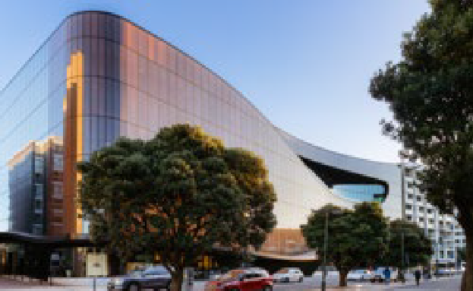
Tākina
Tākina, the capital’s new convention and events centre, was completed and certified to a 5 Star Green Star Custom Design rating. Implemented initiatives will result in an estimated 60% reduction in energy use at the venue and an estimated 66% reduction
in operational greenhouse gas emissions when benchmarked against a comparable new build.

Wellington Botanic Garden ki Paekākā
The Paekākā Botanic Garden nursery glasshouses had their gas space heating replaced with heat pumps, the first project of its kind in New Zealand. Previously, the gas heaters in the glasshouses used to blow hot air around at floor level and were often temperamental
and unreliable. They used up to 33,000 kWh of gas per month in the winter, the same amount as 30 average Kiwi homes use in a year, in just one month. As well as being costly, the unpredictable temperatures caused health issues in the plants. A year on from
the installation, the results show how beneficial this work has been. Glasshouse operating costs have been halved, with a 64% reduction in energy use and a 100% reduction in gas consumption. There has also been a visible improvement in resident plants.

Council housing assets
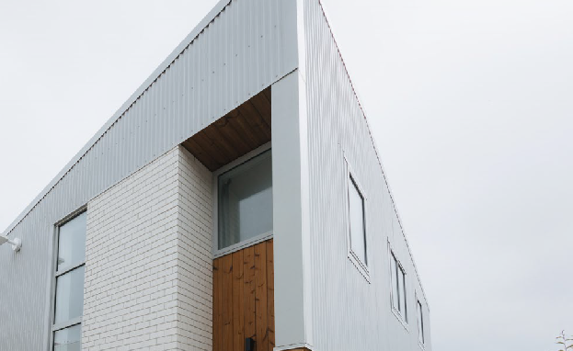
Council housing is both infrastructure that is part of our Climate Smart Buildings and Infrastructure
project, and also a community of tenants we support to take climate action.
In June 2022, the Council established a new community housing entity, Te Toi Mahana Trust, to take over
the operation of the Council’s social housing service. Council will remain an active partner with Te Toi Mahana to achieve the goals set out in Te Atakura. The City Housing team has delivered a range of climate- related projects in the areas of food, transport, and buildings. Tenants have been taking the lead on food- related projects, receiving and distributing quality surplus food within their communities, developing their communal māra kai (community gardens), and planting fruit trees in City Housing green spaces. There is a collaboration with Kaicycle and Sustainability Trust focused on composting, and we are partnering to enable community-based transport initiatives such as with Mechanical Tempest, an organisation that reuses and upgrades bicycles in the city.

Te Atakura – First to Zero 2023 Update 43

Measuring our progress
In the Implementation Plan, we outlined a range of potential indicators for us to evaluate the impact of the planned actions.

Key indicators of change

Some of these have proven impractical or difficult to measure. For this action area, we have focused on measures that evaluate progress of our actions, and we track the emissions generated by our activities.

Indicators | 2020 2021 2022  (as at 30 June) (as at 30 June) (as at 30 June) |  |  | 2023  (as at 30 June)
Council GHG emissions (tCO₂–e) | 110,639 | 145,83117 | 115,664 | 98,791
Waste – annual landfilled rubbish (tonnes) | 97,745 | 89,287 | 85,135 | 160,32418
Waste – diverted from landfill (tonnes)19 | 17,900 | 18,174 | 17,179 | 16,719
Green waste (tonnes) | 5,210 | 5,482 | 5,295 | 5,288
Commercial food waste (Kai to compost) (tonnes) | 1,392 | 1,521 | 1,201 | 1,156
Recycling (tonnes) | 10,679 | 10,568 | 10,232 | 9,598.46
Tip Shop – diverted from landfill (tonnes)20 | 19 | 19 | 44 | 2521
Scrap metal (tonnes) | 571 | 557 | 531 | 373
Hazardous waste (tonnes) | 29 | 29 | 30 | 20
Council battery electric passenger vehicle fleet | 5% | 6% | 12% | 68%
Reduce total waste to landfill by 50% by 2030 |  |  |  | New indicator for FY24
Reduce biogenic methane gas emissions by at least 30% by 2035 |  |  |  | New indicator for FY24
Divert 50-70% of organic waste from landfill by 2030 |  |  |  | New indicator for FY24
Reduce per capita kerbside waste by 40% by 2030 |  |  |  | New indicator for FY24
Divert 50% of construction and demolition waste from landfill by 2030; 70% by 2035 |  |  |  | New indicator for FY24
Note: Landfill data is from Southern Landfill

  - This increase reflects the change in scope of our inventory, to include emissions from across our full value chain.
  - This increase is largely due to the treatment of contaminated soil. Before July 2022, contaminated soil was diverted from the live landfill to re-contour a closed landfill. As such, volumes were excluded from previous years reporting.
  - This figure relates to material diverted from the transfer station and includes green, hazardous, commercial food scraps, scrap metal as well as recycling tonnages from the kerbside and the recycle centre.
  - Refers to recovered items diverted from the transfer station to be processed thorugh the Tip Shop for recycle, repair or re-use.
  - The Tip Shop is employing more resource to support the recovery of re-usable items from the transfer station. This reduction can also be attributed to an increase in people dropping goods off at the Tip Shop before entering the landfill.

44 Wellington City Council

Action area: Advocacy
We require government action and partnership to help us meet our city targets by 2030 and 2050. Council advocated on behalf of Wellington residents in a number of climate-related consultations.

Central government policy
Central government has provided advice and guidance that clearly indicates local government has a fundamental role to play in delivering national climate action at a local level. However, we require national leadership in this space. We are committed to doing everything possible to accelerate climate
action in the capital, and will continue to advocate for national policies relevant to our residents to accelerate climate action in Wellington and cover the areas we don’t have power over.
We are committed to doing everything possible to accelerate climate action in the capital.

Council took part in the consultation process
for both the Aotearoa New Zealand Emissions Reduction Plan and the National Adaptation Plan, and in our submissions expressed our strong view that central government needs to be more ambitious, more specific about the role of local government and provide funding to support local government action.

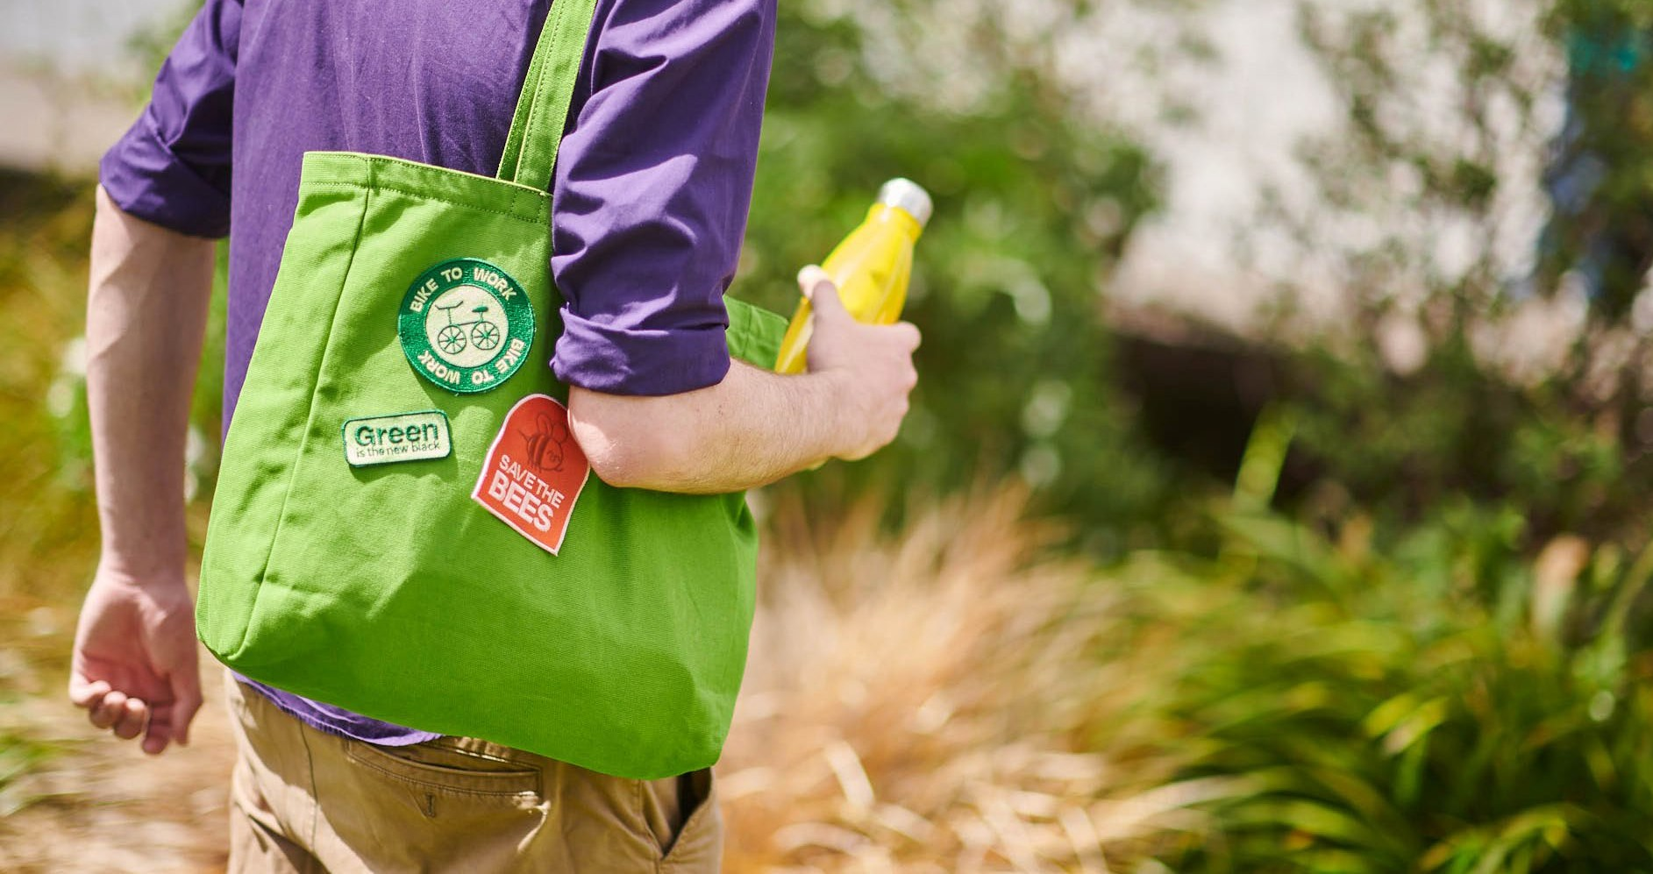

Te Atakura – First to Zero 2023 Update 45

Regional emissions reduction
We are contributing to a new Regional Emissions Reduction Plan through our involvement in the Wellington Leadership Committee. This will help shape the other regional workstreams, including the Regional Growth Framework. The purpose of the plan is to identify and focus on areas where a co-ordinated, regional solution is required including large waste processing facilities, electricity supply networks and transportation links.
The plan has now progressed through a series of workshops throughout 2023 involving all sections of the community and a draft is being prepared for adoption in early 2024.

Zero waste and a circular economy
This strategy provides further detail on transitioning towards a circular economy, with the vision that New Zealand will be a low- emissions, low-waste society, built upon a circular economy by 2050.
The Aotearoa New Zealand Emissions Reduction Plan outlines the future direction for recycling collections and organic waste management, and the need to divert this material from landfill. Central government funding is available for councils to process organic waste and create recovery infrastructure, as well as for the implementation of kerbside organic collections.
Council developed the Zero Waste Strategy to align with the Ministry for the Environment’s waste strategy Te rautaki para, which was published in March 2023. This strategy provides further detail on transitioning towards a circular economy, with the vision that New Zealand will be a low-emissions, low- waste society, built upon a circular economy by 2050.

Adaptation
A summary of advocacy submissions relating to adaptation is included in the adaptation section.

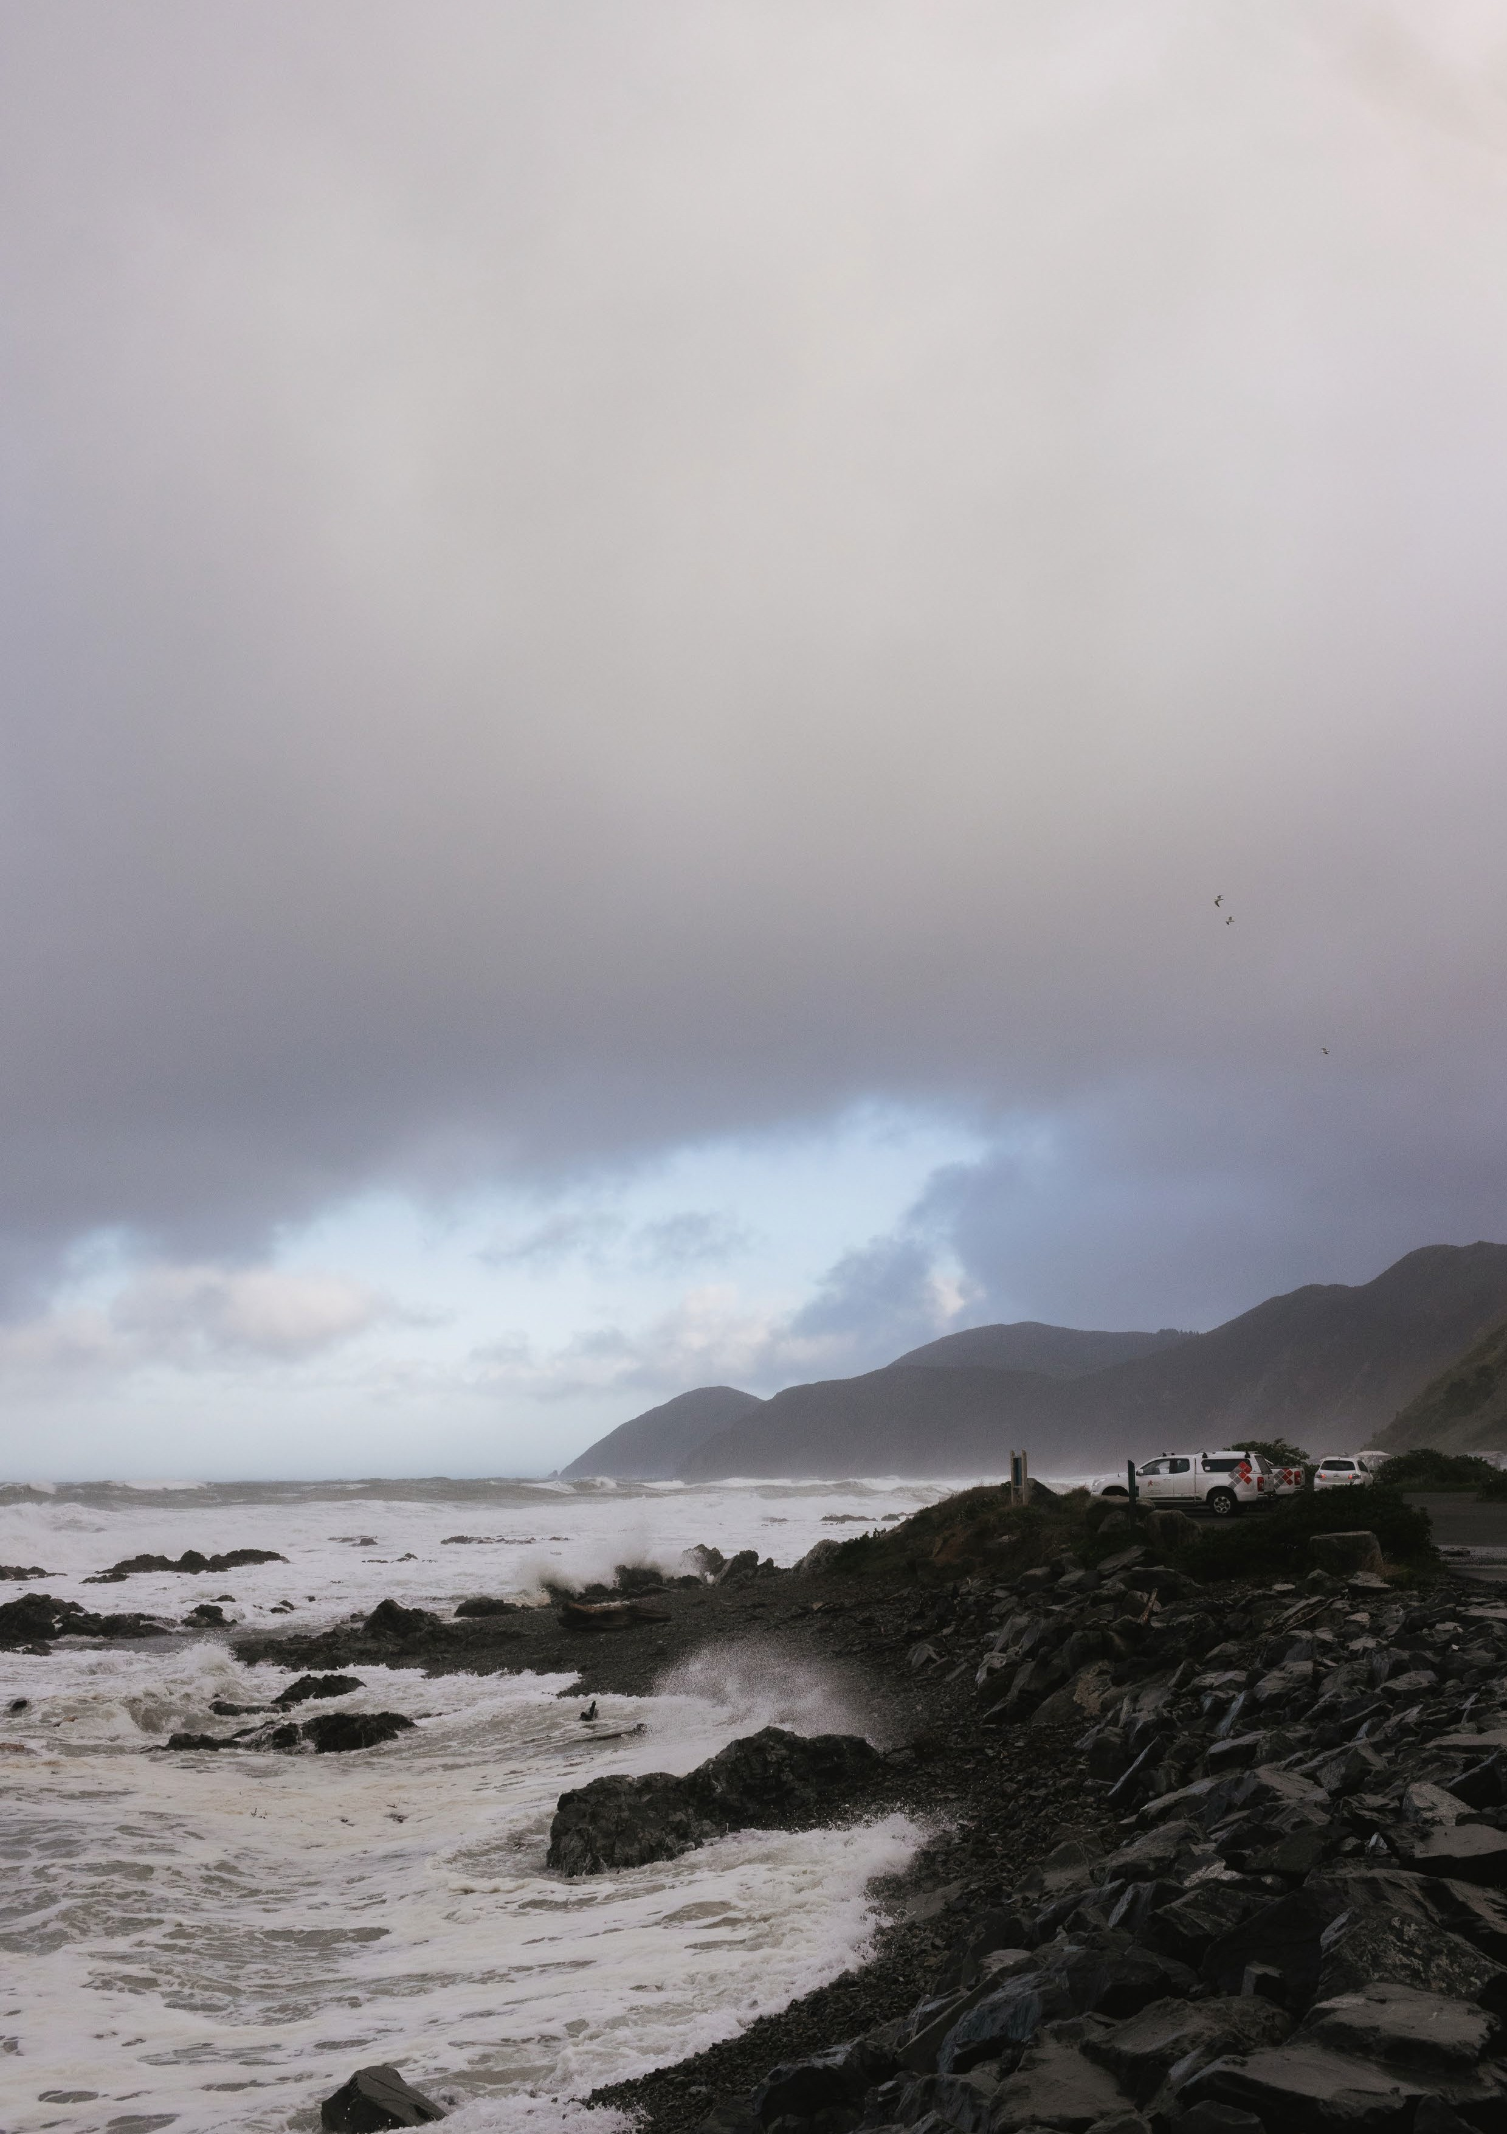

Progress on action areas to adapt to the impacts of climate change

Our approach to adaptation has evolved significantly since the adoption of the Implementation Plan in 2020. In 2022 we outlined four action areas that focus our work, and in 2023 Council adopted the Climate Adaptation Community Engagement Roadmap that outlines how these action areas will be progressed in order to support our work with communities.

Action area: Understanding the problem

The latest Intergovernmental Panel on Climate Change report highlights that climate change impacts and risks are becoming increasingly complex and more difficult to manage. Our focus is on understanding in greater detail what localised impacts will likely to be so we can make well-informed decisions on how to adapt to our changing environment.

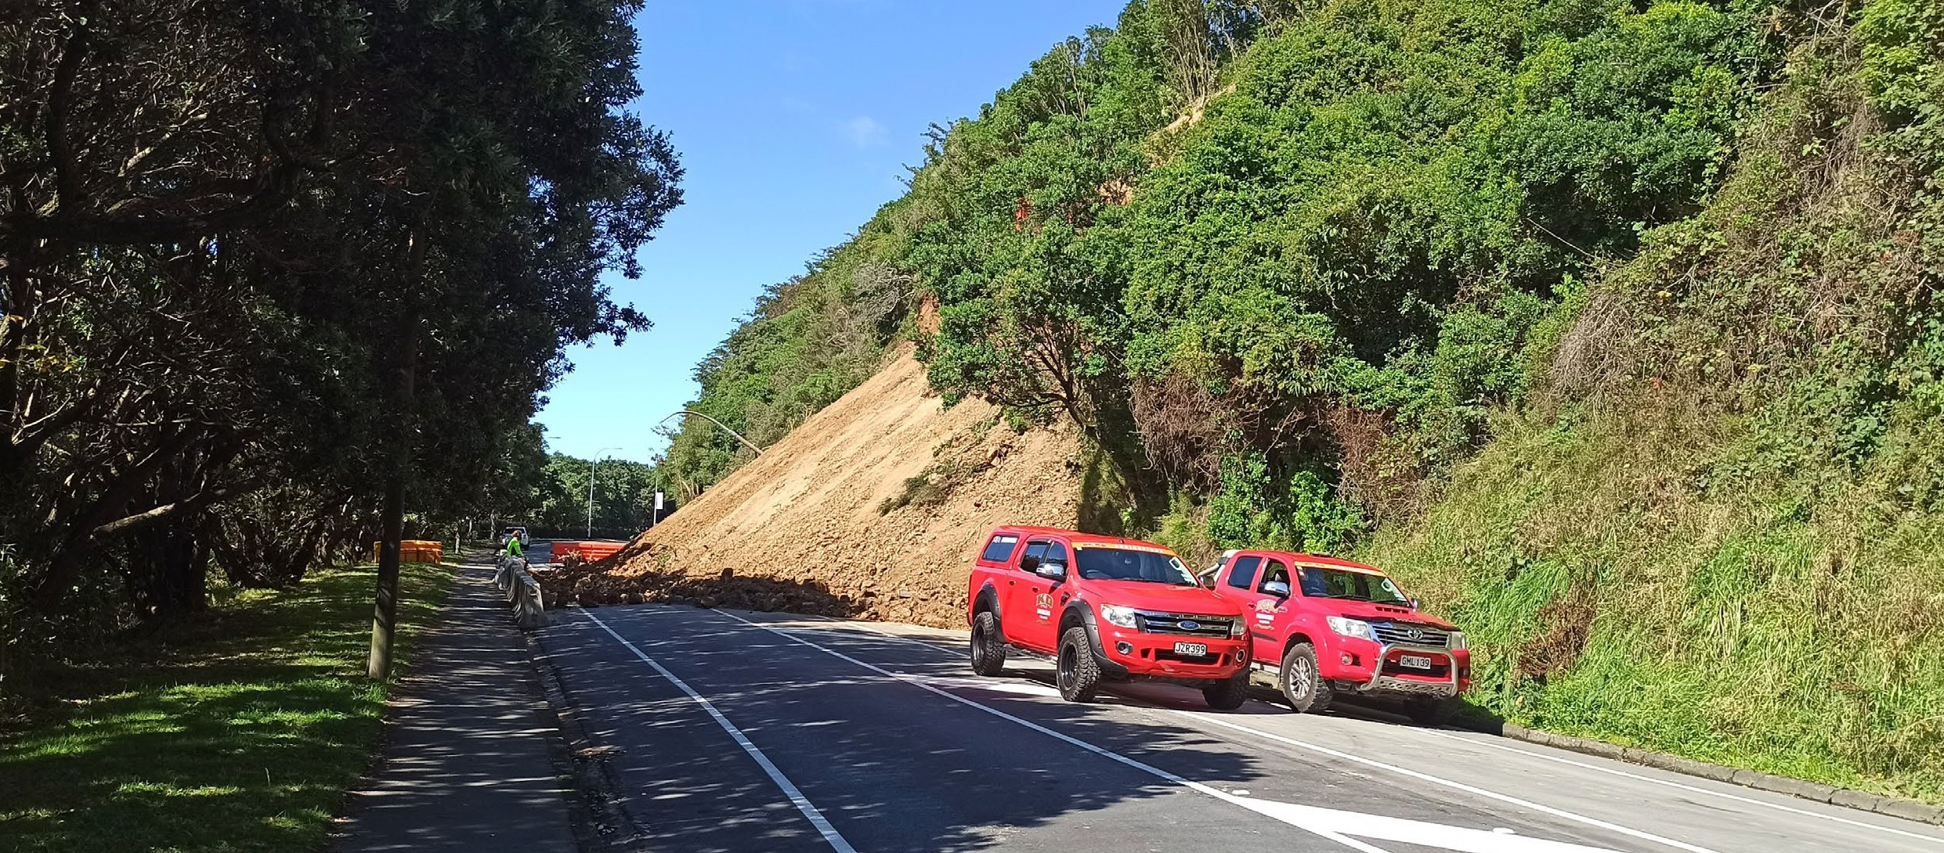
We have been developing a detailed picture of how climate change will affect the city and region, and the likely impacts on people. By having a science-based understanding of the problem, we can build a robust evidence base for our decisions on how to adapt to these changes.

What’s underway

Updating hazard maps with current adaptation projections
Climate impacts can be highly localised. Wellington’s hazard maps are an important tool for empowering Wellingtonians to make decisions based on the
most granular information available and ensure that the risks can be incorporated into our planning documents as accurately as possible. These risks are
being considered and applied to our spatial planning and growth projections for the city. The proposed District Plan now includes a new risk-based approach to managing development across the city based on hazard and climate change risks.
Climate change impacts and risks are becoming increasingly complex and more difficult to manage.
We are also planning a more detailed climate change quantitative risk and vulnerability assessment to inform both the Council’s Climate Adaptation Plan and Climate Adaptation Community Engagement Roadmap.

Understanding the implications for the region
The Council is leading the first phase of one of the Wellington Regional Leadership Committee’s projects – the delivery of a comprehensive climate change impact assessment on behalf of nine councils – Wellington city, Kapati, Hutt, Lower Hutt, Porirua, South Wairarapa, Masterton District Council, Carterton District Council, and Greater Wellington Regional Council – in the Wellington region, in partnership with central government and mana whenua.
This assessment is the first step in delivering regional- scale climate adaptation planning. The assessment will be one of the country’s most complex and comprehensive assessments of regional impacts.
We are working with many of New Zealand’s top experts from Beca, NIWA, GNS Science, and Te Herenga Waka – Victoria University of Wellington to deliver an assessment of the projected impacts over the next 100 years on our:
- Natural ecosystems
- Physical assets and infrastructure
- The economy and community – including human health, safety and well-being, and cultural life and identity.
The report is being peer reviewed and finalised in 2024. This report is an important input for the development of the Wellington Regional Climate
Adaptation Plan as part of the Wellington Regional Leadership Committee’s adaptation project.
The assessment will be one of the country’s most complex and comprehensive assessments of regional impacts.

April 2023
Climate Change Adaptation Community Engagement Roadmap approved

August 2023
Wellington Regional Climate Change Impact Assessment report completed

Action area: Developing a strategic adaptation approach

We need a strategic approach that brings together multiple voices across the city so we can respond proactively and with agility to a fast-changing context.

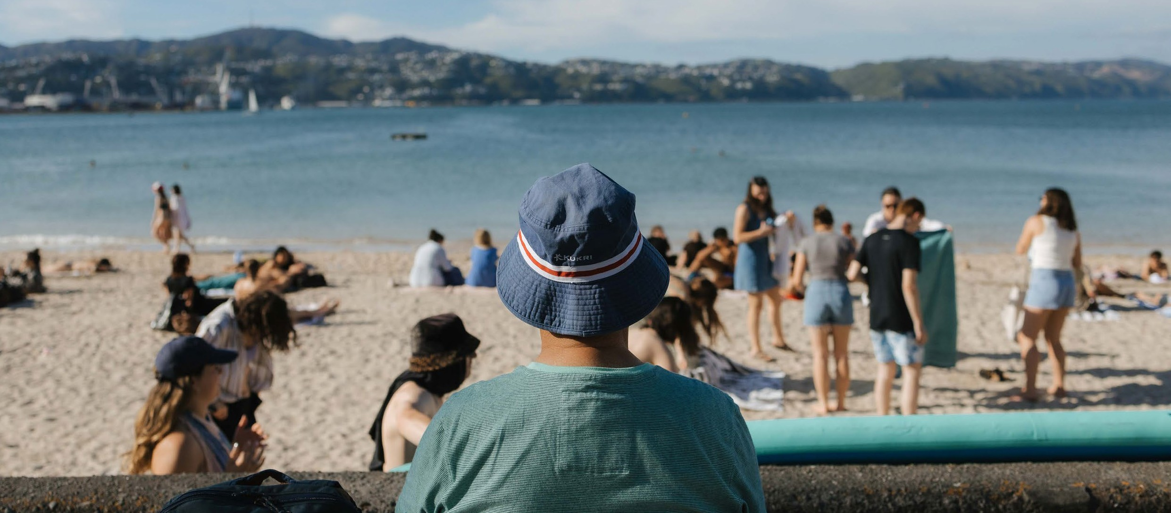
The Council’s strategic approach will bring together our understanding of the challenge, the evolving government policy context, mana whenua points of view, and the voices of impacted communities.
The starting point is a conversation on what principles need to be incorporated into our framework, reflecting the priorities of councillors and Wellingtonians.
For example, social equity, te Tiriti o Waitangi, and community co-design.

What’s underway

Developing a strategic framework for climate adaptation
Developing a strategic framework for climate adaptation will be the starting point for the Council and communities to create adaptive pathways that plan for and respond to climate change impacts now and in the future. This builds on the Council’s previous work, including the Resilience Strategy.
The framework will outline an approach to developing ‘dynamic adaptation pathways’, which can be applied at various scales, and will inform the third phase
of our Climate Adaptation Community Engagement Roadmap adopted by Council in April 2023.
The framework is being designed to be applied to help solve different risks and to be revised in the future as new information, new ideas, new technology, and funding sources emerge.
It will be designed to align with the New Zealand Coastal Policy Statement 2010, the 2017 Ministry for the Environment’s Coastal Hazards and Climate Change Guidance for Local Government, and the first National Adaptation Plan, the Ministry for the Environment’s interim guidance on the use of new
sea-level rise projections, as well as updated future policies, and relevant strategies, policies and plans from the Council.

Developing an adaptation plan for Council-owned assets
Once our strategic framework is in place, we will also be able to develop dynamic adaptation pathways
for Council-owned assets, including our recreation facilities, roads, public reserves, etc. This will enable us to plan for the likely costs of either being able to adapt our assets to the impacts or moving our assets to safer ground.

Action area: Advocacy

To be equitable and effective, local adaptation work needs to be funded consistently and equitably across communities and the country, with clear guidance on whether the costs will fall on individuals, communities, or be spread out nationally.

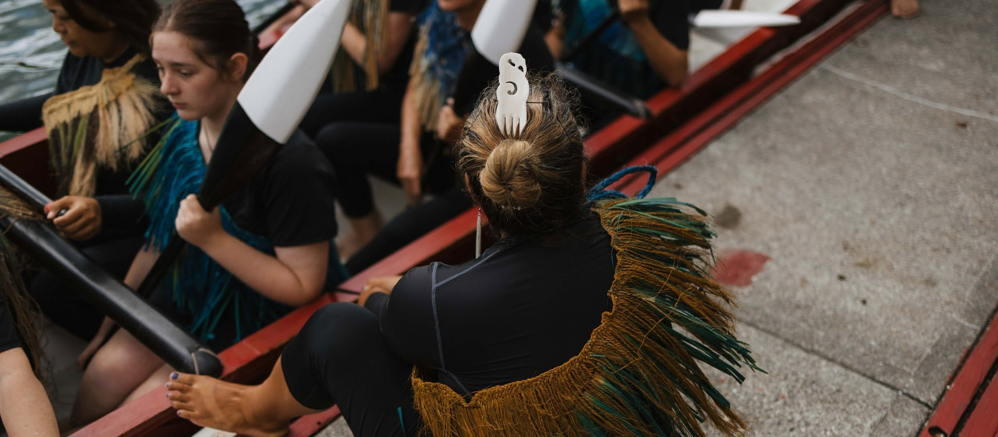
In the past few years, government has been undertaking significant changes to the legal and policy framework
to support adaptation to the impacts of climate change including the Resource Management Reform (including the proposed Climate Adaptation Act), Three Waters Reform and Future for Local Government. With the change in government in 2023, councils face more uncertainty regarding the policy environment to support community adaptation planning.

Review of the draft National Adaptation Plan
In 2022, the Council submitted feedback on the government’s draft National Adaptation Plan. Council encouraged stronger direction and coordination from government. This would clarify roles and responsibilities as well as funding mechanisms, and support adaptation planning at the local level.

Partnership with the Environmental Defence Society
The Council has supported the Environmental Defence Society and others to undertake research that will inform the drafting of proposals for the Climate Adaptation Act. The first two of three papers have been made available online and have already been utilised by the Ministry for Environment to inform the 2023 the 2023 Report of the Expert Working Group on Managed Retreat.

Submission on the Inquiry into Climate Adaptation
In November 2023, the Council submitted feedback on the government’s Inquiry into Climate Adaptation which sought feedback on a range of topics relating to the key questions for local climate adaptation plans: Who decides? Who pays? The Council provided feedback that called for greater urgency
for the establishment of the Climate Adaptation Act that would clarify funding and the role of local government, as well as greater standardisation of guidance and practical tools and other support to
Councils and communities to plan for climate change.

Action area: Working with local communities

Community participation will be vital to the process of making difficult climate change adaptation decisions for the city’s long-term resilience.

The people closest to the impacts need to have a ‘seat at the table’ to both to bring their unique understanding of the context and to shape how
we collectively respond to the challenges ahead.
To enable meaningful participation, we need to communicate the full picture of how climate change will impact Wellington and to create ways for people with diverse needs and perspectives to contribute in an ongoing way.

What’s underway

Climate Adaptation Community Engagement Roadmap
In April 2023, Council adopted the Climate Adaptation Community Engagement Roadmap which sets out
the approach to planning for climate change in Wellington over the next six+ years.

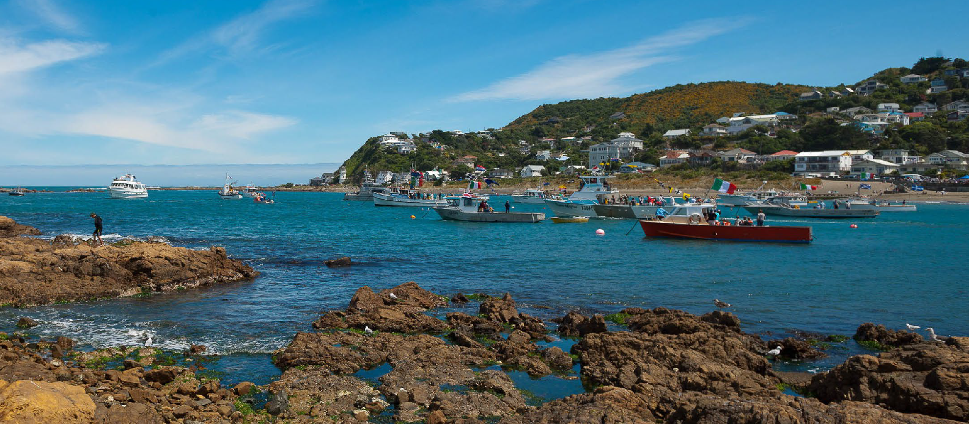

In FY23, we started the implementation of the first two phases of the roadmap:
Phase 1 Scoping and groundwork
Phase 2 Engage the city to raise awareness
Phase 3 Consultation on Phases 4–6
Phase 4 Planning with local communities
Phase 5 Council decision- making
Phase 6 Doing and reviewing

The first phase sets out steps to build the foundations of a flexible, scalable and affordable approach including building partnerships with mana whenua, Wellington Regional Council and other agencies, undertaking climate change risk assessments, and developing tools to support adaptation planning processes.
The second phase sets out activities to better inform and talk to residents about local climate change impacts. The public engagement will be ongoing, and will be tailored and built on over time. Communities want to know about and take action on reducing climate risks and impacts so our engagements will address both. This phase includes the Bloomberg digital twin project and community climate action mentioned below.
The third phase is when communities will have the opportunity to provide feedback on the proposed approach and initial areas for the pilot of the community adaptation planning (Phases 4 to 6 of the Roadmap).
The fourth phase is where Council will facilitate proactive planning with high-risk communities to develop local climate adaptation plans. The approach may need to be piloted first before it is scaled up.
These local plans will be designed to interface with city-wide climate change adaptation planning, to connect local values to city-wide strategies in the long-term.
The fifth phase is when Council may need to make decisions regarding the investment, or other implementation measures, resulting from the community planning process in the previous phase.
The sixth and final phase focuses on implementation, monitoring and reporting of the planning phase.

Bloomberg digital twin project and community engagement tool (2022–2025)
The Wellington Climate Adaptation Digital City Model project is a flagship project being developed to support Phase 2 and Phase 4 of the Climate Adaptation Community Engagement Roadmap and scale its local engagement across the city. In January 2022, this project won the prestigious Bloomberg Global Mayors Challenge. Wellington City Council was named one
of 15 winners to receive US$1million to deliver the project, out of over 600 applicants from 99 countries.
A digital city model is a life-like representation of Wellington that brings to life complex information such as climate impacts and adaptation options. This creates accessible, engaging experiences for people to explore the changing shape of Wellington, looking to the past and contributing to our future. In 2023 the first prototype of the Te Motukairangi area (Miramar,
Kilbirnie and Lyall Bay) was developed and tested with the feedback from more than 600 Wellingtonians. The next steps will include scaling up and undertaking the build of the digital tool to support city-wide education on climate change impacts and adaptation as part
of Council’s new Climate Adaptation Community Engagement Roadmap.
We expect to release the first version of the digital tool in 2024 and will continue to refine the tool based on feedback from the community.

The second phase sets out activities to better inform and talk to residents about local climate change impacts. The public engagement will be ongoing, and will be tailored and built on over time.

Community climate action
By sharing resources and our wero (challenge) and using community- led approaches, communities
will increase their capability and capacity to respond to this climate challenge with action that works for them and is sustained by them.
Our community climate action mahi is funded through a grant from the Department of Internal Affairs to support community-led climate planning and action, in advance of budget decisions in the 2024 Long-term Plan. We are working across the city to support communities who want to learn more about the causes and impacts of climate change and take action. By sharing resources and the wero (challenge) with communities and using community-led approaches, communities will increase their capability and capacity to respond to this climate challenge with action that works for them and is sustained by them. This will support emissions reductions and resilience as part of the Climate Adaptation Community Engagement Roadmap.
We are also linking our community engagement with the aspirations of mana
whenua to uphold Tākai Here, our partnership agreement with mana whenua.
We are taking an equitable transitions approach, committing to also bringing our resources to communities that are traditionally excluded from government programmes so that they have opportunities to develop as much as those communities who do more often engage with Council. We are also linking our community engagement with the aspirations of mana whenua to uphold Tākai Here, our partnership agreement with mana whenua.
Activities to support community climate action include:
- Climate conversations webinar sharing the Wellington climate context for the public
- Participating in and supporting community events
- Developing and delivering community climate leadership training
- Developing multi-use educational resources for the community.
- Contracting community groups and NGOs
to carry out the development of local climate wānanga, workshops and planning.

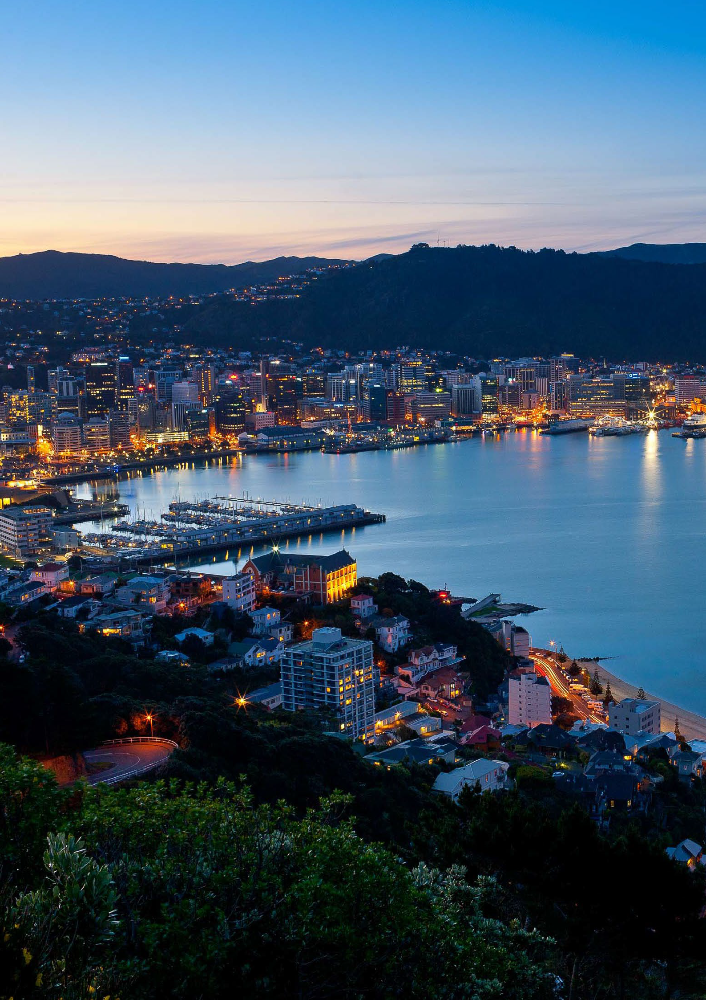

Appendix 1: Actions status

Transport and urban form actions

Action | Lead | GHG Reduction | Status 2021 (as at 30 June) | Status 2022 (as at 30 June) | Status 2023 (as at 30 June)
Mass rapid transit | WCC, GWRC,  Waka Kotahi, Govt | Major | Underway | Underway | Underway
People-friendly City Streets | WCC, GWRC,  Waka Kotahi, Govt | Major | Underway | Underway | Underway
Enabling urban density (Planning for Growth) | WCC | Major | Underway | Underway | Underway
Practical support to change travel habits | WCC | Enabling | Ongoing | Ongoing | Ongoing
Car-sharing | Business sector | Moderate | Ongoing | Ongoing | Ongoing
Shared mobility  (e-scooters and e-bikes) | Business sector | Minor | Underway | Ongoing | Ongoing
Charged-up Capital (Public EV chargers) | WCC | Moderate | Underway | Underway | Underway
Fossil fuel free streets | WCC, GWRC,  NZTA, Central Govt | Enabling | Scoping | Absorbed into LGWM | N/A
Flexible working | WCC, GWRC,  NZTA, Central Govt | Major | More R&D required | Absorbed into ongoing travel behaviour change work | N/A
Identify aviation and marine opportunities | Business sector | Unclear | More R&D required | More R&D required | More R&D required
Active Workplace Travel Fund | WCC | Enabling | N/A | Underway | Ongoing
Green Network Plan | WCC | Moderate | N/A | Scoping | Underway
Paneke Pōneke | WCC | Enabling | Scoping | Underway | Underway

Building energy actions

Action | Lead | GHG Reduction | Status 2021 Status 2022 (as at 30 June) (as at 30 June) |  | Status 2023 (as at 30 June)
Warmer Kiwi Homes | EECA (10-20%  top up by WCC) | Minor | Ongoing | Ongoing | Ongoing
Home Energy Saver | Sustainability Trust | Minor | Ongoing | Ongoing | Ongoing
Neighbourhood grids | Contact Energy | Minor | Completed | N/A | N/A
Business Energy Saver Pilot | WCC with delivery partner | Moderate | Scoping | Scoping | Evolved into Let’s Talk Shop
Development contributions | WCC | Minor | Scoping | Absorbed into EAPF | N/A
Supporting building sustainability improvements | WCC | Enabling | More R&D required | Investigation complete | N/A
Environmental and Accessibility Performance Fund (EAPF) | WCC | Enabling | N/A | Scoping | Ongoing

City-wide initiatives actions

Action | Lead | GHG Reduction | Status 2021 Status 2022 (as at 30 June) (as at 30 June) |  | Status 2023 (as at 30 June)
Te Atakura action investigation | WCC | Enabling | Scoping | Scoping | Underway
Wellington Climate Lab | WCC, business sector, community sector, academia | Enabling | Scoping | Underway | Absorbed into action investigation
Climate and Sustainability Fund | WCC | Enabling | Underway | Underway | Ongoing
Climate action education, events and activation | WCC | Enabling | Scoping | Underway | Ongoing
Zero Together 22 | WCC | Enabling | Underway | Underway | Ongoing
Let’s Talk Shop23 | WCC with delivery partner | Enabling | N/A | Scoping | Pilot
Te Anamata Ā-Kai o Tō WCC Tātou Tāone - Our City’s  Food Future 24 |  | Enabling | Underway | Underway | Ongoing
Accelerate opportunities to support carbon farming | WCC | Enabling | Underway | Underway | Ongoing

  - Renamed from Future Living Skills programme.
  - Renamed from Business Energy Saver.
  - Renamed from Sustainable Food Programme.

The Council itself actions

Action | Lead | GHG Reduction | Status 2021 Status 2022 (as at 30 June) (as at 30 June) |  | Status 2023 (as at 30 June)
Council greenhouse gas emission measurement | WCC | Enabling | Underway | Underway | Ongoing
Sewage Sludge Solution | WCC | Major | Awaiting funding | Awaiting funding | Underway
Diversion of food waste | WCC | Minor | Underway | Para Kai pilot completed | Scoping
Waste strategy review | WCC | Major | Scoping | Underway | Completed
EV First Fleet | WCC | Minor | Underway | Underway | Underway
Energy Management Strategy and Plan | WCC | Enabling | Scoping | Underway | Underway
Displacing natural gas | WCC | Minor | More R&D required | Underway | Underway (part of energy strategy)
Solar community facilities | WCC | Minor | Scoping | On hold | Discontinued
Climate Smart Buildings and Infrastructure | WCC | Enabling | Underway | Underway | Underway
Hybrid working 25 | WCC | Minor | Underway | Underway | Underway
Procurement - Broader Outcomes 26 | WCC | Enabling | Underway | Underway | Underway
Improve governance | WCC | Enabling | Underway | Underway | Underway
Staff engagement | WCC | Enabling | Underway | Underway | Underway

  - Renamed from Flexible working.
  - Renamed from Procurement.

Adaptation actions

Action | Lead | Status 2022 | Status 2023 (as of 30 June)
Leading the Wellington Regional Climate Change Impact Assessment | WCC | Underway | Underway
Updating hazard maps with current adaptation projections | WCC | Completed | N/A
Developing Wellington City Council’s Climate Change Impact Assessment | WCC | Scoping | Scoping
Developing the Wellington City Council Climate Adaptation Plan | WCC | Scoping | Scoping
Bloomberg Digital Twin project and Community Engagement Tool | WCC | Underway | Underway
Developing a community-based Dynamic Adaptive Pathways Planning programme for high-risk communities | WCC | Underway | Underway
Document lessons from Wellington City Council case-studies: Mākara & Owhiro Bay | WCC | Completed | N/A
Developing a strategic framework for climate adaptation | WCC | N/A | Scoping

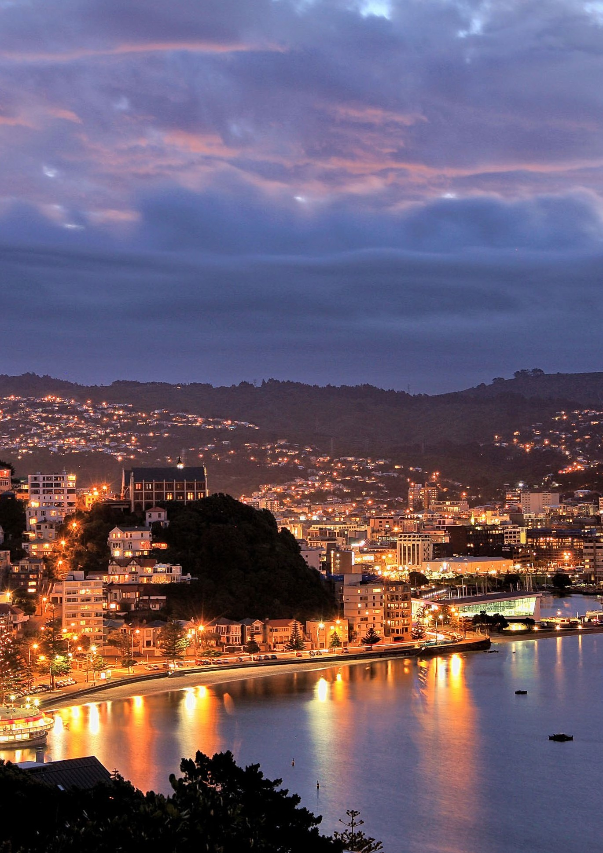

Appendix 2: Climate and Sustainability Fund

Climate and Sustainability Fund – projects update

Organisation | Project | Key actions/deliverables | Status/update
Wellington Regional Chamber of Commerce | Go Zero - Sustainability Bootcamp Pilot  Granted March 2022 | Deliver sustainability bootcamp to equip small to medium enterprises (SMEs) in Wellington with tools  to cut carbon emissions, and run this bootcamp twice a year. Anticipated 20 participants in  each cohort. | Completed
 |  |  | This pilot was completed in December 2022.
 |  |  | Two cohorts of six sessions were delivered
 |  |  | to 27 participants from a range of Wellington
 |  |  | businesses. While this fell short of the
 |  |  | anticipated number, in the post-bootcamp
 |  |  | survey most participants reported feeling
 |  |  | more empowered by the new knowledge and
 |  |  | tools to reduce carbon emissions in their
 |  |  | workplaces and chose to join the alumni
 |  |  | group to continue to connect and support
 |  |  | each other to take climate action in their
 |  |  | businesses. This pilot generated key findings
 |  |  | regarding barriers to business uptake and
 |  |  | opportunities for improvement, leading to
 |  |  | refinements to the project.
Wellington Regional Chamber of Commerce | Go Zero - Sustainability Bootcamp next project round  Granted December 2022 | Continuation of sustainability bootcamp, incorporating refinements from the pilot. Broadened scope to region-wide (WCC funding for Wellington  SMEs only), aiming for 30 participants per cohort. | Underway
 |  |  | The second project round is underway. A cohort
 |  |  | of 18 organisations, including 16 Wellington
 |  |  | businesses, completed the bootcamp in
 |  |  | June 2023, and the next tranche has begun
 |  |  | with a cohort of 20 participants, including
 |  |  | 14 Wellington businesses. Funding has been
 |  |  | adjusted based on lower participant numbers.
 |  |  | The final report on the impact and learnings
 |  |  | from the project is due in December 2023.
Sustainability Trust | Wellington Climate Action Centre  Granted March 2022 | Transforming the existing eco-centre into a new Wellington Climate Action Centre. | Cancelled
 |  |  | This project was cancelled due to the
 |  |  | Sustainability Trust being unable to secure
 |  |  | additional funding from other sources.
 |  |  | The funds are being repaid and will be re-
 |  |  | allocated in future funding rounds.

Organisation Project | Key actions/deliverables | Status/update
Lodabike Report into residential e-bike storage barriers and solutions in Wellington  Granted March 2022 | Complete local research to identify e-bike storage barriers in households and present solutions to increase e-bike ownership and use in Wellington. | Completed  This project has been completed. This report clearly identifies that residential access  and storage issues are barriers to uptake of e-bikes in Wellington, and revealed a range of potential solutions WCC can investigate.  This research was carried out collaboratively, canvassing current and prospective e-bike users, residents, retailers, architects,  online community groups, council staff and industry bodies. While most of the implementation of these solutions now sits with WCC, the report has already been used to advise the City Design team and Te Toi Mahana, supported various submissions  on the LTP and created visibility of creative community-led solutions already being implemented, supporting other Wellington residents to address this issue.
Greenback Plantme  Limited Growathon  Granted March 2022 | Develop a free gamified digital platform that provides users with resources for growing food successfully at home and tracks the carbon reduction benefits of backyard food production in Wellington. | Delayed  The delivery of this project has been delayed. We have agreed on a new completion and reporting date of 28 March 2024.
A Rocha Aotearoa Eco Church  NZ – Wellington Initiatives  Granted March 2022 (co-funded) | Supporting grassroots efforts by churches  in Wellington to understand their carbon footprint, develop climate action plans and the development and promotion of a carbon calculator for churches to measure their impact. | Completed  The funded activities have been completed. By the end of this initial funding period, there were seven active eco churches and three denominational partners based  in Wellington, and 12 across the greater Wellington region. 10 further churches in Wellington are in conversation about joining. Over the funding period, 580 people joined online and in-person sessions. Eco Churches have taken actions including community gardening, pātaka kai, bicycle repair  days, repair cafes, zero waste community workshops, biodiversity restoration work, planting of native trees and fruit trees. Their carbon calculator tool was launched in March 2023 and is being piloted with local churches.

Organisation | Project Key actions/deliverables | Status/update
EkeRua | Increasing e-bike Deliver two pilots aimed accessibility at increasing e-bike pilots and the accessibility and the  purchase and purchase and fit out of a  fit out of a container workshop for  their new site at South  new container Wellington Intermediate workshop School. The first pilot is  an e-cargo bike library Granted May 2022 to give Wellingtonians (Ride-to-buy pilot access to a longer trial is co-funded) of an e-cargo bike. The  second pilot is a ride-to-  buy scheme, exploring alternative pathways to e-bike ownership for people on low incomes to help address the current inequities in access to these active, low emission transport options. | Container workshop completed
ReBicycle |  | The new container workshop is fully
 |  | operational. Since opening, they have
 |  | hosted over 33 fix-ups and events on site,
 |  | each attracting between 4 to 40 people, with
 |  | hundreds of bikes received, repaired and
 |  | given back to the community.
 |  | E-cargo bike library completed
 |  | At the time of their final report (nine
 |  | months into the pilot) they had 17 families
 |  | participate in the pilot. Participating families
 |  | had used the e-cargo bikes to replace car
 |  | trips and almost half the pilot participants
 |  | purchased an e-bike/e-cargo bike afterwards.
 |  | Participating families reported observing
 |  | the far-reaching benefits of owning an
 |  | e-cargo bike (change in perception of cost vs.
 |  | benefit), increased confidence using one, and
 |  | that it normalised cycling in their family and
 |  | sparked conversations and connections with
 |  | whanau and wider community.
 |  | E-bike/e-scooter Ride-to-Buy pilot
 |  | (Wheel Change) underway
 |  | Due to legal challenges associated with
 |  | the original lease-to-buy model, and with
 |  | additional funding provided by Waka Kotahi,
 |  | they have shifted to ‘ride to own’ approach.
 |  | Participants will ‘earn’ the device (e-bike/e-
 |  | scooter/e-trike/e-cargo bike) they are trialling,
 |  | by meeting an agreed weekly/overall riding
 |  | target. Each kilometre ridden is given a
 |  | monetary value, which matches the benefit to
 |  | society of car trips replaced by e-bike/scooter.
 |  | The environmental, social and health benefits
 |  | of riding have been calculated as equivalent to
 |  | $1.35 p/km for e-bike riders.27 [RM1] [RM2] and
 |  | $0.68 p/km for e-scooter riders. Their 16-
 |  | week monitored riding/use phase started
 |  | mid-October 2023, running until the end of
 |  | February 2024.28 They will then work with
 |  | participants on whether they keep or return
 |  | the e- bikes/e-scooters.

  - The $1.35/km value for e-bike riding was derived based on Te Manatū Waka Ministry of Transport (NZ) University of Otago, in association with Ian Wallis Associates Ltd (2023). Domestic Transport Costs and Charges Study. Working Paper D3 Health Impact Active Transport. Available from: DTCC-WP-D3-Health-Impacts-of-Active-Transport-June-2023.pdf.

  - EkeRua ReBicycle have derived this figure based on the following reports Fitt, H., & Curl, A. (2019). E-scooter use in New Zealand: Insights around some frequently asked questions. Available from: https://ir.canterbury.ac.nz/handle/10092/16336 and Grant-Muller, S., et al. (2023). Does the Use of E-Scooters Bring Well-Being Outcomes for the User?: A Study Based on UK Shared E-Scooter Trials. Available from: https:// activetravelstudies.org/article/1298/galley/5177/view/.

Organisation | Project | Key actions/deliverables | Status/update
EkeRua ReBicycle | Project and fundraising manager  Granted December 2022 | Recruitment of a project and fundraising manager for 48 weeks in 2023 to increase opening hours, expand services and run more events. Building capacity towards the long-term goal of having a bike hub in every corner of the city by 2030. | Underway  This project is underway. The project and fundraising manager is working on  streamlining their projects and increasing the number of events and support for the community.
Voice of Aroha | Climate awareness for refugee and migrant communities in Wellington  Granted December 2022 (Co-funded) | Through content creation, community events, workshops and kōrero, Voice of Aroha aims to amplify the voices, stories  and knowledge of refugee communities and migrants to build capacity for their leadership and solutions towards reducing emissions by 2030. | Nearing completion  Over the funding period, Voice of Aroha have delivered three workshops in Wellington central and Porirua, an educational tour,  a 10-day online campaign, and over 20 podcasts about stories and actions related to climate change. Through this they have been able to capture a wealth of knowledge  and stories from former refugee and migrant communities regarding climate action,  as well as key insights around how to communicate climate change information more effectively and equitably. They have seen an increase in their volunteer base, equipping and amplifying emerging climate champions within their communities. Their success has resulted in an invitation to attend the UNHCR conference on climate mobility actions in Fiji, and their volunteers taking  an active role in other local climate action initiatives, fostering partnerships with numerous climate and youth organisations in Wellington and beyond.
Sir Peter Blake Charity Ltd | Development and piloting of a virtual reality climate change module  Granted Dec 2022 (Co-funded) | Development of a virtual reality climate change module with reference to Wellington specific elements and stories, and piloting this in Wellington schools. | Delayed  This project has been delayed due to needing to secure additional funding to deliver the project as proposed. We are working with  Sir Peter Blake Charity Ltd to see this project delivered successfully.

Organisation | Project | Key actions/deliverables | Status/update
Parents for Let’s Talk Climate Development, piloting Climate Aotearoa pilot workshops and testing their Let's  Granted Talk Climate project December 2022 – a series of workshops  for parents and whānau  to learn about how to effectively talk about climate change with their tamariki, neighbours,  co-workers, whānau, local communities and beyond. |  |  | Nearing completion  This project is coming to completion, with several further events planned over the summer months, and their final report is due in March 2024. In their interim report (June 2023) they had 96 people participate in their pilot. The survey results in their  interim report showed participants reporting increased knowledge, efficacy, and feeling well resourced about how to have impactful conversations with their families and wider communities. Attendees of workshops in Lyall Bay, Hataitai and Brooklyn have established local community climate action groups.  Their youth stream, Let’s Talk Climate – Taiohi, has seen strong engagement, with events including picnics (kai and kōrero), an Intro to Action panel and a day-long school holiday programme run in partnership with Enviroschools and Generation Zero.
Inspiring Stories Trust | The Impact Challenge  Granted December 2022 (Co-funded) | Development of rangatahi-led events | Completed  The Impact Challenge was launched at Parliament in June 2023. At Festival for the Future in Wellington, 145 young people shared their dreams of climate justice in four creative writing workshops. Recurring themes were gathered to articulate a shared vision.  Rangatahi across Aotearoa were supported to explore solutions to bring this vision to life in their communities through micro- grants, online and in-person workshops, mentoring and resources. This culminated in a 145 rangatahi deepening their knowledge  around climate justice through attending nine different webinars, leading to three rangatahi- led events in Wellington.

J017904 – November 2023

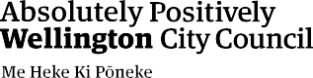
Climate Change Response ClimateAction@wcc.govt.nz wellington.govt.nz

