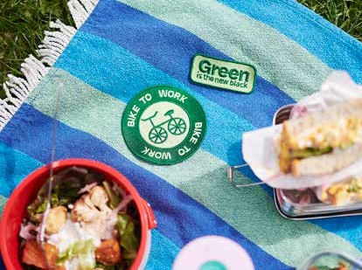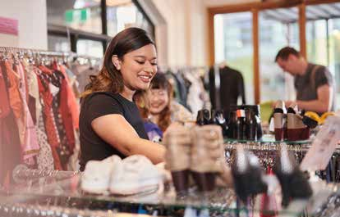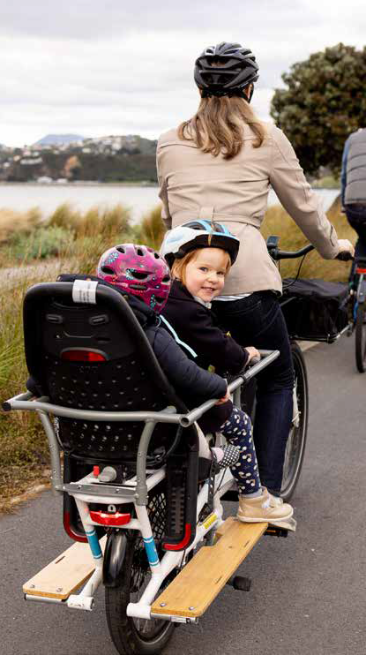

2022 Update

Te Atakura First to Zero

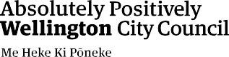

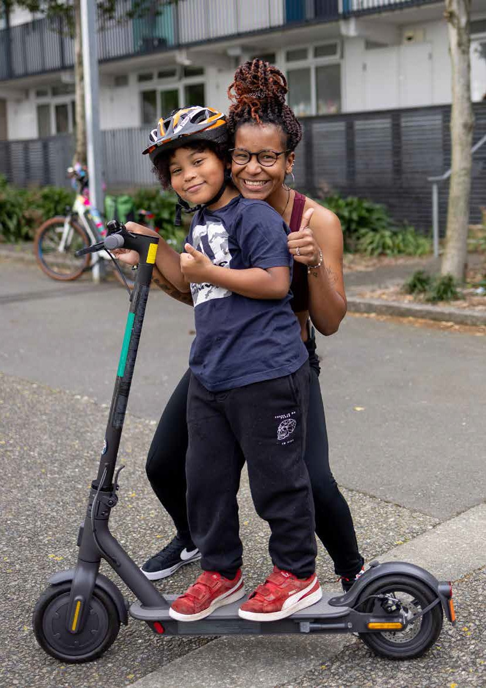

Contents
Introduction 4
Wellington’s emissions and targets 9
Action areas to become a net zero carbon city 13
Action Area: Transport and urban form 14
Action Area: Building energy 18
Action Area: City-wide initiatives 20
Action Area: The Council itself 22
Action Area: Advocacy 26
Action areas to adapt to the impacts of climate change 29
Action Area: Understanding the problem 30
Action Area: Contributing to, and understanding,
central Government policy 31
Action Area: Developing Council’s strategic approach
to adaptation 32
Action Area: Working with local communities 33
Looking forward – the race to zero 36
Appendix: Status of current actions 37
Glossary: Climate change terms 40

Te wero
Toitū te marae a Tāne Toitū te marae a Tangaroa Toitū te iwi
Ngāi Tātou o Pōneke, me noho ngātahi Whāia te aratika

Our challenge
Protect and enhance the realms of the Land and the Waters, and they will sustain and strengthen the People
People of Wellington, together we decide our way forward

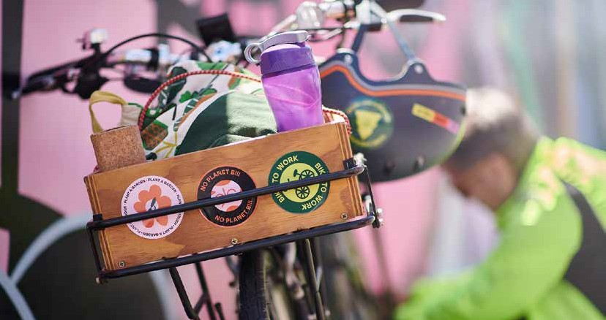
Introduction

We need to take urgent collective climate action to protect the people, places and lifestyle we love because we’re in a climate and ecological emergency. Our world is heating up, and Wellington is already experiencing the impacts, from physical risks such as rising sea levels and more frequent extreme weather events
to impacts on food prices. We are using the earth’s resources at a faster rate than they can be replenished, and threatening the local and global ecosystems that we are a part of and depend upon. Urgent, collective action is needed.
We must act now to reduce our emissions, slow down global warming and prepare to face the impacts of climate change that can’t be avoided – every fraction of a degree of warming averted is worth fighting for. Wellingtonians know this and have consistently told us that they want action on climate change. The Council continues to be committed to achieving the city’s targets of becoming a net zero carbon capital by 2050.

Climate action through city shaping
The Council’s unique role is shaping the city so we can live, work, and play in zero carbon ways. That’s why a significant part of our plan focuses on changing the way we move around and increasing the density of places to create a zero carbon city. This past year has seen important milestones reached in these areas, including getting started on parts of the first transitional bike paths outlined in Paneke Pōneke,
the city’s bike network plan, and the decision to proceed with mass rapid transit through Let’s Get Wellington Moving.1 These transformational projects will ensure that more people have access to zero and low-emission transport choices in both the short and medium term.
Let’s Get Wellington Moving is enabling greater urban density in the heart of the city and providing improved transport options. The proposed District Plan enables more development capacity at greater densities across much of the city, and moves
development pressure away from our most vulnerable coastal and hazard prone environments. The Green Network Plan and the Golden Mile transformation project, both approved this year, are important
steps towards building a thriving people-centric city with vibrant, green spaces, building on our city’s reputation for being a great place to live.
1 Let’s Get Wellington Moving is a partnership between central Government (Waka Kotahi), Greater Wellington Regional Council and Wellington City Council.

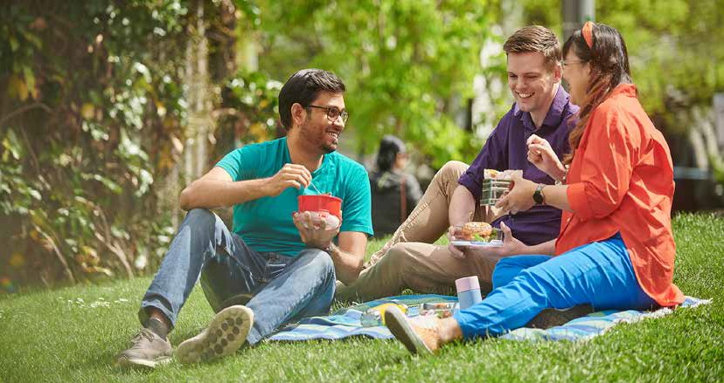
Working with Wellingtonians to take urgent collective climate action
Everyone has a role to play in addressing the climate crisis. Wellingtonians are already working hard to reduce emissions and to adapt to the impacts of climate change, with transformative solutions coming from all parts of the city.
Wellington City Council’s City Activation team was established this year and plans to engage with mana whenua, community, business, social enterprise, and youth to tell their stories and deliver significant carbon reduction initiatives across Te Whanganui-a-Tara.
The emphasis is on creating strong relationships and partnerships to facilitate and accelerate equitable and inclusive climate action at scale. By supporting collaboration and connection, we can transform
commitments made by households, community groups, and businesses into coordinated city-wide activation.
In addition, we have launched two new funding streams in the last year to assist businesses and communities in seizing the opportunity to participate in the creation of a net zero carbon city. These are the Environmental and Accessibility Performance Fund for improving the quality of our buildings and the Climate and Sustainability Fund for community action.

Creating cultural and social change
While the majority want urgent climate action, many are unsure about what needs to be done to significantly reduce everyday emissions. Work is
underway to develop a city-wide education campaign to empower Wellingtonians to take climate action
by identifying what we can do individually and collectively to make a meaningful difference. Over time, the climate action campaign will generate conversations in the community, accelerate social change and shift cultural norms around climate action, creating deep and lasting impact through powerful messaging and community effort.
Supporting this cultural shift are a range of programmes and projects to enable Wellingtonians to shift their behaviour. This work has a current focus on low carbon transport choices, road safety, and waste behaviours, with future plans to focus on food choices and purchasing decisions. Changing how people behave has been recognised for the impact it can
have on reducing emissions; the latest International Panel on Climate Change (IPCC) report estimates that actions to reduce the demand for high-emission goods and services have the potential to reduce greenhouse gas emissions by 40–70% by 2050.

The ecological emergency
Bringing Tākai Here to life
We have been developing our capability to support the climate action efforts and
aspirations of mana whenua in the Wellington region, in order to authentically bring a Te Ao Māori lens to Te Atakura – First to Zero. Climate change is recognised as a key issue for mana whenua Taranaki Whānui ki te Upoko o te
Ika, Te Rūnanga o Te Ātiawa and Ngāti Toa Rangātira. With the signing of Tākai Here, the Council will work towards establishing stronger partnerships with mana whenua on climate action, ensuring the mātauranga of mana whenua is incorporated into our mahi.
Wellington City Council acknowledges the pivotal role mana whenua have and continue to fulfil as kaitiaki over the Wellington region, bringing with them generations of knowledge about caring for te taiao. Our intent is to co- design with and learn from mana whenua and Māori to further our shared aspirations around our climate response.
Council has committed to supporting existing and new environmental initiatives that are led by mana whenua and Māori that will see the restoration of mauri ora to te taiao over the next five years. The Council is upskilling
itself to be a better partner of te Tiriti to mana whenua and coordinating our internal work to support mana whenua in the taiao and climate response space.
Our work is part of a bigger story: the same root causes of the climate crisis are also driving the ecological emergency. How climate change and the interrelated environmental crises interact is becoming better understood and this is being reflected in work across Wellington. There are many threads to this.
Our Natural Capital is Wellington City Council’s biodiversity strategy, and we see the intersection between biodiversity and climate action come
to life in this year’s Green Network Plan and the continued protection and restoration of the city’s parks and reserves. We have set a new target of three million natives planted by 2030, after successfully meeting our target of two million by 2020. This is also supported by work from Zealandia, Predator Free Wellington, and the Wellington Zoo, who
are all global leaders in urban biodiversity and environmental sustainability.
We are working on creating a zero waste city, and we’ve set a goal to reduce the amount of waste going to the Southern Landfill by a third by 2026. Projects are underway to support better waste outcomes including product design and purchasing decisions made by Wellingtonians.

A new approach to economic wellbeing
Responding to the climate and ecological emergencies will require us to reimagine our economic systems.
This year the Council’s Economic Wellbeing Strategy was approved, marking a shift in thinking from economic development to economic wellbeing, delivering a holistic economic strategy to guide a more sustainable, balanced and inclusive economy, and recognising the dynamic complexity of our economy, society and environment. The strategy includes a focus on creating a zero carbon circular economy, which aligns with the Council’s existing zero waste programme and Te Atakura – First to Zero. We have already started work on developing a Doughnut Economics2 framework for Wellington as outlined in the strategy.

- Doughnut Economics asks: what would a sustainable, universally beneficial economy look like? Developed by Oxford economist, Kate Raworth, it has been adopted by cities around the world – see Raworth’s TED talk: https://www.ted.com/talks/kate_raworth_a_ healthy_economy_should_be_designed_to_thrive_not_grow

National leadership is required
Central Government is giving clear signals that local Government has a critical role to play in delivering national climate action locally. What is unclear is how the shifting role of local Government will support
or hinder our ability to deliver on that. Many of the systems, rules, and regulations required for effective climate action are shaped nationally rather than locally. We are committed to using all the levers that we currently have to accelerate climate action in Wellington and will continue to advocate strongly for policies set at a national level that cover the areas that we don’t.
In May 2022 the Government released both the National Emissions Reduction Plan and a draft of the National Adaptation Plan. Council participated in the consultation process for both of these, and expressed our strong view that central Government needs to be more ambitious, more specific about the role of local Government, and assign funding to support local Government to deliver on this role.

Wellington is showing up globally
This has been a big year for global policy, with the IPCC releasing the Working Group III report, which covers global progress on emission reductions
and what is still needed to stay below 1.5 degrees of warming.3 The report highlights the urgency of actions by everyone, while providing detailed
guidance on the most effective emission reduction approaches. At a high level, our climate action plan aligns with the IPCC report recommendations. In the coming year, we will incorporate the findings from the IPCC report into Te Atakura – First to Zero, to ensure we are delivering the most effective climate actions.
New Zealand is often looked to as a leader in some of the ethical and environmental challenges of our time. Our work in Wellington has been recognised for international awards. In 2022 we won the Bloomberg Mayors Challenge – a US$1M global prize
for innovation – and we were finalists for WWF’s One Planet Cities Challenge award. In addition, Wellington was named the number one city worldwide for environmental security in the Economist’s Safe Cities Index 2021.
Wellington continues to be a member of several international initiatives, including the Resilient Cities Network and the Global Covenant of Mayors. In 2021, we joined the Race to Zero pledge, committing to
put inclusive climate action at the centre of all urban decision-making, to create thriving and equitable communities for everyone, to reach net zero by mid- century at the latest, and to report progress annually.

- Climate Change 2022: Mitigation of Climate Change (ipcc.ch)

No matter what,
Embedding climate action into the Council’s work
Not all council officers contribute to our city shaping projects, but every officer has a role to play, and an important contribution to make, in thinking through how climate change intersects with the services they deliver to
the city. This year has seen us further embed climate action into how Council makes decisions and increase the capability and capacity of Council officers to deliver on the goals outlined in Te Atakura – First to Zero.
The Council’s Climate Action Champions Network has grown to over 200 members and is made up of staff from across the Council, responsible for providing climate leadership in their teams, encouraging behaviour change, and providing insight into the development of climate action in their operations.
Our internal climate survey shows an increase in the number of staff who understand how climate action relates to their work, and the contribution they can make.
We have increased reporting requirements in our council papers to ensure decisions are
made in full awareness of their contribution (or not) to our climate change response efforts.
We have launched new internal learning resources and over the next year we will be working with our suppliers on both reporting their emissions to us, and setting science-based targets of their own. We are also in the process of setting a science-based target for Council’s emission reductions, and a comprehensive plan for reaching our target.
we will need to adapt
We are already experiencing impacts from climate change in Wellington, and the severity of those impacts over time will be determined by global efforts to reduce emissions. In the last year, we have made good progress on planning how we will adapt as a
city to those impacts, despite not yet knowing what funding, financing, and regulatory mechanisms will be created through the Climate Change Adaptation Act, which has been delayed to at least 2023.
We’ve started by further developing our understanding of the science and how climate change is impacting and will impact Wellington specifically, and we’ve updated the city’s hazard maps and included them in the proposed District Plan. We’re working across the region to understand what those hazards mean for our communities
and our neighbourhoods. As central Government develops the national response, we’re advocating strongly on behalf of Wellingtonians to ensure funding and regulatory mechanisms are developed to support residents to adapt and to make sure that they understand the needs of communities. Our next steps are to develop specific plans for the most at-risk
communities and to create the Wellington City Council Adaptation Framework and the Wellington Regional Council Adaptation Plan. We will continue listening
to communities, ensuring they have a strong voice in charting our way forward.

Looking forward
Next year we plan to continue our city-shaping work, and provide more support for businesses and communities to accelerate the city’s transition to becoming net zero carbon. This will be based on a
data-driven, deeper understanding of where the most urgent reductions need to be made and where the biggest opportunities lie.

Wellington’s emissions and targets

Wellingtonians have consistently told us they want climate action
Council’s annual Climate Action Monitor survey shows the majority of Wellingtonians said significant action is required straight away.4 But when asked how well they understood what climate actions are needed for Wellington to become a net zero carbon capital by 2050, only 9 percent said they had a good
understanding while 42 percent said they did not have a good understanding. Despite this, evidence shows Wellingtonians are trying to reduce their emissions
in a variety of ways including changing how they move, what they eat, what they buy and by reducing waste that goes into landfill. The city’s targets reflect Wellingtonians’ desire for meaningful change.

Emission Reductions Pathways6

City targets
Cities are estimated to contribute 70% of all CO2 emissions globally, which means they are uniquely positioned to address climate change. Our city targets were set in alignment with national and international commitments to limit global warming to below
1.5 degrees using the One Planet City Challenge science-based methodology.5
The chart below shows the city’s historical emissions, the pathway to reaching our targets, and compares these to what our emissions would be without intervention and with a growing population.
Wellington city’s net greenhouse gas emissions between 2001 and 2020 fell by 7%. Over the same period, the population grew by 24%. Between financial year 2019/2020 and 2021/2022 greenhouse gas emissions fell by a further 9%. These are encouraging trends which show we are on track for reaching our targets. However, this does not reduce the urgency. We need ongoing urgent collective climate action to avoid the worst impacts of climate change.

1,400,000
1,200,000
Gross emissions – CO2e
1,000,000
800,000
600,000
400,000
200,000
0
2001 2005 2010 2015 2020 2025 2030 2035 2040 2045 2050

Gross emissions
Science based target
Business as usual scenario

- When asked how quickly we need to act to reduce Wellington city’s carbon emissions, a combined 90 percent of those surveyed said either significant action was required straight away (54 percent) or that we should start now and increase efforts over the next few years (36 percent). The city’s targets reflect Wellingtonians’ desire for meaningful change.
- Current best practice is to set a science-based target, which is a methodology developed by the Science Based Target Initiative to ensure that each sector of the economy is doing their part, that targets are equitable, and likely to meet the Paris Agreement ambition of limiting global warming to 1.5 degrees. We have used the One Planet City Challenge (OPCC) methodology, as outlined in the SBTi’s City Guidance document. SBTs-for-cities-guide.pdf (sciencebasedtargetsnetwork.org). Note that we used 2018 to set the target in alignment with the methodology, and then re-calculated it to use 2020 as the base year.
- There have been changes to the methodology since the last city inventory (2019/2020). As such, the numbers for 2019/2020 have been updated for consistency and to enable comparison.

Wellington city’s emissions
The graph below provides a breakdown of the city’s emissions, based on the inventory for the year ending 30 June 2022. Total gross emissions for the year were 853,513 tCO2e (carbon dioxide equivalent), with 77% of these coming from the electricity and natural gas used in homes and businesses (building energy), the petrol and diesel we use in our vehicles (road transport), industrial energy use, and waste. These are the areas where we can achieve the greatest reductions over the next decade by changing how we live and move around the city. Previously, we calculated an inventory of the city’s greenhouse gas emissions every three to four years. As of this year, we will be doing it at least every two years.

Wellington city emissions breakdown 2021/22

Production and consumption emissions
Our measurements of the greenhouse gas emissions for the city and our targets focus on emissions directly produced in Wellington city, otherwise known as Scope 1 and 2 emissions.7 This aligns to international best practice guidance for city inventories, and the way national emissions are calculated. But it doesn’t tell the full story. The carbon footprint of our city
also includes consumption emissions, otherwise known as Scope 3, which covers emissions from creating, transporting, selling, using, and disposing of products that we bring in from elsewhere to consume in Wellington. Insights into consumption-based emissions enable cities to develop different strategies and climate actions towards our city-wide efforts.

Waste
8.6%
Otherwaste
0.5%
Wastewater
0.9%
Solid Waste
7.2%

Transport 45.5%
Other transport 1.1%
Marine
5.3%
Aviation
5.1%
Petrol and diesel
34.0%
Industrial Processes and Product Use 7.0%
Agriculture
1.7%

853,513
tCO e

Stationery energy
37.3%
Electricity
18.3%
Natural gas
15.1%
LPG
1.7%
Other
stationary energy
2.2%

- Scope 1 emissions are all the direct emissions from an organisation’s actions or under their control (eg emissions from gas boilers, vehicles, and industrial processes). Scope 2 emissions are indirect emissions from electricity purchased and used by the organisation. Scope 3 emissions are all other indirect emissions from activities of the organisation, occurring from sources that they do not own or control (eg all purchased goods, emissions from suppliers, any travel not in company owned vehicles). Scope 3 are usually the greatest share of the carbon footprint.

Even though our consumption emissions aren’t included in our current targets, we still want to reduce them. Our zero-waste programme of work, for example, includes a focus on enabling Wellingtonians to make different choices when they buy physical things, including through advocating for a transition to a waste-free, circular economy.
Along with other cities around the world, we have been working on a consumption-based emissions inventory for Wellington to better understand where we can have the biggest impact on reducing our consumption emissions. This information can help Wellingtonians and businesses prioritise their climate actions and contribute to our city-wide efforts. The findings, due to be released in early 2023, estimate Wellington city’s consumption using the best available data and rational assumptions
at approximately 1,392,000 tCO2e of emissions in FY2019/2020. This is in addition to the emissions calculated using the production-based methodology for the same time period. The largest categories of emission sources were consumption of food and drink (23%), followed by emissions from Central Government expenditure (12%) and emissions from the investment in residential buildings (11%).

Where reductions will come from
Emission reductions will need to come from everywhere. This includes the Council delivering on its climate action plan, Te Atakura – First to Zero, as well as providing the catalyst for others to take action and contribute ideas. It includes central government policy on decarbonising transport and electricity. And it includes key emitters within the city implementing robust plans for rapid decarbonisation. This highlights the importance of our role in advocating for policy change, the investments we are making to accelerate action, and our role in supporting others to act. The graph below summarises potential sources
of emissions reductions based on proposed, existing, planned and funded initiatives, and modelling from the Climate Change Commission undertaken last year for their advice to government. We will update this as we develop new actions or identify actions that others are taking that will impact on the city’s emissions, including any updated analysis from the Climate Change Commission or central government
on the emissions reduction potential of policy settings outlined in the recently released national emissions reduction plan.

Wellington city Indicative Emissions Path

100% 100% 7%
-3%
-4%
-10%
-6%
-2%
-4%
-36%

80%

60%

40%

20%

0%

2020
baseline

Transport mode shift (Regional)

Electrification of transport (Govt)

Forecasted marine/air increase...

Renewable elec % increase (CCC)

Reduction in natural gas

IPPU
decrase (CCC)

Stationary energy, waste (WCC)

Gap to 2030
(goal)

-43%
Gap to 2050
(goal)

Emmisions

Emmissions cuts

Shortfall to meet goals

Wellington City Council’s emissions
In addition to tracking the city’s emissions, Wellington City Council also tracks its own corporate emissions. We have been measuring the Council’s annual Scope 1 and Scope 2 emissions, as well as a selection of Scope 3 emissions, for many years. From mid-2021, we started measuring Scope 3 emissions from our full value chain, including all our suppliers. This gives us a more complete picture of our emissions.
Measuring the emissions from our entire value chain is in alignment with best practice. By choosing a methodology that gives us the most complete picture of our emissions, it enables us to see the full range of reduction opportunities. However, for some emissions sources, the calculation can only give an approximate picture. For example, some of our supplier categories are calculated based on spend data (ie categorising all expenditure each year) using Motu NZ spend-based emissions factors, so if the cost of something goes
up, that appears as an increase in emissions, and changing suppliers to lower carbon options won’t be

Wellington city emissions breakdown 2021/22
reflected in our data. We plan to transition over time to emissions data provided by our suppliers, as part of our conversation with them on climate action.
To align with our expanded emissions inventory, we are refreshing the Council’s emission reduction plan, building on the plans we already have in place. For example, we are electrifying our fleet of vehicles by 2030, we have an energy reduction strategy and natural gas reduction plan, and we have new technology at the landfill to reduce the impact of the methane produced.
We are also looking at how to reduce emissions in activities outside of our direct control but where we have influence, such as through our purchases, the way we deliver our services, the way we manage our contracts, and our investments.
The below chart breaks down Wellington City Council’s FY22 emissions by source, across Scope 1, 2 & 3. Waste is the biggest component of council’s emissions, which includes all emissions from the Southern Landfill and
the city’s wastewater emissions. This is because we fully own these assets. While this makes WCC’s footprint larger than an otherwise comparable city, it gives us more opportunity to influence emissions from the city’s waste.

Purchased goods and services (Cat 1) 7.9%
Scope 3 – Indirect Value Chain 49.5%
Other scope
0.1%
Investments (Cat 15)
6.5%
Downstream leased assets (Cat 13)
0.9%
Upstream transportation and distribution (Cat 4)
0.7%
Fuel – and energy-related activities (Cat 3)
2.3%
Capital goods (Cat 2)
31%
~180,000
tCO e
Scope 1 – Direct
48.8%
Waste
42.7%
Mobile combustion (Diesel and Petrol) 0.3%
Nat Gas
1.8%
Other
4.0%
Scope 2 – Indirect Electricity Consumed 1.7%

Electricity
1.7%

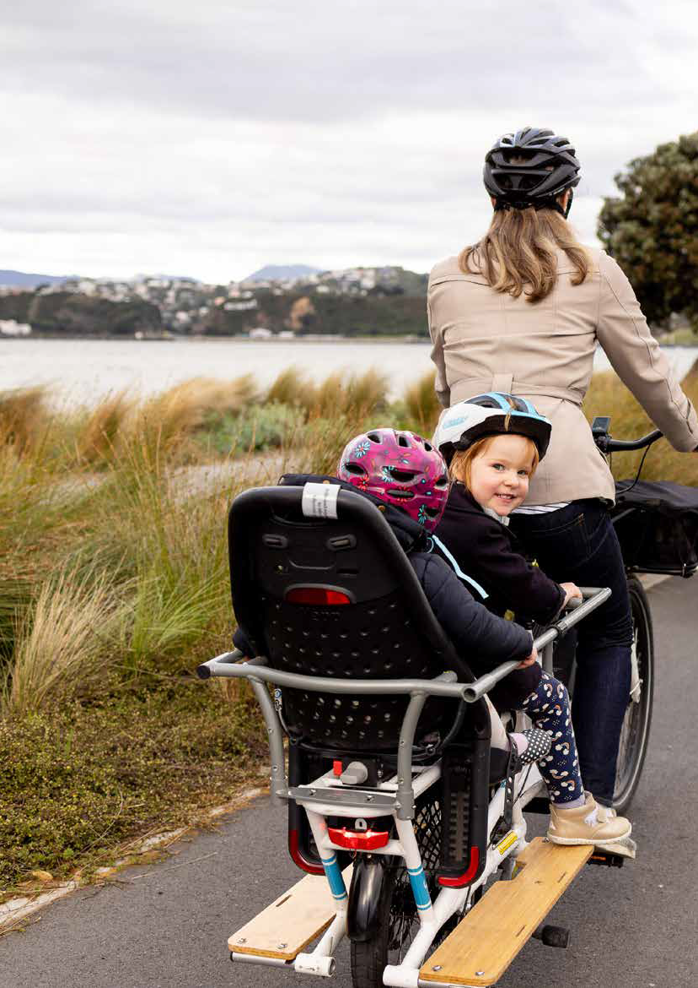
Action areas
to become a net zero carbon city

Te Atakura – First to Zero 2022 Update 13

Action Area: Transport and urban form

How we move around contributes more than a third of the city’s emissions, and the density of the city shapes the options available for low emission living.

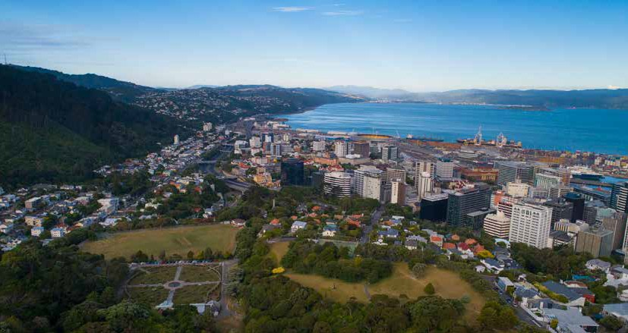
Road transport contributes about 35% of the city’s emissions and is an area where we need to see significant reductions.
The desire for a compact, net zero carbon city has been a consistent message from Wellingtonians through the Planning for Growth programme that is now given regulatory form in the proposed District Plan. Coupled with our work on the transport system, we are delivering climate action that also connects us, and makes it easier and more inviting to get around our city in zero carbon ways.
Central Government has put in place policies like electric vehicle subsidies and scrap-and-replace for high emission vehicles that will facilitate the uptake of low emission vehicles as well as other key recommendations for transport in the National Emission Reduction Plan.

What’s underway

Enabling more housing
The Spatial Plan, adopted last year, was the first significant step in the Planning for Growth
programme, supporting the transformation of the city to accommodate the expected increase in our population in medium to high density housing. The proposed District Plan grounds these principles into regulation – the draft District Plan was consulted on this financial year, and the resulting proposed District Plan will be formally consulted on and adopted in FY23. The plan will allow more people who want to, to live centrally. When combined with higher levels of public transport delivered by Greater Wellington Regional Council and Let’s Get Wellington Moving, this will reduce travel distances, increase public transport use and active transport (walking and cycling), and reduce city emissions.

Let’s Get Wellington Moving
Let’s Get Wellington Moving (LGWM) is central to the Council’s work to reduce transport emissions, simultaneously delivering improved liveability, accessibility, safety, and resilience. Through investments in mass rapid transit and improvement of public and active transport, LGWM will provide the infrastructure to move more people with fewer vehicles, enabling the development of more housing, and lowering emissions from transport.
The programme has reached several milestones this year. Due to the potential for new housing and neighbourhood growth, Government selected the southern light rail option as preferred. The People-
friendly City Streets programme has started pedestrian improvements across the central city to ensure safer, quicker, and easier walking facilities, as well as identifying projects to improve connections for people on bikes, buses, or walking on 19 key routes between the central city and suburban centres. It also initiated the Johnsonville/Ngā Ūranga Improvement Project, which aims to give buses priority at key intersections and ensure safer separation for cyclists and pedestrians from State Highway 1 traffic. The Golden Mile transformation
project’s detailed design was shared publicly in July 2022 and will go through the traffic resolutions process prior to starting construction in 2023. In addition, consultation on the Thorndon Quay & Hutt Road Improvement Project ended in December 2022. Both projects are likely to significantly improve walking, cycling and public transport facilities in the city.
A variety of other improvements are being planned, including a new roundabout for Aotea Quay and a new crossing on Cobham Drive, which has started construction. Incentives for low carbon travel are being explored, including pricing mechanisms such as a commuter parking levy or congestion pricing.

Changing travel habits
Supporting a shift from high emission transport options (eg cars, vans, trucks) to low emission (eg buses, walking, cycling, car share) starts with providing better infrastructure. We also need to address other barriers that get in the way of people accessing active and
public transport. Wellington City Council has adopted a sustainable transport hierarchy, which prioritises moving by walking, cycling, and public transport,
so that our city’s streets work better for everyone.

Sustainable Transport Hierarchy

Walking
Cycling & micro-mobility
(shared e-scooter, e-bikes, e-mopeds)

Public transport
(trains, buses, light rail, ferries)
Delivery vehicles
Car sharing and pool vehicles
Rideshare and taxis
Private vehicles & motorcycles
Aircraft

Paneke Pōneke
Our bike network plan, Paneke Pōneke, is creating a citywide network of connected bike routes in
tandem with walking improvements and big public transport changes. We are rapidly rolling out interim routes across Wellington, and over time we will make permanent changes to the routes following feedback from people who use them. Changes are underway on a number of routes, including upgrading The Parade in Island Bay to increase safety, and Newtown to the city, rolling out an adaptable new street layout on part of Riddiford Street, Adelaide Road, and Cambridge and Kent terraces to the waterfront. More work is planned over the next year, including the Botanic Garden ki Paekākā to the city, Brooklyn hill, and further improvements on the South Coast to the
City route.

Car sharing
Car sharing enables short-term access to a private vehicle so residents can have access to a car when they need it without owning one themselves. We are working in partnership with car share operators to grow their popularity and use by Wellingtonians. Memberships of Cityhop and Mevo have doubled over the last year, with 25,000 membership accounts registered.

Charged-up Capital
In response to increased demand for electric vehicle charging facilities, the Council plans to provide 60 more fast chargers (25kW) over the next four years, in partnership with EECA and Meridian, resulting in a comprehensive network at council-owned facilities
like community centres, parks and sports grounds. By 2023, seven new chargers on five different sites will be installed. This programme of work is essential given Wellington’s increasing enthusiasm for electric cars
– the number of new electric vehicle registrations has tripled this year, and the share of electric cars in the city’s passenger fleet has increased from 1.7% to 5.5%.

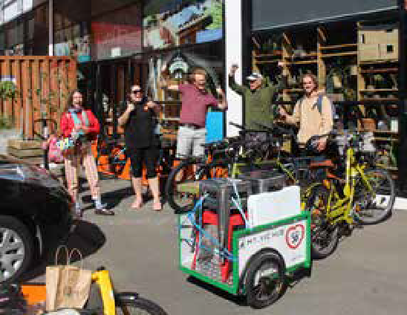

Workplace Travel Planning
Starting this year, we have a dedicated member of staff helping businesses and organisations make it easier for staff to walk, bike or get to work in more active ways through workplace travel planning. These plans can then receive financial support through the Active Workplace Travel Fund. Launched in 2020, there is
$50,000 of funding available each year, and to date, seven businesses and organisations have made changes for their staff.

e-Scooters
Wellington has licenced Beam and Flamingo to operate a total of 800 e-scooters around the city until March 2024. The number of trips being taken on public e-scooters continues to rise. The average number of daily trips taken between 1 February and 25 June in 2021 and 2022, has risen by 31%. During the weekday morning and afternoon peaks, more
than 30% of all trips taken begin or end at the railway station, indicating e-scooters provide a good link to public transport in Wellington.

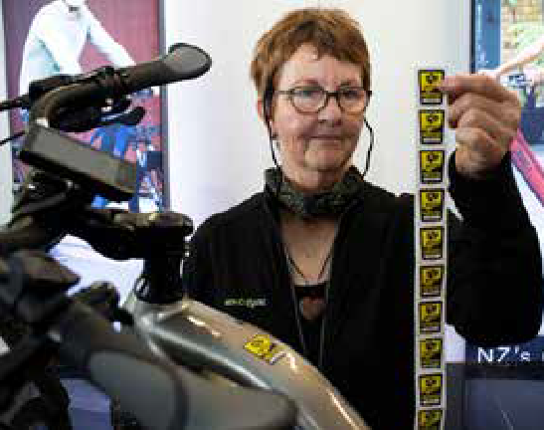What else is planned

529 Garage
With the risk of bike theft a real deterrent to would-be cyclists, we are working across the region to deter would-be thieves. We are working to implement 529 Garage, a community-driven, free-to-the-public bike registry and recovery service. With nearly 8,000 bikes registered in New Zealand as of June 2022, the initiative has been embraced by the cycling community. In Vancouver, where 529 Garage was founded, bike theft
numbers dropped by 40% over four years, an encouraging success story we are hoping to replicate here to keep cyclists on their bikes.

Wellington Central City Green Network Plan
The Green Network Plan sets the direction and targets for how we increase green space in Wellington’s central city in the next 10 years. The plan addresses the current lack of green spaces, provides for growth and addresses the climate and ecological emergency declared by the Council in 2019.
The plan’s targets are to double the number of trees from 2,000 to 4,000, improve the greening of 20 existing spaces, and deliver two new urban parks. This will boost our climate efforts by capturing carbon dioxide, as well as make the city more resilient to the impacts of climate change through reducing stormwater runoff and their cooling effect.

Key indicators of change

Indicators | 2021  (as at 30 June) | 2022  (as at 30 June)
Car sharing – total members | 12,955 | 25,308
Electric vehicles – total charge points | 34 | 39
Residential street chargers | 28 | 31
Fast charges | 6 | 88
Total no vehicles registered in Wellington | 28,005 | 23,589
Total battery EVs registered in Wellington | 474 | 1,311
% of battery EVs of all vehicle Registrations in Wellington | 1.7% | 5.5%
Cycleways – in kms | 38.3 | 39.5
Note: in the Te Atakura – First to Zero 2021 Update there was data on the mode of transport people used to travel into the CBD during peak times. This data wasn’t captured for 2022 due to COVID-19 restrictions so it has been omitted, but equivalent measures are being reinstated for 2023.

- We note that a few of these chargers are not currently operational at the time of publication due to COVID-19 related supply chain disruption making repairs more challenging.

Action Area: Building energy

Building energy is a key focus area of Te Atakura – First to Zero as stationary energy accounts for around 35% of Wellington city’s total carbon emissions through the consumption of electricity and natural gas.

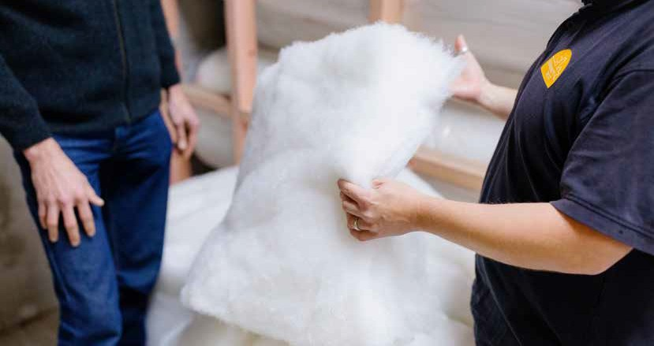
Wellington City Council administers the Building Act but has no local powers to require an improved standard that would reduce energy consumption across Wellington’s building stock. We continue
to advocate for stronger policy settings, and we participate in MBIE’s Building for Climate Change programme of work, and then locally, our focus is on incentivising better practices.

What’s underway

Home Energy Saver expansion
Home energy efficiency assessments provide valuable opportunities for Wellington households to access free and trusted advice and make good
investments to create healthier, more energy efficient and lower carbon homes. Over the last financial
year, Sustainability Trust delivered close to 700 assessments. This was lower than our target of 1400 homes, as COVID-19 significantly disrupted both the willingness of homeowners to have assessors do site visits, and the availability of staff to do
the assessments. Around 13,645 homes have been assessed since 2014.

Warmer Kiwi Homes
In the last financial year, Sustainability Trust delivered over 70 home insulation upgrades supported by the Council as part of the EECA Warmer Kiwi Homes initiative. We will continue to support this programme in the coming year and look to broaden support for heat pump installation. Around 9,000 Wellington homes have received insulation through the programme since 2011.

What else is planned

Business Energy Saver pilot
We will be engaging with businesses in Wellington to understand the barriers faced in climate action,
particularly reducing reliance on fossil fuels. The pilot scheme will be co-designed with key stakeholders prior to an open tender following a formal procurement plan.

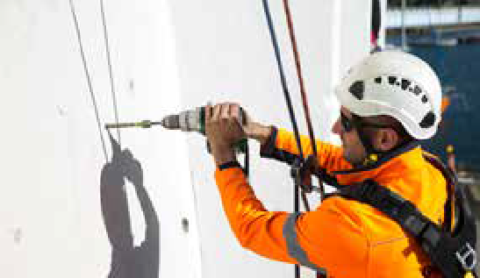Supporting building sustainability improvements

Environmental and Accessibility Performance Fund
The Environmental and Accessibility Performance (EAP) Fund was approved during the 2022/23 Annual Plan process and replaces the previous policy of offering a 50% remission on development contributions.
This provides greater flexibility to achieve the outcomes councillors identified as important to Wellingtonians, and certainty of how much funding is available. The fund will provide up to $20M over the next seven years to commercial and residential developments across new and retrofitted buildings that achieve a green building certificate and/
or accessible design certification, with the improvement of residential developments a key focus.
In addition to creating a new fund for new and existing buildings to achieve overall ‘green building’ certificates, the Council will also explore ways to support smaller scale environmental improvements across the existing building sector. This will be focused on energy-efficiency improvements and natural gas displacement for small to medium sized buildings that don’t meet criteria for large-scale funding from the Energy Efficiency and Conservation Authority (EECA).

Key indicators of change

Indicators | 2021  (as at 30 June) | 2022  (as at 30 June)
Home Energy Saver – # of Wellington homes audited | 12,955 | 13,645
Home Energy Saver – % of Wellington homes audited9 | 16% | 17%
Warmer Kiwi Homes – total homes insulated since 2011 | 9,197 | 9,197

- 81,003 dwellings as per 2018 census.

Action Area: City-wide initiatives

Te Atakura – First to Zero blueprint included a number of enabling actions where the Council can support or partner with others to foster innovation and drive climate action within the community.

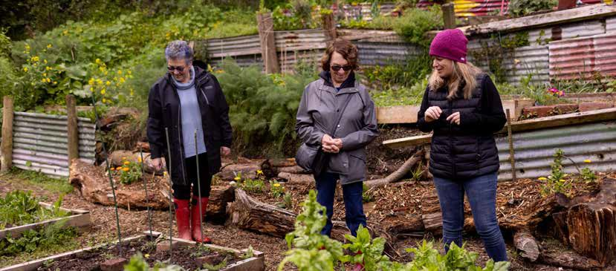
In addition to running several projects to enable more participation by businesses and residents, over the past year the Council has positioned itself to better support the city in taking the highest impact actions and the creation of further funding to harness these efforts.

What’s underway

City activation
While local and central Government policy settings are essential, there is a significant amount of carbon reduction that can only be executed by businesses, community groups, and the broader city. A new City Activation team has been created in the Climate Change Response business unit, building on the insights from the co-design work with stakeholders during the investigation of the Climate Lab idea, and absorbing the Zero Carbon Challenge and Climathon initiatives. The focus of this team is on working in partnership with others to create transformation, not tweaks, resulting in significant emissions reductions in the next eight years, taking a social equity and
mana whenua lens. The team is beginning storytelling, mapping, and connecting activities this year.

Sustainable Food Programme
The Sustainable Food Programme covers several projects. This includes Food Future, the city’s food systems action plan, which will be published later this year and will provide the roadmap for a sustainable food system in Te Whanganui-a-Tara. As a ‘living document’ its priorities will be reviewed every three years. At this stage, focus is on developing a sustainable food procurement approach for Council, activating community gardens as sustainable food learning hubs and implementing a composting hubs trial.

Accelerating opportunities to support carbon farming
With the aim of establishing new native forests and expanding carbon sinks in the outer green belt, the Council formed a partnership with Te Herenga Waka
— Victoria University of Wellington in December 2020. Under that partnership, the Council leased an 11-hectare parcel of land for 33 years to the university, and they expect to plant up to 28,000 trees on the site. In the past year, a total of 2,400 trees were planted over three days with the help of university students, staff, and alumni as volunteer planters. The site is providing teaching opportunities for under- graduate course work and summer scholarships, and is the subject of a research project investigating the
effectiveness of mānuka and kānuka as nursery crops.

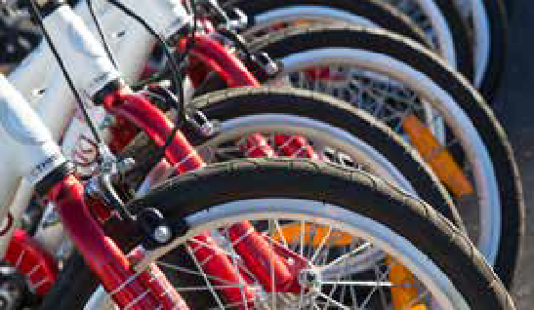What else is planned

Climate and Sustainability Fund launched
The Climate and Sustainability Fund was launched in early 2022 to boost climate action across our community. With a budget of
$250,000 per year for five years, it has funded six climate initiatives across Wellington
in its first year, including a sustainability “bootcamp” for Wellington businesses run by the Chamber of Commerce, an app to help Wellingtonians successfully grow food at home and track associated carbon benefits, a climate action planning programme by local church communities, an investigation of how to store e-bikes at home and work, a cargo
e-bike trials programme, a rent-to-own e-bike programme for low income households (by ReBicycle), and a contribution to Sustainability Trust to deliver climate action education for both locals and visitors to Wellington. The next round for the fund is in October, and we are working on establishing a pipeline of potential applications that meet the priorities of the fund, including initiatives that are delivered
by or in partnership with mana whenua and Māori organisations.

Te Atakura action investigations
Actions identified in Te Atakura – First to Zero implementation plan, even when combined with the work of Let’s Get Wellington Moving and policy changes by central Government, are not enough for Wellington city to meet its carbon reduction targets.
Additional actions are required to meet this shortfall and deliver the urgent, significant, and at-scale reductions needed by 2030, and in the following two decades. As we examine the past two years’ emissions data for the Council and the City, we are developing a clearer picture of where the most urgent emission cuts will be needed, and where the greatest opportunities are. A dedicated funding stream has been approved over the next two years to support the development
of new ideas for city reductions.

Zero Together
Zero Together, the new name for the Future Living Skills programme, will be launched in February 2023 with the theme of ‘Everyday actions for a better climate future’. The new name reflects changes in the programme to strengthen the focus on climate action and alignment with Te Atakura – First to Zero. Zero Together supports Wellingtonians to make smart, affordable, and lower- carbon household choices. The programme strongly complements current carbon and waste reduction efforts in Wellington, helps harness the growing demand by residents to take action on climate change, and builds a sense of community amongst participants.

Key indicators of change

Indicators | 2021  (as at 30 June) | 2022  (as at 30 June)
Total funding disbursed by the Climate and Sustainability Fund | Not measured | $250,000
Number of projects funded | Not measured | 6
Number of trees planted | Not measured | 2,400
tCO2e sequestered annually in Council owned forestry (measured in carbon credits granted) | 932 | 67410

- Some radiata pine trees were harvested to prevent illegal track building and further damage to the forest.

Action Area: The Council itself

The Council has set a target to reduce all emissions under our direct control to net zero by 2050.

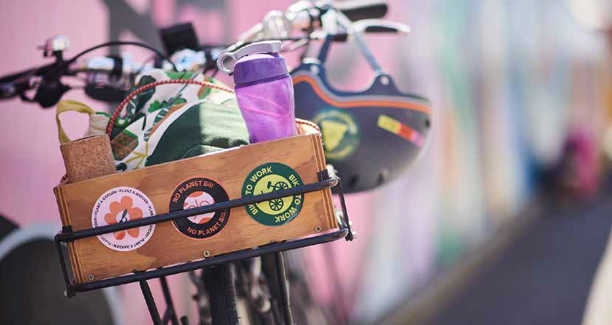
The Council has pursued several emissions reduction projects over the past two decades. Moving forward, the opportunity is to use our large external spend to influence suppliers both to understand and report on their carbon footprint and to set and achieve science- based reduction targets.
To enable this, we’ve undergone a business process and software transformation project to enable us to increase visibility of the emissions from our entire value chain. We are also moving to monthly data collection for a broader range of emissions sources, which will give greater insight into carbon reduction opportunities.
In FY22, WCC’s emissions were approximately 180,000 tonnes of CO2e. The breakdown can be found on page 12. This includes the emissions of all council controlled organisations. This was made up of 87,747 tonnes of Scope 1 emissions, 2,719 tonnes of Scope 2 emissions, and 89,052 tonnes of Scope 3 emissions. The largest source was waste, making up 46.7%
and including all emissions from Southern Landfill and the city’s waste water. This is categorised as Scope 1 for WCC because Southern Landfill is wholly owned by Council, even though it includes all of the city’s waste. The next largest category was heavy construction, which is a scope 3 emission source, making up 30.7%.
Work is underway to write our council emissions reduction plan. This plan pulls together our existing work in the energy management strategy, the zero- waste programme, and our climate smart buildings and infrastructure policy, as well as new activities such as supplier engagement initiatives.
The Council’s emissions reduction plan will also be an opportunity to identify other reduction initiatives and to engage a broader range of Council officers in understanding their business unit carbon emissions and how they can, through their role, deliver climate action for the Council and the city.

What’s underway

Council greenhouse gas emissions measurement
We are committed to reducing the Council’s climate change impacts. As outlined in the introduction, from mid-2021, we started measuring the Scope 3 emissions from our full value chain, including all of our suppliers. This has given us a more complete picture of our emissions. This data will form the baseline for developing a corporate emissions reduction plan for Wellington City Council.
In line with the National Emissions Reduction Plan, our procurement policies have the potential to incentivise our suppliers to meet their own carbon emission reduction goals.

Laying the foundations for a zero-waste city
Methane emissions from our landfill makes up around half of Council emissions, and 7.5% of the city’s total emissions. It also plays a central role in the wider ecological emergency, through its role in pollution and resource use. With a regional target of reducing waste to landfill by one third by 2026, the next few years will require a transformational change in how we deal with waste in our city.
In 2022, we launched the Zero Waste Programme.
Key projects include rethinking rubbish and recycling collection, an investigation of resource recovery network expansion, the future of the Southern Landfill and options for managing our residual waste, and the delivery of the sludge minimisation facility.
Alongside this strategic work, our waste minimisation team continues to implement behaviour change initiatives including education, campaigns and advocacy, driving the shift towards a circular economy where the focus is on eliminating waste
by reusing, recycling, refurbishing, and extending product lifespans.
At the Southern Landfill, a new partnership has led to improvements in the capture of landfill gas, lowering our emissions and climate impact, with the site producing enough electricity to power around 1,233 homes annually.

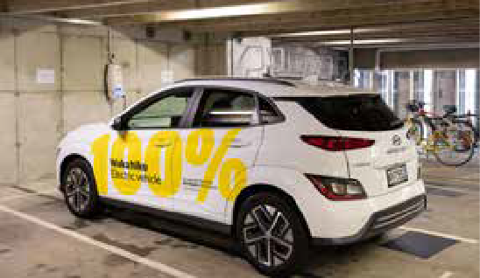

EV First Fleet
The goal of this project is to replace all fossil fuel light passenger vehicles in the Council’s fleet with electric vehicles by 2025 and all SUVs, vans, and utes by 2030. We now have 40 EVs in our fleet, with more electric-powered replacements and a reduction of the overall fleet planned.
These waka hiko are easy to spot around the city with their 100% electric branding.

Energy Management Strategy and Plan
The Energy Management Strategy focuses on improving our energy efficiency and removing natural gas use from our facilities, as planned over the next five years. We will be working with the key stakeholders to identify and overcome potential barriers during the transition.

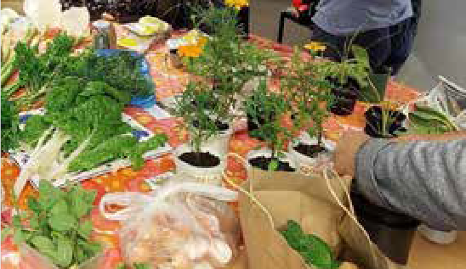Āhuarangi Whaiwhakaaro – Climate smart building and infrastructure policy
This policy is intended to apply to new and refurbished council buildings and civil works (footpaths, roads, etc), and complements the Energy Management Strategy and Plan, which covers existing council buildings. This policy will improve energy efficiency and reduce environmental impacts in the construction, operation, and maintenance of all municipal buildings and infrastructure. An additional benefit is that
the Council will lead by example and inspire the community and the design and development sector to undertake climate-smart actions as we wait for building code reforms as part of MBIE’s Building for
Climate Change programme of work. By the end of this year, we expect to finish the policy work and develop
a technical guidance document to enable this policy to be delivered on individual projects11.
As an early example of what this looks like in practice, we have incorporated improved energy efficiency standards into our Te Kāinga affordable housing programme, and the library rebuild project will be certified to a Green Star 5 standard. The intention of this policy, however, is to move from a project-by- project approach to an agreed set of guidelines that will set a consistent standard for our vertical and horizontal infrastructure projects.

Para Kai: Organics collection trial
When food waste ends up in a landfill it releases more methane than if it decomposed naturally in the likes of a compost bin, so a project called the Para Kai Trial
compared different options for households to reduce the amount of food waste they send to landfill each year.
From September 2020 to March 2022, 500 households trialled a weekly kerbside food waste collection service, while another 450 households composted their food waste in either a compost bin, worm farm, or bokashi system. The audit results showed a 38.8% reduction
in food waste going to landfill for the households with the weekly collection service. For the households participating in the home composting trial, this dropped to a 16.4% reduction. These results, alongside the survey responses, will feed into the Council’s review of kerbside collection services.

- This will incorporate what was identified in the previous Te Atakura update as ‘Greenstar and Homestar for buildings – Environmentally Sustainable Asset Policy’, and ‘NABERSNZ for WCC Buildings’ projects.

City Housing
City Housing is delivering on a range of climate-related projects in the areas of food, transport, and buildings. These projects seek to centre tenants’ voices and priorities.
Tenants have been taking the lead on food- related projects, receiving and distributing quality surplus food within their communities, developing their communal māra kai (community gardens), and planting fruit
trees in City Housing green spaces. A recent workshop, in collaboration with Kaicycle and Sustainability Trust, focused on composting. Tenant gardeners learnt more about utilising their food scraps to capture carbon and build healthy, biodiverse soils for growing more good food. Tenant transport is another area of work, with more bike racks being installed and car sharing options being explored.
Another major focus area has been on buildings. City Housing contributed to the draft Climate Smart Buildings and Infrastructure Policy and will ensure all construction tenders have climate change requirements, including the minimisation of construction waste. We
are also exploring other construction methods to reduce carbon emissions and help alleviate energy poverty. In addition, 30% of the Council’s 1,900 homes have been upgraded to Healthy Homes standards, with the remaining homes on track for upgrade by July 2024. The Council is also contributing to a five-year research project, Public Housing and Urban Regeneration: Maximising Wellbeing.
These projects have benefits to tenants beyond climate impact, such as improving wellbeing, health outcomes and community connection.

What else is planned

Council Emissions Reduction Plan
A corporate emissions reduction plan for Wellington City Council is underway. This will guide the Council’s work to reduce its own emissions over the coming years. This process will also include a review of possible interim emissions targets and carbon budgets for the Council.

Sewage sludge solution
Improving our treatment of Wellington’s sewage sludge by-products will enable us to reduce methane emissions at Southern Landfill. Sludge (solids produced from the wastewater treatment process) must be mixed with solid general waste for disposal in the landfill. Adopting new sludge processing technologies will remove this mixing requirement, allowing us to reduce the quantity of waste we need to accept at the landfill. A new sludge treatment plant is planned for construction by June 2026, which will reduce the mass of the sludge by over 80%. The plant design is being developed, and funding arrangements will be confirmed in December. In parallel, the Council is exploring options with iwi and community stakeholders to divert the treated sludge from
landfill for other uses.

Procurement – Better Outcomes
The Commercial Partnerships team is updating the Council’s procurement policy and procedures, and contract management framework and publishing the broader outcomes strategy. Collectively, the commercial function at Council will become more outcomes focused, and better aligned with critical strategic commitments like Te Atakura – First to Zero and Tūpiki Ora. The intention is that climate, sustainability, and social outcomes will be centred in commercial decision-making.

Hybrid Working
Supporting hybrid working options not only gives people more flexibility on how they integrate work with the rest of their lives, it also has significant impact on the Council’s indirect transport-related emissions. The Council’s updated flexible working programme celebrates different work styles, lifting the boundaries for how staff create a balanced, motivated, innovative and productive team. This programme supports flexible schedules, location of work, roles, and leave needs. In response to an
increase in people choosing to work from home and a growth in the Council’s overall staffing, a hybrid working strategy will support people to work in diverse ways and locations, while also enabling
the effective, efficient management of corporate accommodation at Tahiwi and Kai Ūpoko.

Key indicators of change

Indicators | 2021  (as at 30 June) | 2022  (as at 30 June)
Waste – annual landfilled rubbish – in tonnes | 89,287 | 85,135
Waste – diverted from landfill – in tonnes | 18,174 | 17,17912
Green waste – in tonnes | 5,482 | 5,295
Commercial food waste (Kai to compost) – in tonnes | 1,521 | 1,201
Recycling – in tonnes | 10,568 | 10,232
Tip Shop removal – in tonnes | 19 | 4413
Scrap metal – in tonnes | 557 | 531
Hazardous waste – in tonnes | 29 | 30
EVs in WCC fleet | 6% | 12%

- COVID-19 generated stoppages in glass recycling at several points over the year.
- Closed during COVID-19 in August and closed Mon-Fri in June/July for Transfer station roof repairs.

Action Area: Advocacy

We have little influence over many areas of our emissions profile, and that is where we require central Government action and partnership to meet our city target.

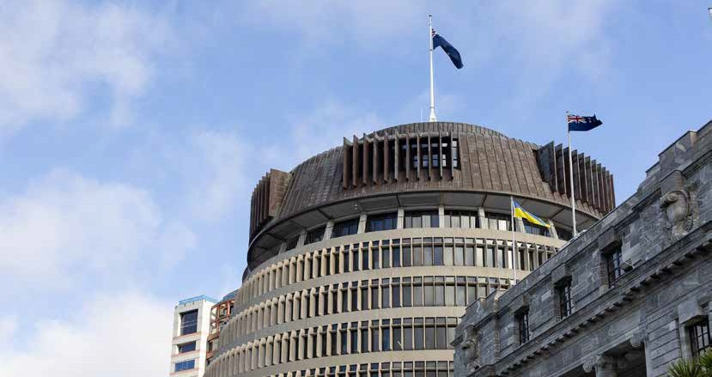
This past year saw the much-anticipated release of the Government’s National Emissions Reduction Plan, as well as other more targeted policies and guidance relating to climate change. Below is a summary of the central Government context and how it relates to
Te Atakura – First to Zero, and to Wellingtonians.

National Emissions Reduction Plan
The National Emissions Reduction Plan, released in May 2022, provided the Government’s response to the recommendations of the Climate Change Commission. The plan confirms the emissions
budgets for the next 15 years as well as the actions that will be taken to reduce emissions. With actions across all sectors of the economy as well as system level changes, the plan has significant implications for the success of Te Atakura – First to Zero.
The plan sets out a clear expectation that the Government will work in partnership with Māori to deliver climate action, will empower Māori to deliver their own solutions, and will ensure mātauranga Māori (traditional knowledge) informs learning and decisions. Working in partnership with mana whenua
Taranaki Whānui ki te Upoko o te Ika, Te Rūnanga o Te Ātiawa, and Ngāti Toa Rangātira is a priority for the Council. The actions from the plan will help to support this.
The emissions budgets are roughly the same as those recommended by the Climate Change Commission, with the initial emissions budget period (2022 to 2025) laying the foundations for action in subsequent budgets. However, both the overall budgets and
the decision to push many of the emission reducing activities into future years don’t align with the level of ambition Council was seeking, and several aspects Council advocated for through its submission to the Climate Change Commission are still areas where we will need to continue to push for change.

Expected impact of the first emissions reduction plan on emissions over the first three emissions budgets

80

Emissions budget 3

Emissions budget 2

Emissions budget 1

70

60

50
Emissions (Mt CO2-e)

40

30

20

10

0
2019
2020
2021
2022
2023
2024
2025
2026
2027
2028
2029
2030
2031
2032
2033
2034
2035
2036
2037
2038
2039
2040
2041
2042
2043
2044
2045
2046
2047
2048
2049
2050

Historical emissions
Baseline projected emissions
Emissions budgets

Emissions level with policy (high policy impact) Additional emmisions under low policy impact

Transport
To encourage active modes of transport, we have advocated for the ability to adopt quick changes to streets, enabling the trial of low-cost interventions. The plan supports this with actions that specifically incentivise this approach, and the Government will consider regulatory changes to enable this. The Plan also provides support for electric bikes, a mode of active transport that we recognise has the greatest potential to displace private vehicle travel.
To encourage people out of cars, we need to be able to use a range of pricing tools such as congestion charging and parking fees alongside other incentives. The plan provides no certainty that these will be made available to local authorities.
Te Atakura – First to Zero recognises that for climate solutions to be successful, they also need to be accessible and affordable. The transport section of the plan specifically recognises this with actions to ensure there are travel choices for those that may be disadvantaged.

Energy
The Emissions Reduction Plan confirms the Government policy support for increasing renewable generation (wind, hydro, solar, and geothermal) as well as ensuring the system and market can support high levels of renewables. A high proportion of renewable electricity is key to reducing energy-related emissions within Wellington.
There is also a commitment to updating regulatory settings in the electricity distribution sector to support the transition to a low-emissions economy. This goes some way to addressing concerns we have about the capacity of the electricity distribution network to meet the increased growth in electricity demand from electric vehicles, heat pumps, and transitions away from gas.
We have also raised the challenges our small and medium businesses face when planning to reduce emissions from their operations by switching from gas to electricity, for example. The Government has responded with new grant funding aimed at allowing a broader segment of the business community to shift to lower emission operations.

Buildings
The Council has been proactive in engaging with Government to seek changes that will enable healthier, warmer, and lower emission buildings.
Several key changes are already underway to improve the energy performance of new buildings, including the Building for Climate Change programme and proposed changes to the Building Code. The Emissions Reduction Plan has confirmed these actions and places a strong focus on existing buildings with the introduction of mandatory energy performance certificates, a commitment to consider how building retrofits can be increased, and options to expand the Warmer Kiwi Homes programme.
Alongside improvements in efficiency, the Council also sought a date by which there would be no more new gas connections, enabling developers and network providers to prepare for this. The Government has instead opted to develop a gas transition plan for the whole gas industry.
The Council has been active in pushing for changes in the Building Code by demonstrating how a climate smart building policy and targeted funding (such as the launch of the Environmental and Accessibility Performance Fund) can drive the inclusion of sustainability criteria in new and retrofitted buildings.

Waste
The Government has put in place key improvements to the waste system in the last year with increases in the cost of sending waste to landfill (via the waste levy) and the expansion of product stewardship schemes.
The Council’s submission to the Climate Change Commission sought greater focus on the waste streams and practices that produce emissions. The Emissions Reduction Plan addresses this with a focus on reducing organic waste (food and garden waste) and diverting organic waste from landfills, with a similar approach to construction and demolition waste.
Funding, resources, and support are included in the plan to help improve kerbside collection of organic waste and ensure the appropriate infrastructure is in place to recover and process food and garden waste.

Future advocacy areas
Throughout the Emissions Reduction Plan, there are references to plans and strategies that are still to be developed, and there are aspects that still need to be funded. We will be actively engaging with the appropriate Government departments on these aspects. We will also continue to advocate for a number of policy areas that were not adequately addressed in the plan, including:
- A ban on fossil-fuelled vehicles
- A set date for ending new natural gas connections
- Congestion charging and other pricing tools
- Public transport subsidies and investments
- Building performance certificates for residential buildings

Regional emissions reduction
Through the Wellington Leadership Committee,
we are contributing to the development of a regional emissions reduction plan. This is expected to help shape the other regional workstreams, including the Regional Growth Framework.

Action areas to adapt to the impacts of
climate change

In the Te Atakura – First to Zero 2021 Update, we committed to an increased focus on adaptation, and since then there has been rapid progress on several new initiatives and the development of a forward programme of work. This builds on the Council’s Resilience Strategy and updated research to better understand the risks and hazards associated with climate change locally.
As a community, we need to come together to decide where and how we will grow as a city, and how best to live with our changing environment.
Next steps involve working alongside other local authorities and mana whenua in the region and giving feedback on central Government policy to guide a consistent approach to adaptation. At the same time, many impacts will be specific to particular areas, so our plans need to take into consideration the different needs of different communities within our city as well as the work happening regionally and nationally. Adaptation plans need to be dynamic to respond as the climate risks increase.

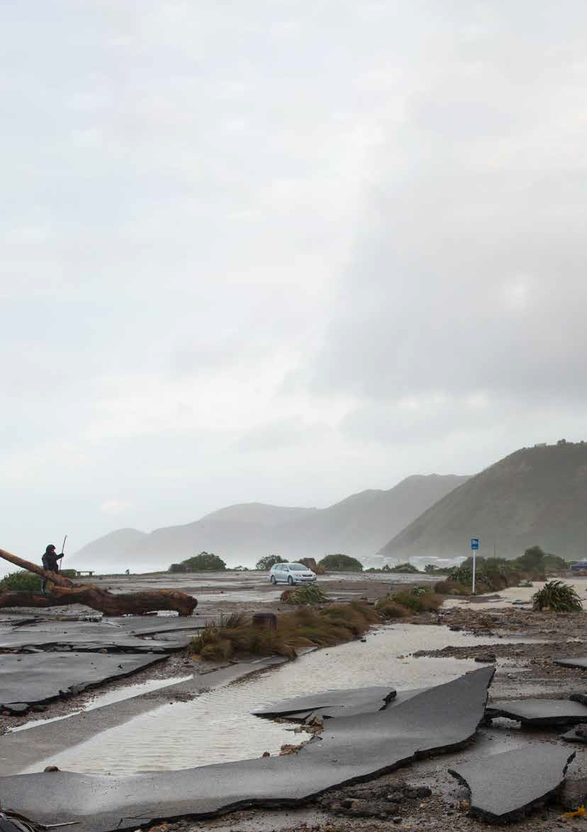

Te Atakura – First to Zero 2022 Update 29

Action Area: Understanding the problem

Rapid progress has been made on global forecasts of how climate change will play out. We need to understand how those impacts translate locally so we can make well-informed decisions on how to adapt to our changing environment.

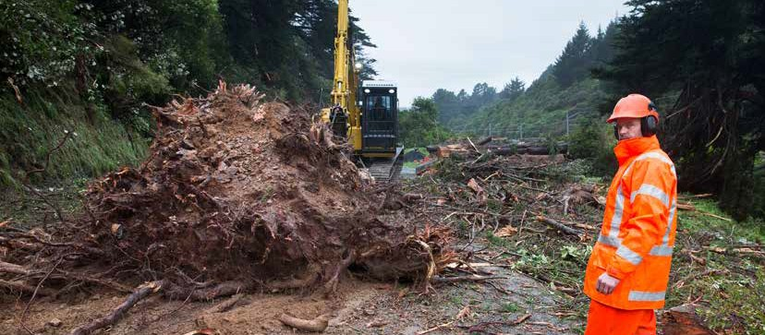
We are developing a detailed picture of how climate change will affect the city and the way it functions as well as the likely impacts on people. By having a science-based understanding of the problem, we can
build a robust evidence base for our decisions on how to adapt to these changes.

What’s underway

Updating hazard maps with current adaptation projections
Climate impacts can be highly localised. Wellington’s hazard maps are an important tool for empowering Wellingtonians to make decisions based on the
most granular information available and ensure that the risks can be incorporated into our planning documents as accurately as possible. These risks are
being considered and applied to our spatial planning and growth projections for the city. In the lead up
to the 2022 proposed District Plan, the hazard maps were updated using NIWA data. The proposed District Plan includes a new risk-based approach to managing development across the city based on hazard and climate change risks.

What else is planned

Understanding the implications
The Council is leading the first phase of one of the Wellington Regional Leadership Committee’s projects
– the delivery of a comprehensive climate change impact assessment on behalf of nine councils in the Wellington region, in partnership with central Government and mana whenua.
This assessment is the first step in delivering on council-level and regional-scale climate adaptation plans. The assessment will be one of the country’s most complex and comprehensive assessments of nationwide impacts. We are working with many of New Zealand’s top experts from Beca, NIWA, GNS Science, and Te Herenga Waka — Victoria University of Wellington to deliver an assessment of the projected impacts over the next 100 years on our development activities, natural ecosystems, physical assets and infrastructure, the economy and community— including human health, safety and well-being—
and cultural life and identity.
This will create a robust scientific evidence base for the impacts of climate change on council property, infrastructure, and council services as well as the impact on communities in general, and will feed into the development of the Wellington Regional Climate Adaptation Plan.

Action Area: Contributing to, and understanding, central Government policy

To be equitable and effective, local adaptation work needs to be funded consistently and equitably across the country and across communities, with clear guidance on whether the costs will fall on individuals, communities, or be spread out nationally.

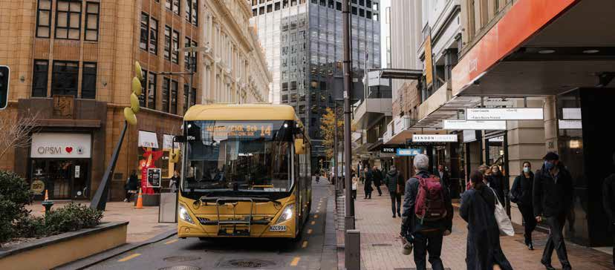
Unfortunately, the current central Government framework does not enable that. Central Government knows this, but the promised response has not
yet been delivered, even though climate change is impacting communities now. Communities need clarity on where decision-making authority lies and who will bear the cost. We need flexible funding, financing, and regulatory mechanisms.
Central Government is planning significant changes to the legal and policy framework to support adaptation to the impacts of climate change in
New Zealand. The most significant of these is the replacement of the Resource Management Act (1991) with three new laws, and the Government has indicated that one of these, the Climate Adaptation Act, will be introduced in 2023. The legislation and the plan will be key to providing local authorities with the powers and guidance necessary to ensure a robust response and give effect to Te Tiriti o Waitangi.
Other policy changes impacting the Council’s adaptation work include the Three Waters Reform and the Future for Local Government Reform.

What’s underway

Review of the draft National Adaptation Plan
In June 2022, the Council submitted feedback on the Government’s draft National Adaptation Plan. The plan was a significant contribution, and is urgently required. Council encouraged stronger direction and coordination from central Government to clarify local Government roles and responsibilities, funding mechanisms, data collection and monitoring, and other tools to support and improve the efficiency and effectiveness of our work to lead adaptation planning at the local level. We also urged that increasing attention be given to upskilling communities to lead and participate in adaptation to climate change.

Partnership with the Environmental Defence Society
The Council will partner with the Environmental Defence Society and others to undertake research that will inform the drafting of proposals for the
Climate Adaptation Act. Our involvement will advocate for legislation that clearly outlines how roles and responsibilities will be shared, including funding mechanisms across Government, for implementing local climate adaptation.

Action Area: Developing Council’s strategic approach to adaptation

We need a strategic approach that brings together multiple voices across the city so that we can respond proactively and with agility to a fast-changing context.

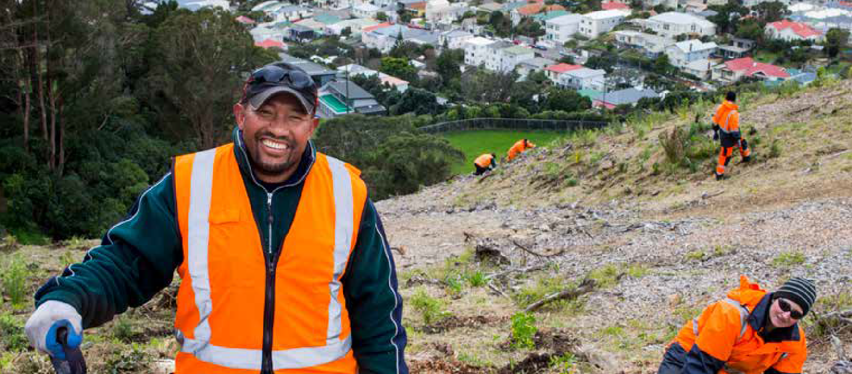
The Council’s strategic approach will bring together our understanding of the challenge, the evolving central Government policy context, mana whenua points of view, and the voices of impacted communities.
The starting point of this is a conversation on what principles need to be incorporated into our framework, reflecting the priorities of Councillors and Wellingtonians. For example, social equity, Te Tiriti, and community co-design.

What’s underway

Developing a strategic framework for climate adaptation
Developing a strategic framework for climate adaptation will be the starting point for the Council and communities to create adaptive pathways that plan for and respond to climate change impacts now and in the future. This builds on the Council’s previous work, including the Resilience Strategy.
The Framework will outline an approach to developing “dynamic adaptation pathways”, which can be applied at various scales. The framework
is being designed to be applied to help solve different risks and to be revised in the future as new
information, new ideas, new technology, and funding sources emerge.
It is being designed to aligned with the New Zealand Coastal Policy Statement 2010, the 2017 Ministry
for the Environment’s (MfE) Coastal Hazards and Climate Change Guidance for Local Government, and the first National Adaptation Plan (due for release in August 2022), as well as future policies, and relevant strategies, policies and plans from the Council.

Developing an adaptation plan for Council-owned assets
Once we have in place our strategic framework,
we will also be able to develop dynamic adaptation pathways for Council-owned assets, including our recreation facilities, roads, public reserves, etc. This will enable us to plan ahead for the likely costs of either being able to adapt our assets to the impacts or moving our assets to safer ground.

Action Area: Working with local communities

Community participation will be vital to the process of making difficult climate change adaptation decisions for the city’s long-term resilience.

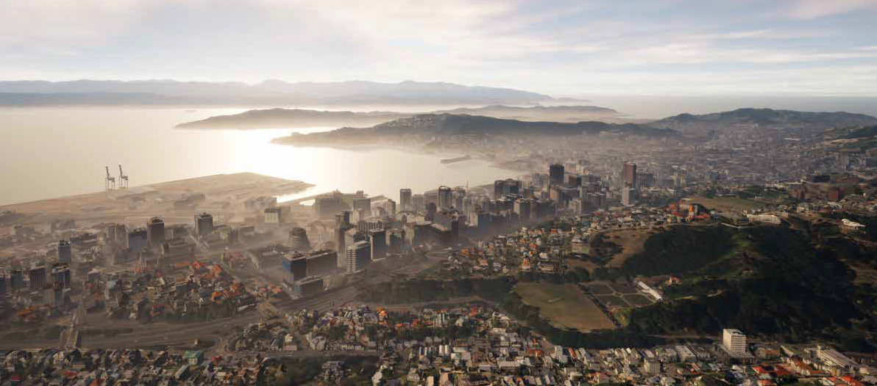
The people closest to the impacts need to have a seat at the table – both to bring their unique understanding of the context and to shape how we collectively
respond to the challenges ahead. To enable meaningful participation, we need to communicate the full picture of how climate change will impact Wellington and
to create ways for people with diverse needs and perspectives to contribute in an ongoing way.

What’s underway

Bloomberg digital twin project and community engagement tool
A digital twin is a virtual representation of the systems and things that make up the city—a 3D model brought to life by real-time data from sensors and processes to help understand, communicate, and make better decisions on how Wellington works and grows.
We are building a web-based accessible and interactive engagement tool that will allow us to co-create how the city adapts to climate change
with mana whenua, scientists, and residents. It will weave together climate change adaptation planning
with our digital city model, which will use gaming technology to provide hyper-realistic visualisations of Wellington’s past, present and future, climate impacts and adaptation options. The tool will allow residents to share information and ideas with the Council, enabling critical and coordinated adaptation decisions to be made in line with community priorities.
In January, this project won the prestigious Bloomberg Mayors Challenge, a global competition recognising the boldest and most ambitious urban innovations that address current issues including economic recovery and growth, health and wellbeing, climate and environment, and gender and equality.
Wellington City Council was named one of 15 winners to receive US$1M to deliver the project, out of over 600 applicants from 99 countries.
It will be rolled out over the next three years. The open-source code will be available for other coastal cities to access and utilise for their own purposes.

Wellington’s digital twin, a 3D virtual map of the city that can be used as an engagement tool.

Coastal restoration (living shorelines, dune revegetation, beach renourishment, dune reconstruction)
Citizen Science
–monitoring coastlines

Coastal defences for protecting public assets (walls, pumps, drainage upgrades, raise land levels, breakwaters, groynes, armouring)

Empower Wellingtonians with accessible information about climate change risks and adaptation options

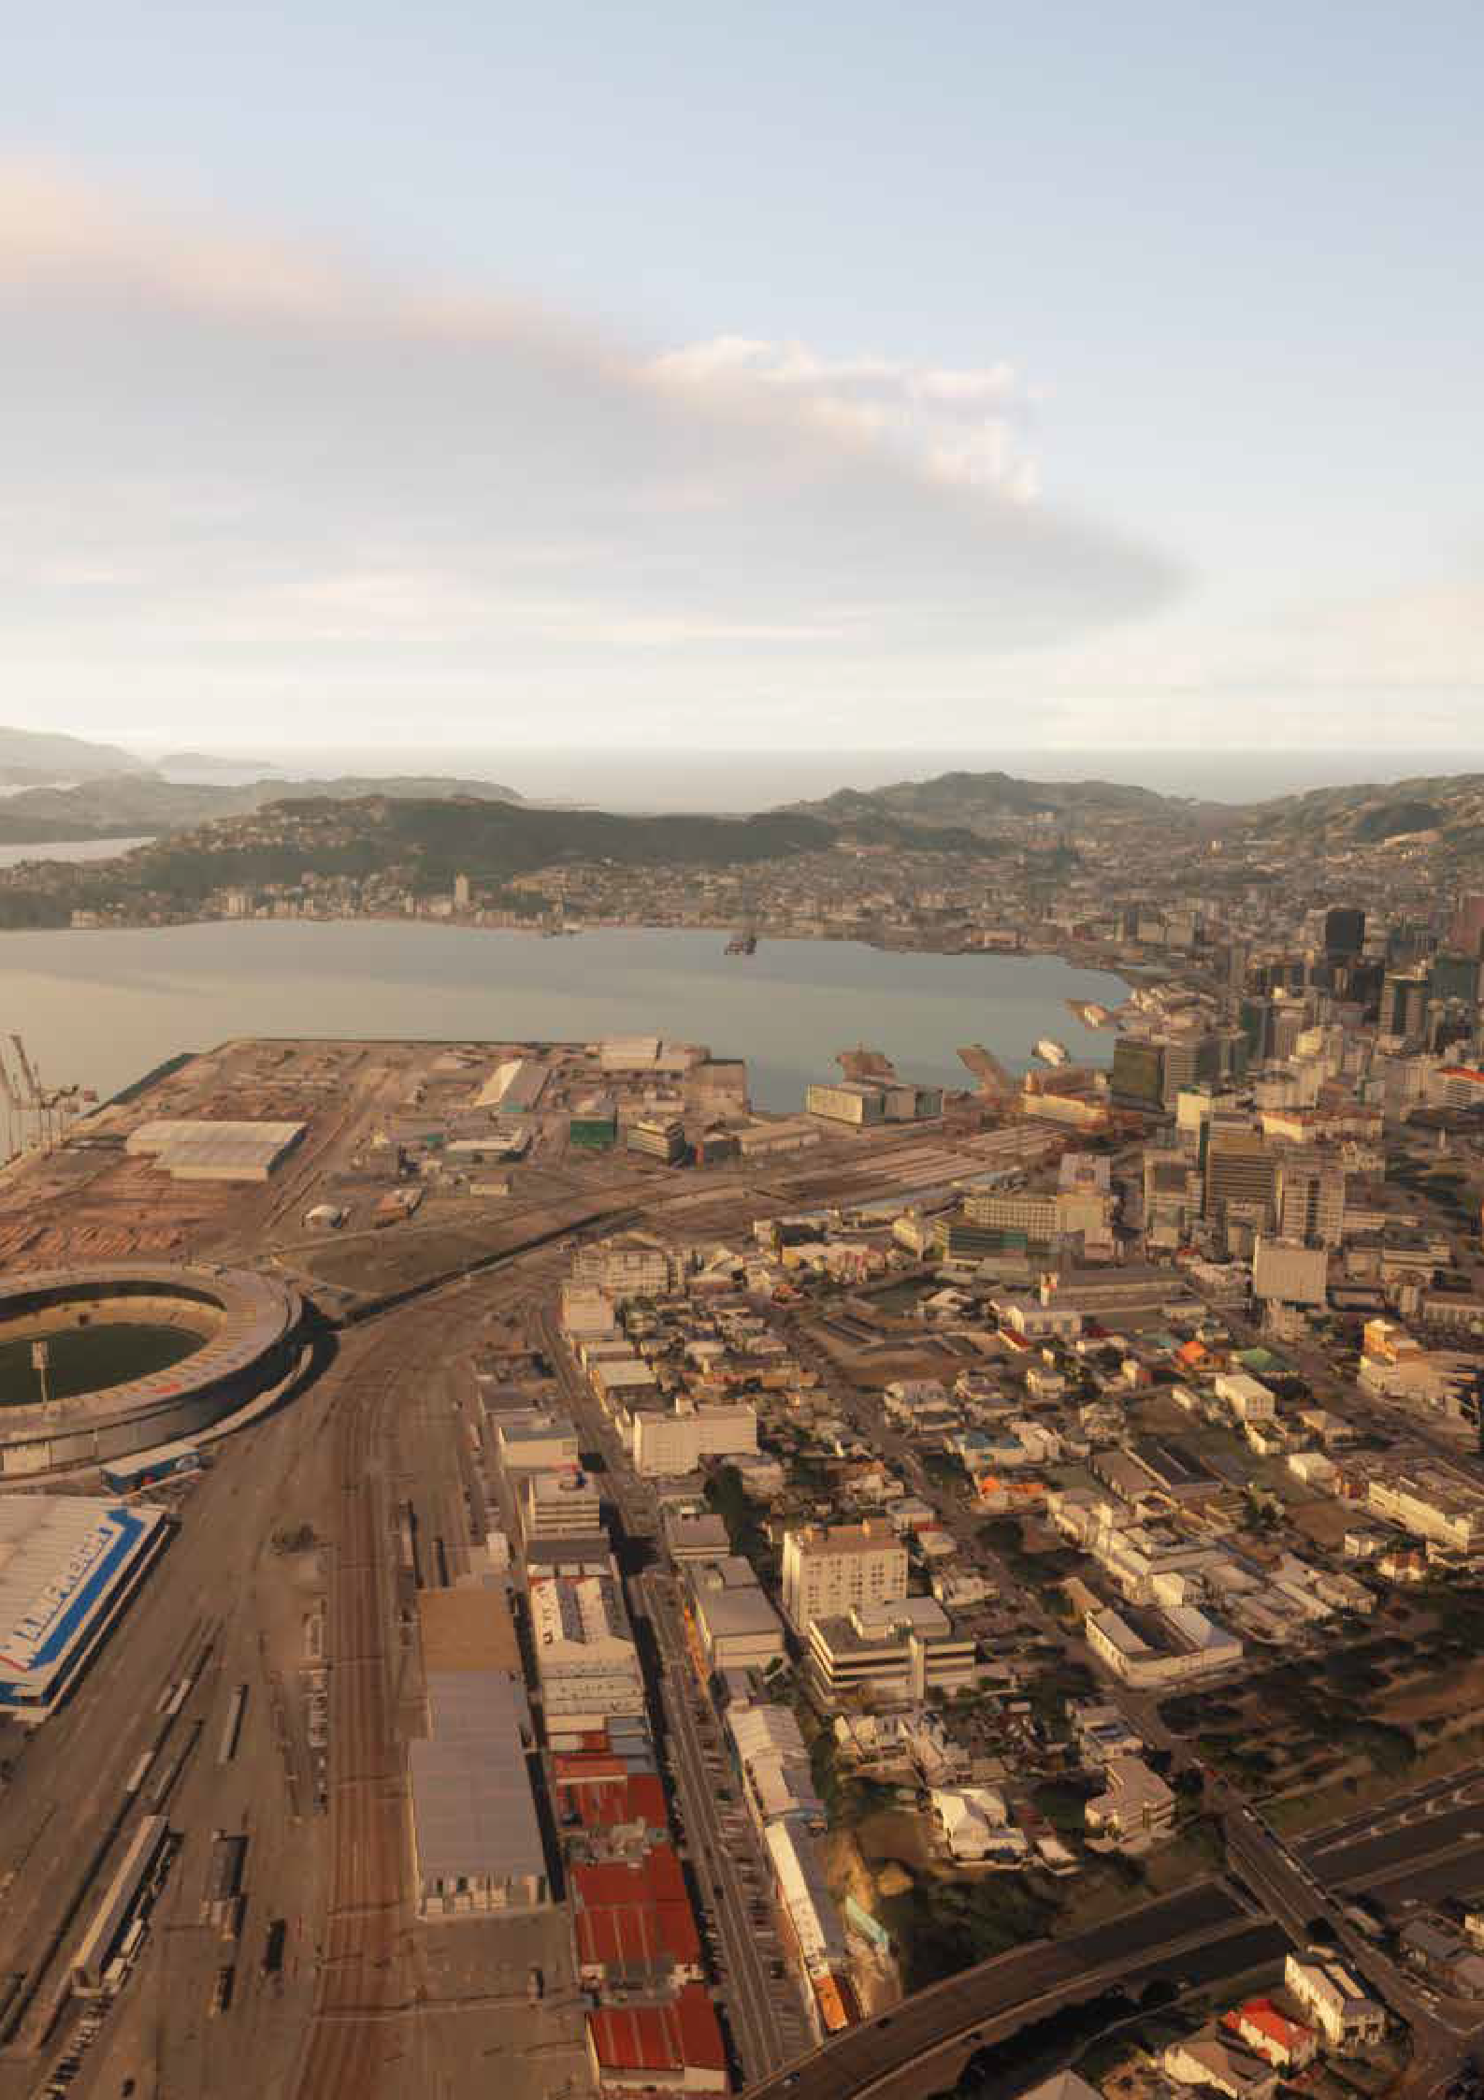
Water sensitive urban design / Sponge City

Urban planning and city shaping

34 Te Atakura – First to Zero 2022 Update

What else is planned

Developing community-based adaptation plans for high-risk communities
Based on learning to date, a planning programme will be developed for high-risk communities to help them prepare for future climate change impacts.
This will feed into a Ministry for the Environment guide on adaptation. The approach will build on the Council’s experience working with communities
in Mākara, Island Bay, and Owhiro Bay to develop climate change adaptation plans, as well as changes to the national and regional policy context. The Council is using the best-practice framework called Dynamic Adaptive Pathways Planning (DAPP) whereby local plans are developed in accordance with best available scientific evidence, policy settings, technology, and importantly, community values and priorities.

The approach will be designed to support the highest- risk communities to adapt to climate change, and
the Council will begin piloting the approach with the newly established Coastal Climate Change Coalition. These local plans will be designed to interface with city-wide climate change adaptation planning, to connect local values to city-wide strategies in the long-term.

st

Dynamic adaptation pathways planning approach

a
10
Review and adjust
1
Preparation and context
2
Hazard and sea-level rise assessments
3
Values and objectives
9
Monitor
Community engagement

Drivers of change
New climate information; signals and triggers; social cultural and economic change
4
Vulnerability and risk
8
Implementation plan
7
Adaptive planning strategy (with triggers)
6
Option evaluation
5
Identify options and pathways

Source: MfE Coastal Hazards Guide 2017, pg 14, adapted from Max Oulton (University of Waikato) and UN-Habitat (2014)

Looking forward – the race to zero

The work ahead is ambitious. Everyone’s contribution will be necessary. Supporting communities and businesses to reduce emissions will be a focus for Wellington City Council, alongside role modelling emissions cuts in our own work. We see our unique role as shaping the city and bringing together groups whose impact can be greater than the sum of their parts. There is a need for change at multiple levels: cultural change, social change, regulatory change, and infrastructure change.
This update of e Atakura – First to Zero includes our latest emissions data from both the Council and the city for the past years. Over the next few months we will be expanding our understanding of the
full footprint of the city, by using the Doughnut Economics framework to create a portrait of Wellington’s environmental and social measures, and by creating sector-based zero-emissions pathways for our city’s economy. We will publish these research projects once they are completed. This helps us all better understand the full picture of what’s necessary and what’s possible to reduce emissions in line
with our targets. This will be the foundation of our collective work going forward.
We are always keen to hear from Wellingtonians and other interested people and organisations. You can contact us at ClimateAction@wcc.govt.nz

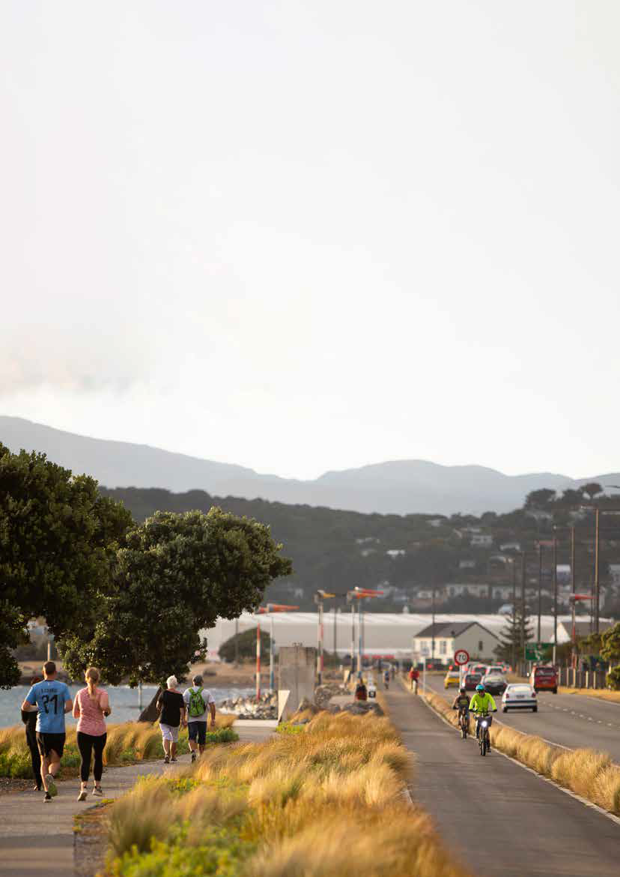

36 Te Atakura – First to Zero 2022 Update

Appendix: Status of current actions

Action | Focus area | Lead | GHG  Reduction | Status 2021 | Status 2022
Let’s Get Wellington Moving | Transport and urban form | WCC, GWRC, NZTA,  Central Govt | Major | Underway | Underway
Creating Streets for People  – starting with cycling | Transport and urban form | WCC, GWRC, NZTA,  Central Govt | Major | Underway | Underway
Planning for Growth | Transport and urban form | WCC | Major | Underway | Underway
Travel behaviour change | Transport and urban form | WCC | Enabling | Ongoing | Ongoing
Car sharing | Transport and urban form | Business sector | Moderate | Ongoing | Ongoing
E-scooter sharing | Transport and urban form | Business sector | Minor | Underway | Underway
Charged up Capital – Public EV chargers | Transport and urban form | WCC | Moderate | Underway | Underway
Fossil fuel free streets | Transport and urban form | WCC, GWRC, NZTA,  Central Govt | Enabling | Scoping | Absorbed into LGWM
Incentivising city-wide flexible working14 | Transport and urban form | WCC, GWRC, NZTA,  Central Govt | Major | More R&D required | Absorbed into ongoing travel behaviour change work
Identify aviation and marine opportunities | Transport and urban form | Business sector | Unclear | More R&D required | More R&D required
Warmer Kiwi Homes | Building energy | EECA (10-20% top  up by WCC) | Minor | Ongoing | Ongoing
Home Energy Saver | Building energy | Sustainability Trust | Minor | Ongoing | Ongoing
Neighbourhood grids | Building energy | Contact energy | Minor | Completed | Completed
Business Energy Saver Pilot | Building energy | WCC with delivery partner | Moderate | Scoping | Scoping
Development contributions | Building energy | WCC | Minor | Scoping | Absorbed into EAPF
Supporting building sustainability improvements | Building energy | WCC | Enabling | More R&D required | Absorbed into EAPF
Te Akatura action investigation | City-wide | WCC | Enabling | Scoping | Scoping
- Removed due to COVID-19-related behaviour changes

Action | Focus area | Lead | GHG  Reduction | Status 2021 | Status 2022
Wellington Climate Lab15 | City-wide | WCC, business sector, community sector, academia | Enabling | Scoping | Underway
Climate and sustainability fund | City-wide | WCC | Enabling | Underway | Underway
Climate action campaign | City-wide | WCC | Enabling | Scoping | Underway
Zero together16 | City-wide | WCC | Enabling | Underway | Underway
Sustainable Food Programme | City-wide | WCC | Enabling | Underway | Underway
Accelerate opportunities to support carbon farming | City-wide | WCC | Enabling | Underway | Underway
Carbon measurement and management | Council | WCC | Enabling | Underway | Underway
Emissions Reduction Plan | Council | WCC | Enabling | Scoping | Scoping
Sewage Sludge Solution | Council | Wellington Water | Major | Awaiting funding | Awaiting funding
Para Kai17 | Council | WCC | Minor | Underway | Completed
33% waste volume  reduction by 202618 | Council | WCC | Major | Scoping | Underway
EV First Fleet | Council | WCC | Minor | Underway | Underway
Energy Management Strategy and Plan | Council | WCC | Enabling | Scoping | Underway
Displacing natural gas | Council | WCC | Minor | More R&D required | Underway
Solar community facilities | Council | WCC | Minor | Scoping | On hold
Climate Smart Buildings policy | Council | WCC | Enabling | Underway | Underway
Hybrid working19 | Council | WCC | Minor | Underway | Underway
Procurement - Better Outcomes20 | Council | WCC | Enabling | Underway | Underway

- Renamed from Wellington Climate Lab
- Renamed from Future Living Skills programme
- Renamed from Organics Collection Trial
- Renamed from Waste Strategy Review
- Renamed from Flexible working
- Renamed from Procurement

Action | Focus area | Lead | GHG  Reduction | Status 2021 | Status 2022
Improve governance | Council | WCC | Enabling | Underway | Absorbed into staff engagement
Staff engagement | Council | WCC | Enabling | Underway | Underway

New action | Focus area | Lead | GHG Status Reduction 2021 | Status 2022
Active Workplace Travel Fund | Transport and urban form | WCC | Enabling | Underway
Wellington City Central Green Network Plan | Transport and urban form | WCC | Moderate | Scoping
Environmental and Accessibility Performance Fund | Building energy | WCC | Enabling | Underway
Leading the Wellington Regional Climate Change Impact Assessment | Adaptation | WCC | n/a | Underway
Updating hazard maps with current adaptation projections | Adaptation | WCC | n/a | Completed
Developing Wellington City Council’s Climate Change Impact Assessment | Adaptation | WCC | n/a | Scoping
Develop the Wellington City Council Climate Adaptation Plan | Adaptation | WCC | n/a | Underway
Bloomberg digital twin project & community engagement tool | Adaptation | WCC | n/a | Underway
Develop a community- based Dynamic Adaptive Pathways Planning programme for high-risk communities | Adaptation | WCC | n/a | Underway
Document lessons from WCC case-studies: Mākara & Owhiro Bay | Adaptation | WCC | n/a | Completed

Glossary: Climate change terms

This glossary defines some of the specific terms used in this document and that are common in discussions on climate change.

Adaptation: Actions that help manage, moderate, and cope with the effects of climate change. For example, avoiding building in areas likely to be affected by rising sea levels.
Biodiversity: Biological diversity. The variability among living organisms from all sources, and the ecological systems of which they are part; this includes diversity within species, between species and within ecosystems.
Climate change: A pattern of change attributed directly or indirectly to human activity that alters the composition of the atmosphere, affecting global or regional climate. As measured by factors such as average temperature and rainfall, or an alteration in the frequency of extreme weather conditions
Carbon dioxide: A naturally occurring gas, CO2 is also a by-product of burning fossil fuels (such as oil, gas, and coal), of burning biomass,
of land-use changes, and of industrial processes (eg, cement production). It is the principal anthropogenic greenhouse gas (GHG) that affects the Earth’s radiative balance. See also Greenhouse gas (GHG)
Decarbonization: The process by which countries, individuals or other entities aim to achieve zero fossil carbon existence. It typically refers to a reduction
of the carbon emissions associated with electricity, industry, and transport.
Fossil fuels: Fuels made from decomposing animals or plants. Examples include coal, oil, and natural gas, which all contain hydrocarbons. As they are carbon-
based, these fuels produce carbon dioxide when burnt.
Global warming: The steady rise in the global average temperature of the earth’s atmosphere, which is largely caused by increased levels of human-produced greenhouse gas emissions.
Greenhouse gases (GHG): Natural and industrial gases that cause the greenhouse effect on Earth. Carbon dioxide and methane are natural GHGs, and hydrofluorocarbons are industrial GHGs.
Liquefaction: Takes place when loosely packed, water-logged soil at or near the ground surface loses its strength in response to strong ground shaking, eg during an earthquake.
Mitigation: Actions aiming to reduce the impacts of climate change by preventing or reducing the emission of greenhouse gases.
Net zero: Refers to a balance between the amount of greenhouse gas emissions produced and the amount removed from the atmosphere, whereby we are not adding new greenhouse gases to the atmosphere.
Scope 1, 2 and 3 emissions: Scope 1 emissions are all the direct emissions from an organisation’s actions or under their control (eg emissions from gas boilers, vehicles, and industrial processes). Scope 2 emissions are indirect emissions from electricity purchased and used by the organisation. Scope 3 emissions are all other indirect emissions from activities of the organisation, occurring from sources that they do not own or control (eg all purchased goods, emissions from suppliers, any travel not in company owned vehicles). Scope 3 emissions are usually the greatest share of the carbon footprint.
Sequester (also carbon sequestration): The process of capturing from the atmosphere and storing carbon dioxide. This can happen naturally, as growing trees and other plants turn CO2 into biomass stored within the plant. It can also refer to the capture and storage of CO2 through technical processes.

J015901 – December 2022

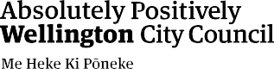
Climate Change Response Team ClimateAction@wcc.govt.nz wellington.govt.nz

